Nottingham Trent University

School of Science and Technology

“Developing an Interactive Game to Enhance Environmental Education on Plastic Pollution”

by

Michal Nickel

in

2025

Project report in part fulfilment

of the requirements for the degree of

Bachelor of Science with Honours

In

Computing

I hereby declare that I am the sole author of this report. I authorise the Nottingham Trent University to lend this report to other institutions or individuals for the purpose of scholarly research.

I also authorise the Nottingham Trent University to reproduce this report by photocopying or by other means, in total or in part, at the request of other institutions or individuals for the purpose of scholarly research.

Michal Nickel

Abstract

The work introduces the problem of ineffective environmental education among youth aged 11–14, specifically regarding plastic pollution. Traditional teaching methods are often passive and fail to engage this age group, resulting in poor knowledge retention and minimal behavioural change. There is a need for interactive tools that present environmental issues in a format that resonates with younger learners and encourages active participation.

To address this, an interactive platformer game was developed using Unreal Engine 5.5, with 3DS Max, Blender, Adobe Photoshop and Sony Vegas Pro supporting asset creation, video and image editing. The game incorporates movement mechanics inspired by Crash Bandicoot, along with educational features such as plastic waste collection, recycling tasks, NPC dialogue, and embedded case studies. Agile methodology guided the development process, allowing for continuous refinement and testing throughout each sprint.

The prototype successfully demonstrates that game-based learning can increase engagement and reinforce environmental awareness. Informal user feedback showed positive responses to both gameplay and educational content. Although limited by time and target user access, the project achieved its main objectives and provides a viable foundation for future development, expansion, and application in educational settings.

Table of Contents

Abstract ii

Table of Contents iii

List of Figures iv

CHAPTER 1 1

Introduction 1

CHAPTER 2 20

CONTEXT 20

CHAPTER 3 37

New Ideas 37

CHAPTER 4 63

Implementation 63

CHAPTER 5 140

RESULTS / DISCUSSION 140

Introduction 140

CHAPTER 6 165

CONCLUSIONS / FUTURE WORK 165

References 173

List of Figures

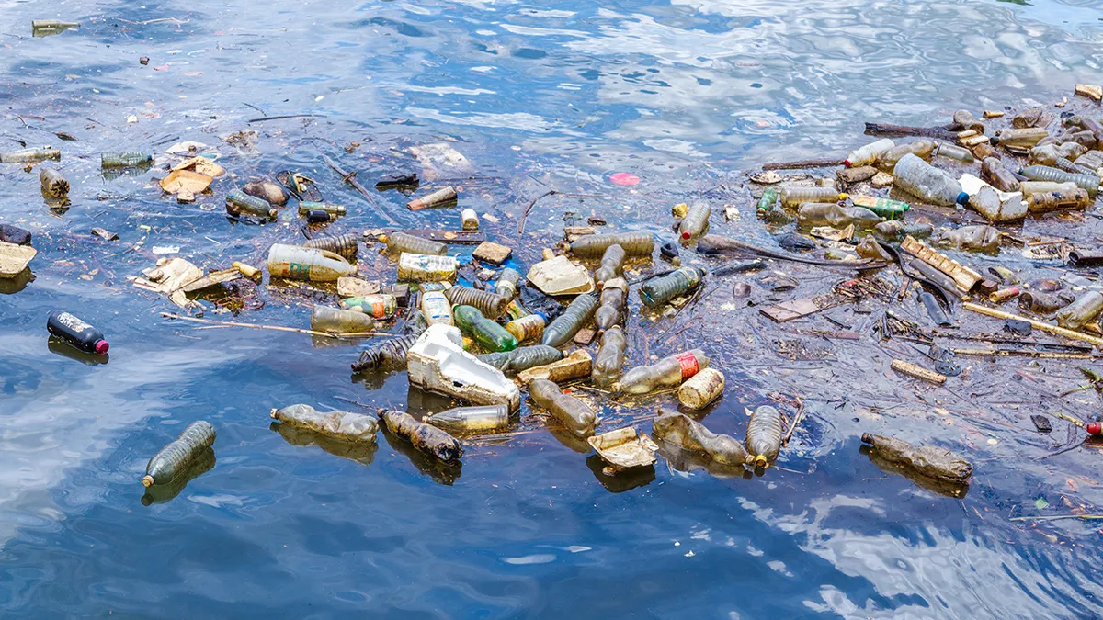*(Figure 1 - Plastic Waste Floating in the Ocean)*

*(Figure 2 – Traditional Teaching Methods)*

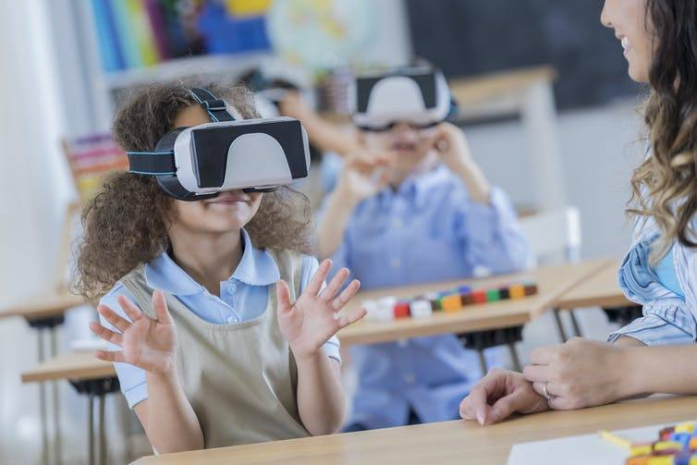*(Figure 3 - Children Playing Education Video Games)*

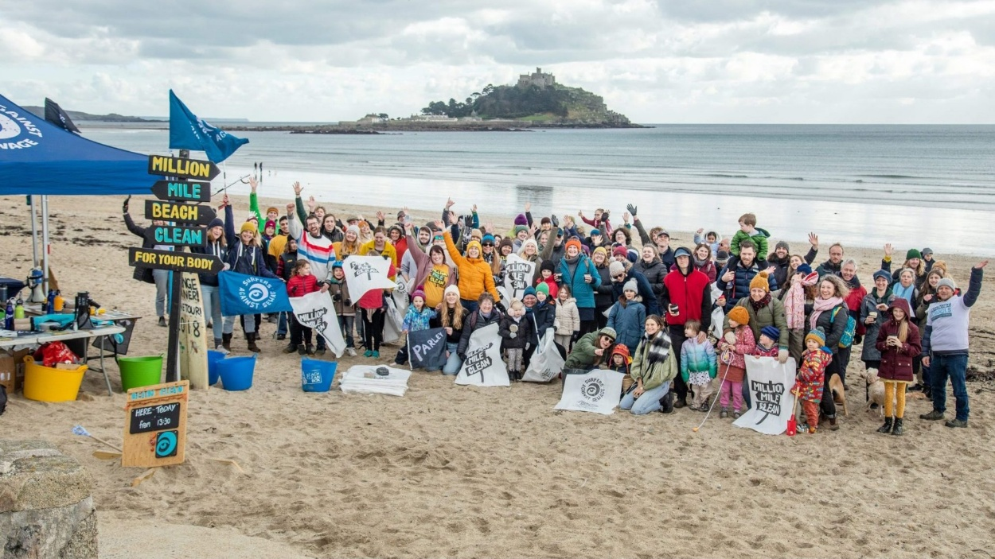*(Figure 4 - Volunteering at Beach Cleanup Event)*

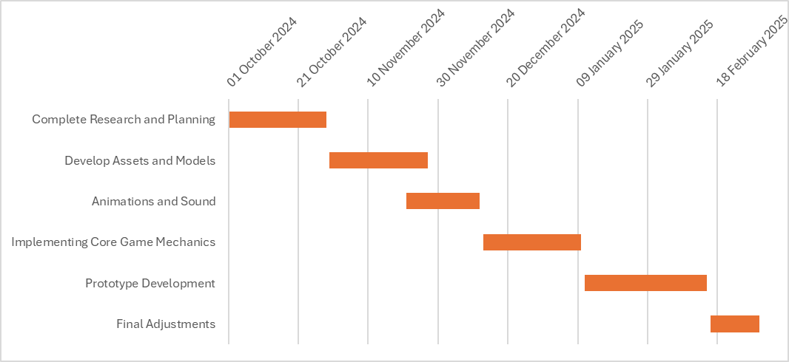*(Figure 5 - Gantt Chart)*

### Inserting image...*(Figure 6 - Plastic is Turning Ocean into a Minefield)*

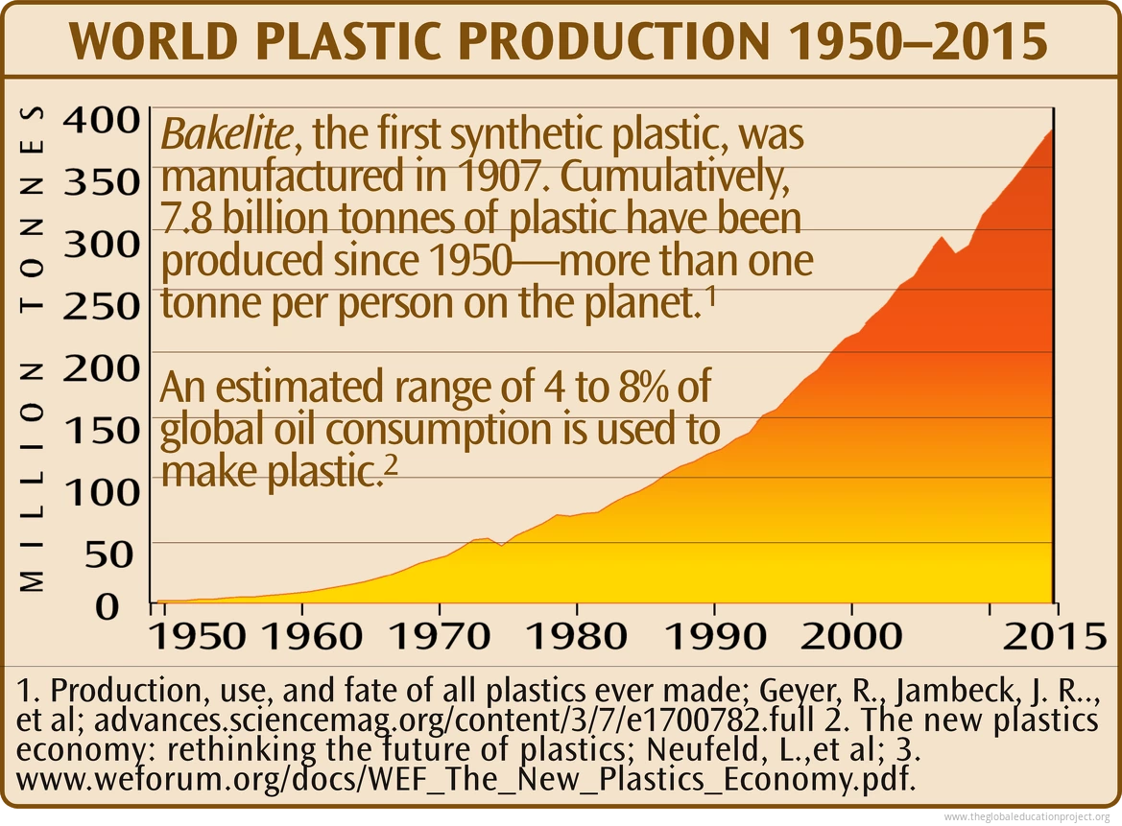*(Figure 7 - Chart of World Plastic Production)*

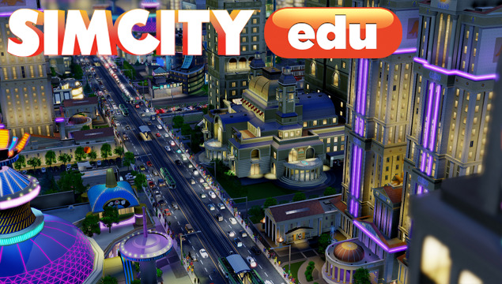*(Figure 8 - Games for Change SimCity EDU)*

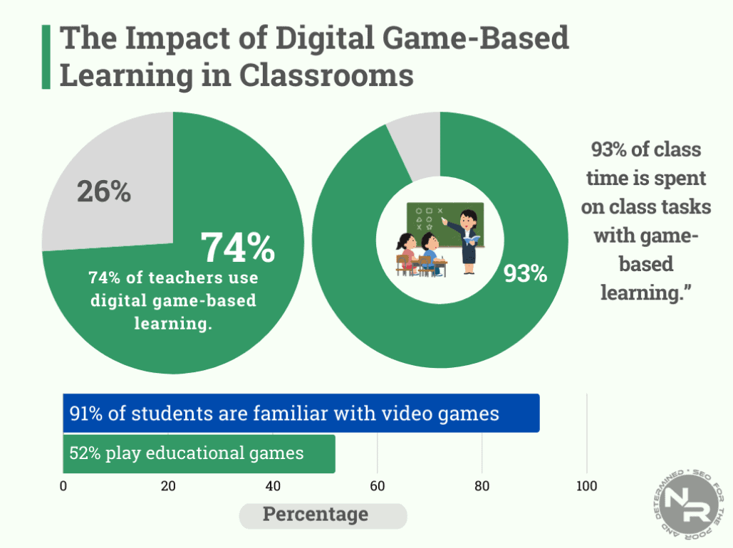*(Figure 9 - Impact of Digital Game-Based Learning in Classrooms)*

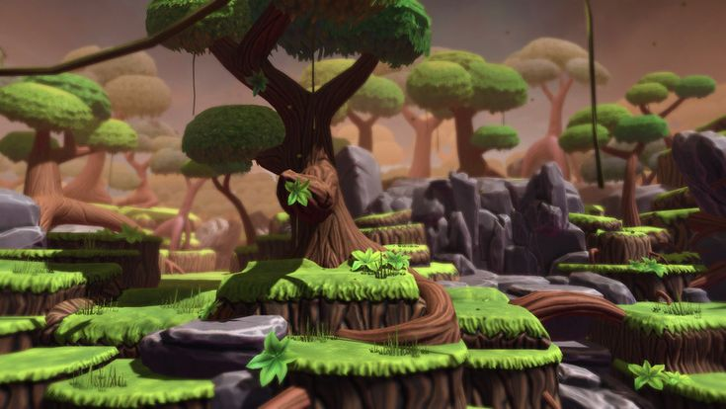*(Figure 10 - Concept Art for 3D Platformer Level with Environmental Themes)*

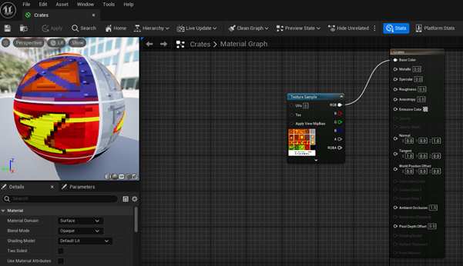*(Figure 11A - Unused Crate Material Setup)*

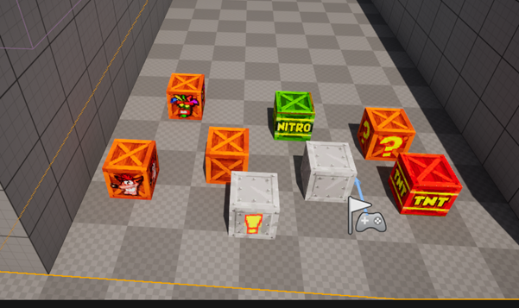*(Figure 11B - Unused Crates In-Game)*

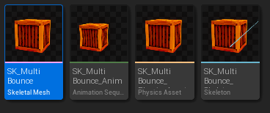

*(Figure 11C – Unused Crate Folder Setup)*

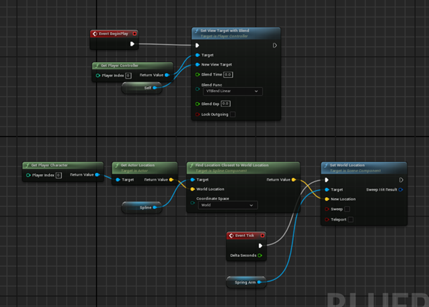*(Figure 12 - Unused Spine Camera Setup Blueprint)*

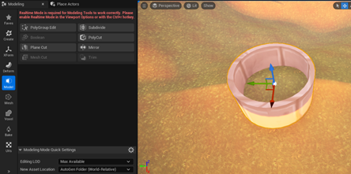

*(Figure 13 – Unused Tunnel Concept)*

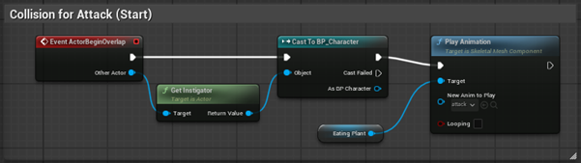*(Figure 14A - Unused Enemy Attack Animation Blueprint)*  
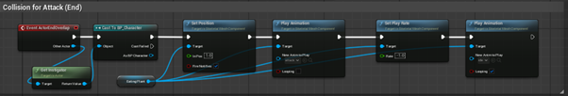*(Figure 14B - Unused Enemy Attack End Animation Blueprint)*

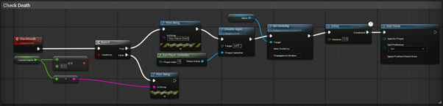 *(Figure 15A - Unused Checking Player Death Blueprint)*

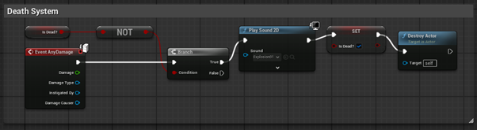*(Figure 15B - Unused Death System Blueprint)*

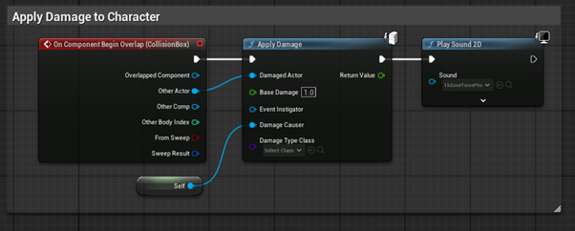*(Figure 15C - Unused Character Damage System Blueprint)*

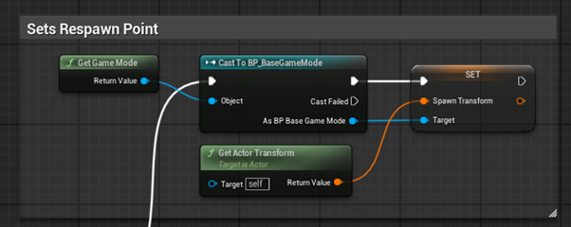*(Figure 16A - Unused Setting Spawn Point to Player Start)*

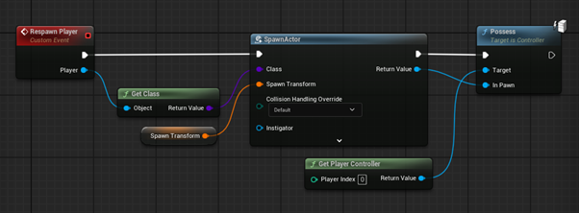*(Figure 16B - Unused Respawn Player to Spawn Transform)*

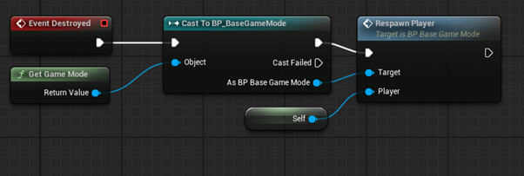*(Figure 16C - Unused Respawn Player)*

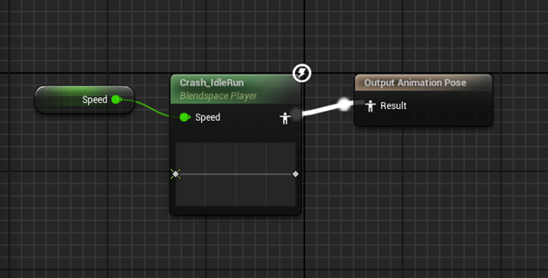*(Figure 17A - Blendspace Animation Applied to Character)*

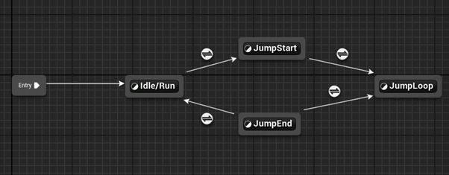*(Figure 17B - Smooth Character Animation Transitions)*  
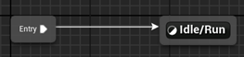 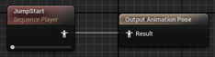  
*(Figure 17C - Default Animations)*

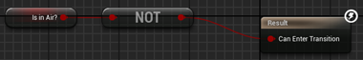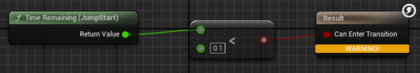  
 *(Figure 18A - Conditions for Animation to Play)*  
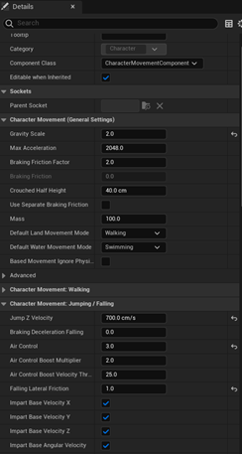  
*(Figure 18B - General Running and Jumping Controls Settings)*



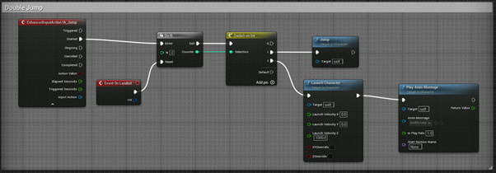*(Figure 19A - Double Jump Settings and Blueprint)*  
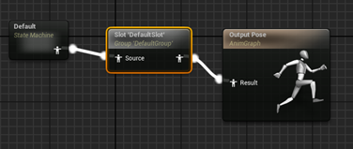   
*(Figure 19B - Double Jump Animation State Machine)*

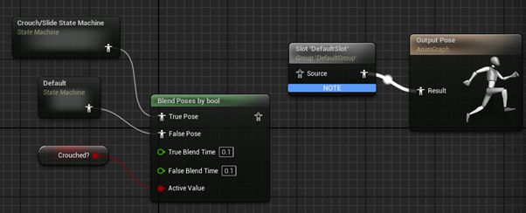*(Figure 20A - Crouch State Machine)*  
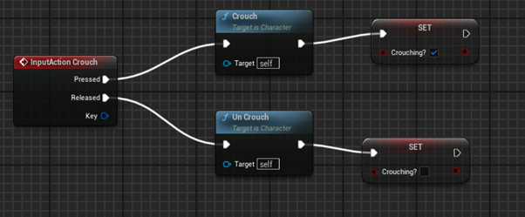*(Figure 20B - Crouch Input Action)*  
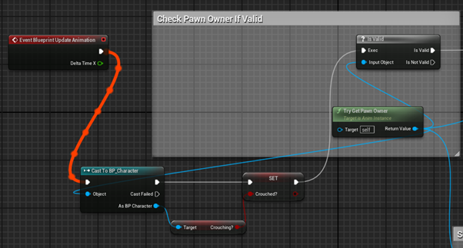*(Figure 20C - Updating Crouch Animation to Character in Blueprint)*

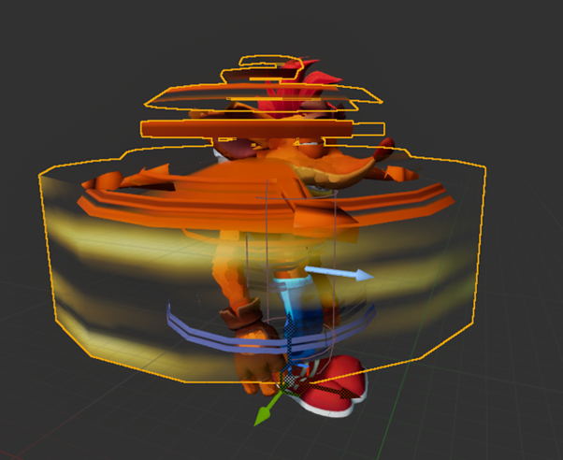*(Figure 21 - BP_Character Viewport of Spin)*

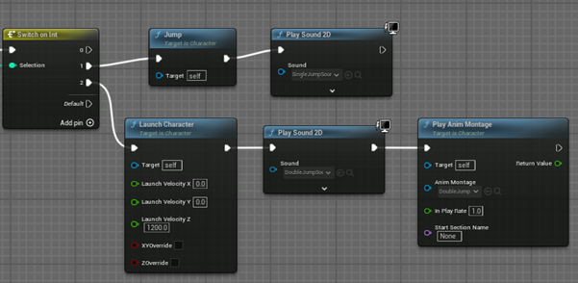*(Figure 22A - Jump & Double Jump Sound Effects)*

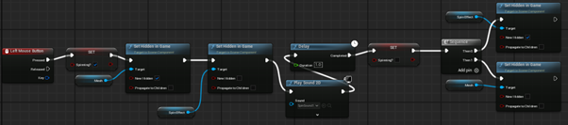*(Figure 23A - Spin Effect Blueprint Functionality)*

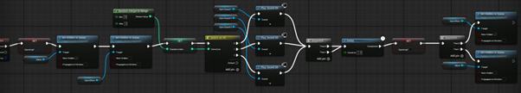*(Figure 23B - Updated Spin Effect Blueprint Functionality)*

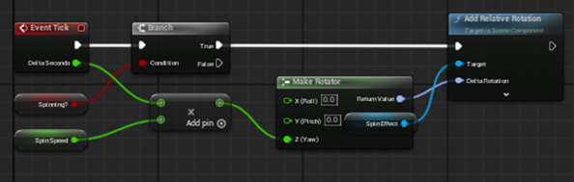

*(Figure 23C - Spin Mesh Rotation Logic)*

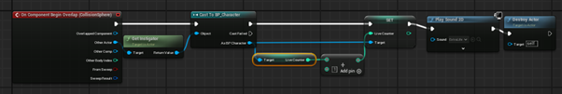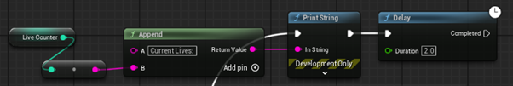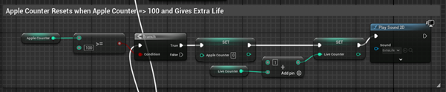*(Figure 24 - Lives & Apples Increment Counters on Collision)*

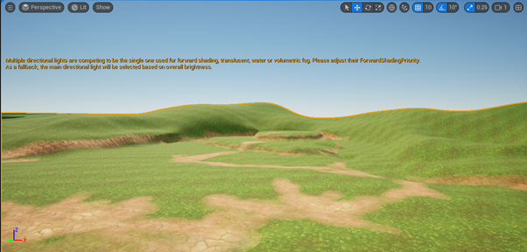*(Figure 25 - Empty Environmental Landscape)*

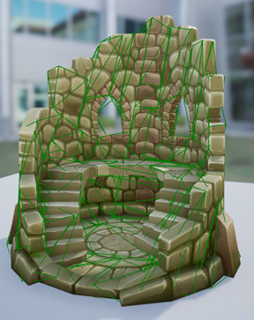

*(Figure 26 – Improved, More Realistic Asset Collision)*

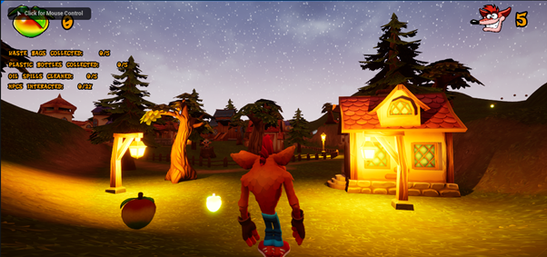*(Figure 27 - Day & Night Cycle in Preview)*

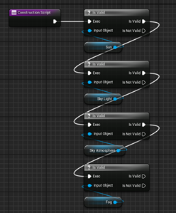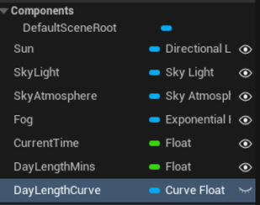

*(Figure 28A – Unused Lighting Scene Logic for Controlling Cycle)*

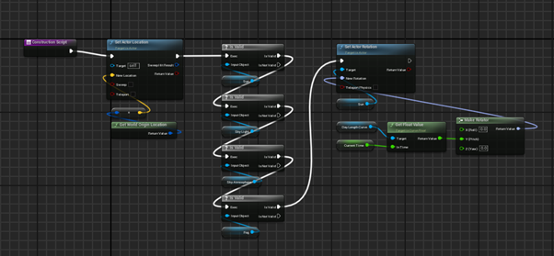*(Figure 28B - Unused Lighting Scene Logic Updated)*

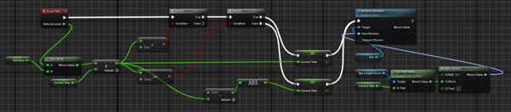*(Figure 28C - Unused Time Logic for Cycle)*

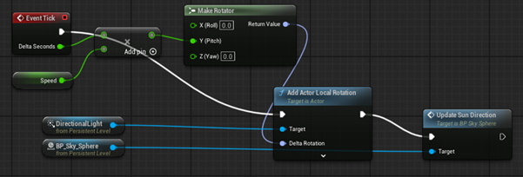*(Figure 29A - New Day & Night Cycle Based on Speed)*

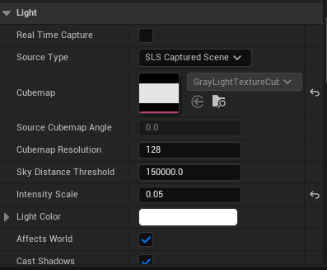

*(Figure 29B – Sky Light Settings for Increased Night Visibility)*

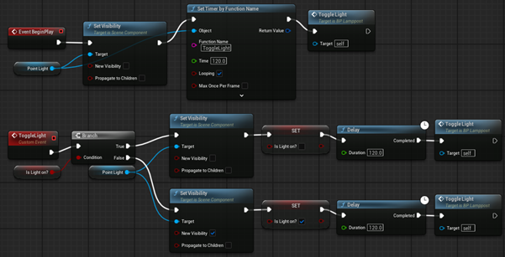*(Figure 30 - Day & Night Cycle Triggered in Level Blueprint)*

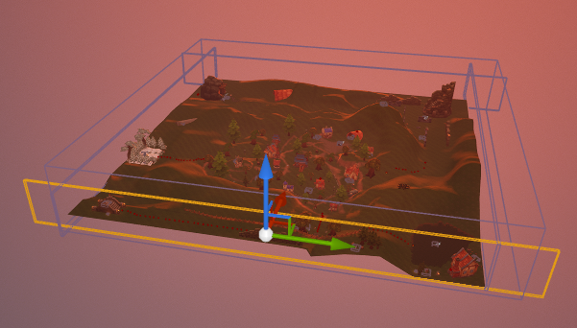*(Figure 31 - Setting Up Blocking Volumes Around Level Boundaries)*

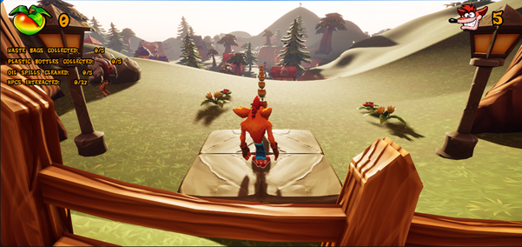*(Figure 32 - Game UI)*

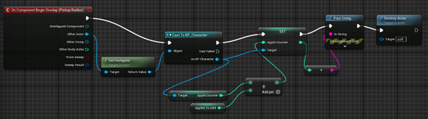*(Figure 33A - Apple Collection Logic)*

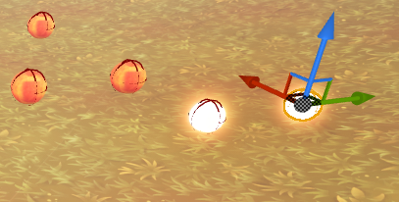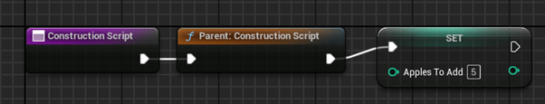*(Figure 33B – Golden Apple Variation)*

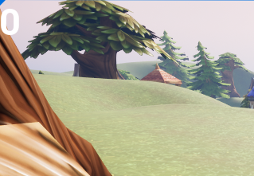

*(Figure 33C – Simple Game UI Counter in Testing)*

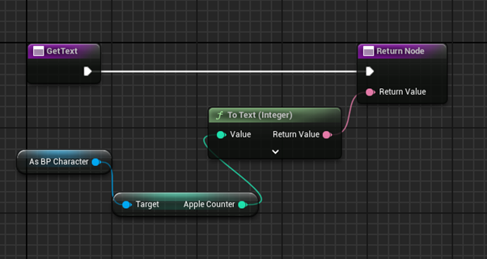*(Figure 33D - Counter UI Widget Event Graph)*

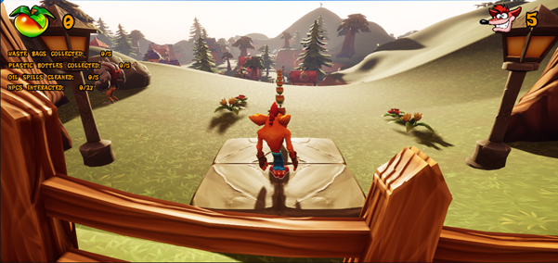

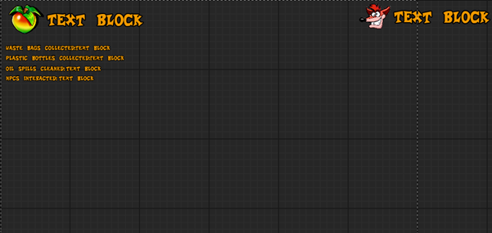

*(Figure 33E - Improved Final Game UI Widget)*

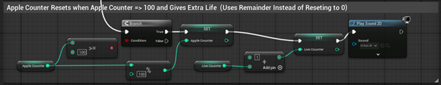*(Figure 34 - Improved Apple Logic when Collecting Over 100 Apples)*

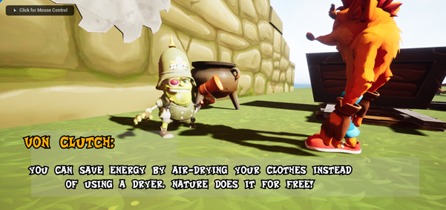*(Figure 35 - In-Game NPC Cutscene)*

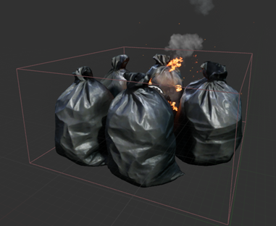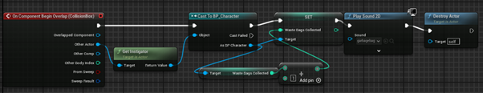*(Figure 36A - Garbage Bag Blueprint Viewport & Collection)*

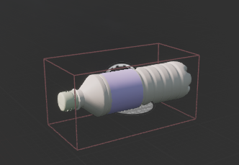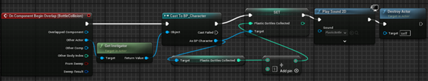*(Figure 36B - Plastic Bottle Blueprint Viewport & Collection)*

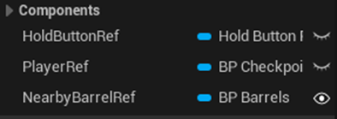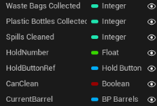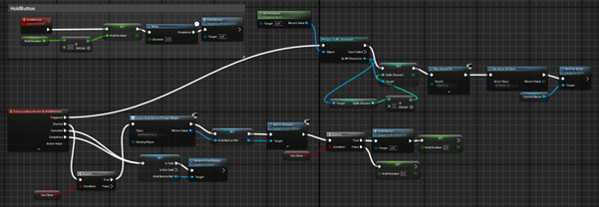*(Figure 36C – Oil Spill Variables and Functionality)*

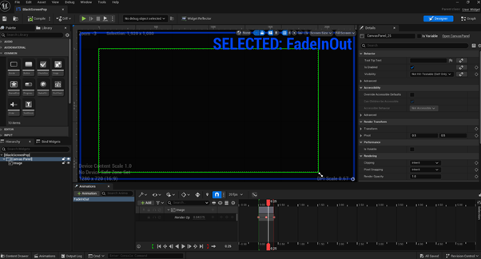

*(Figure 37A - Cutscene Fade Widget Animation)*  
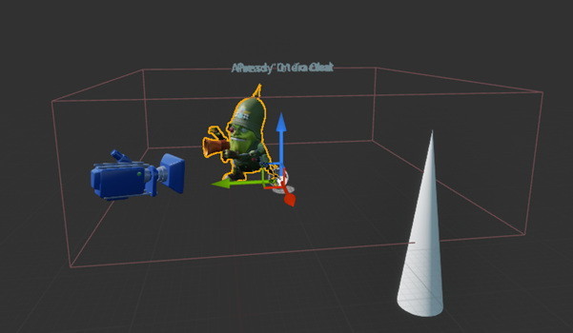

*(Figure 37B - NPC Blueprint Viewport Setup)*

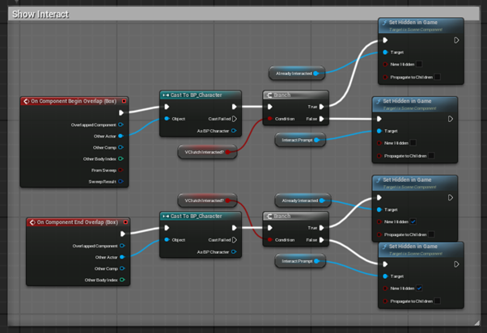

*(Figure 37C - NPC Collision Box Overlap to Show Interact Text)*

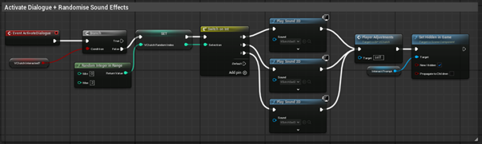*(Figure 37D - Activate NPC Dialogue & Sound)*

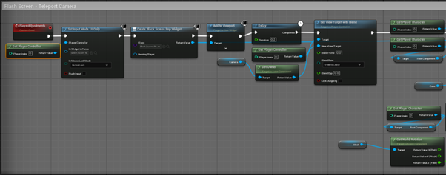*(Figure 37E - Transition to Camera for Cutscene Angle Part 1)*

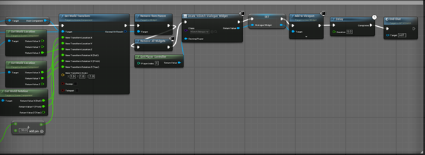

*(Figure 37F - Transition to Camera for Cutscene Angle Part 2)*

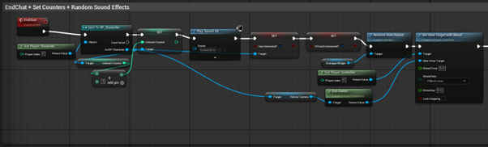

*(Figure 37G - End Chat NPC Cutscene Part 1)*

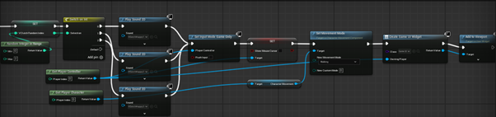*(Figure 37H - End Chat NPC Cutscene Part 2)*

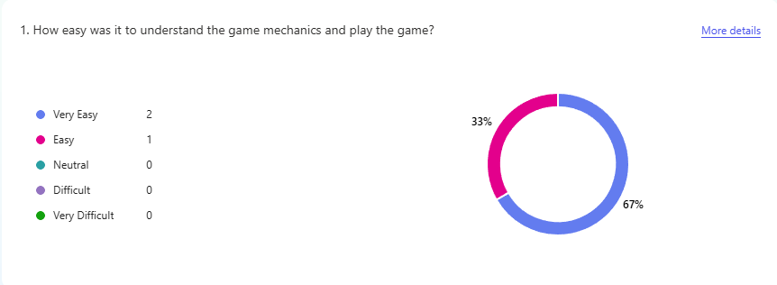*(Figure 38A - Testing Responses Q1)*

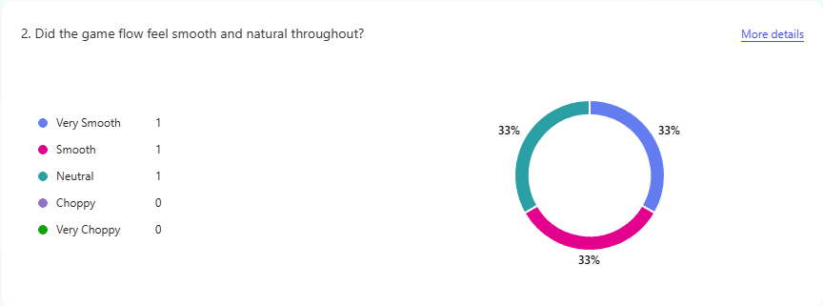*(Figure 38B - Testing Responses Q2)*

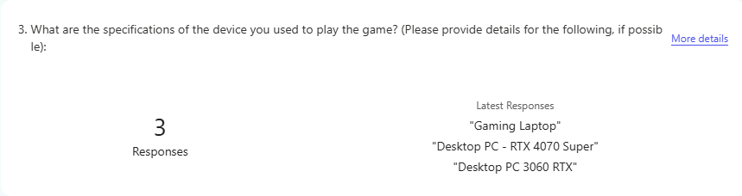*(Figure 38C - Testing Responses Q3)*

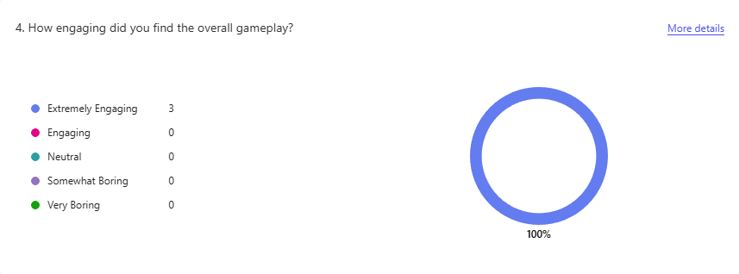*(Figure 38D - Testing Reponses Q4)*

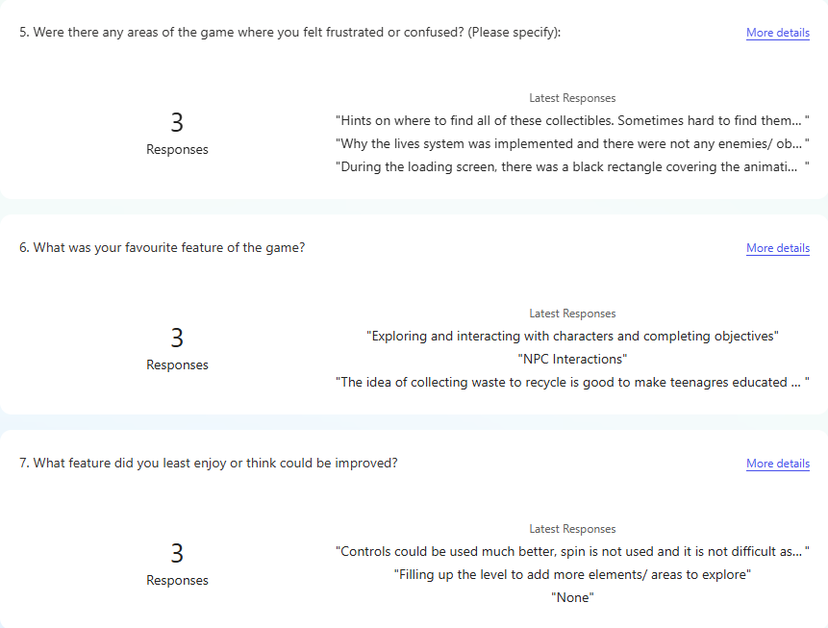*(Figure 38E - Testing Responses Q5, Q6, Q7)*

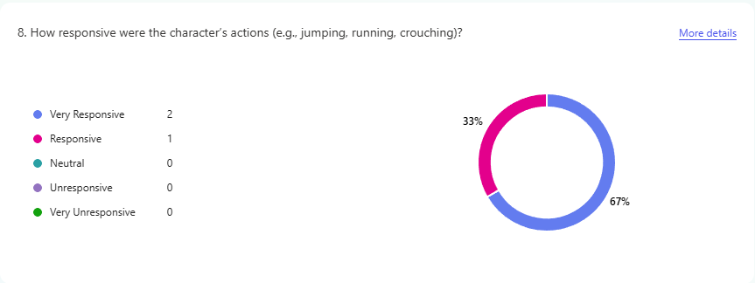*(Figure 38F – Testing Responses Q8)*

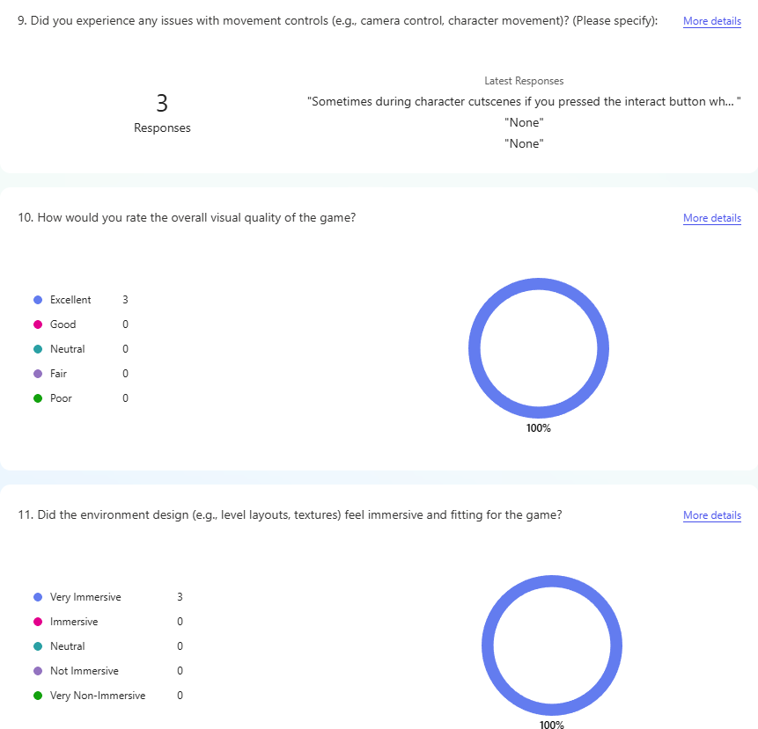*(Figure 38G - Testing Responses Q9, Q10, Q11)*

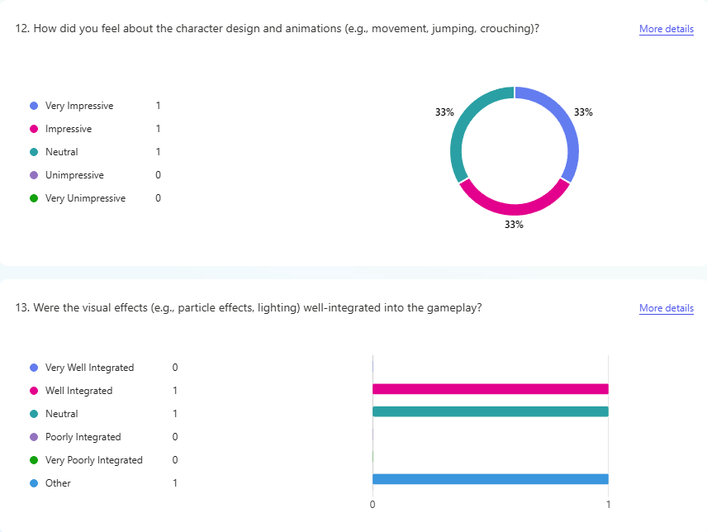*(Figure 38H - Testing Reponses Q12, Q13)*

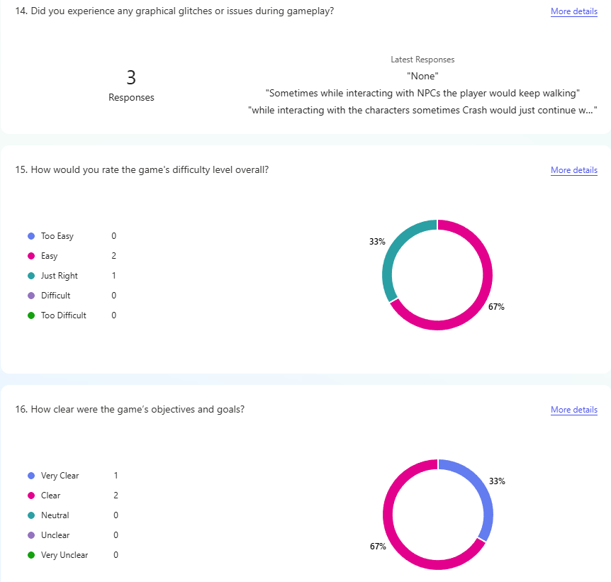*(Figure 38I - Testing Responses Q14, Q15, Q16)*

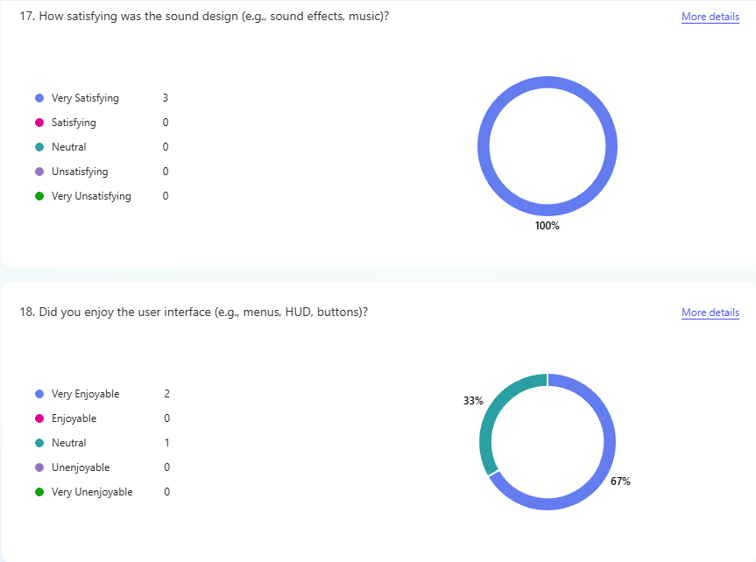*(Figure 38J - Testing Responses Q17, Q18)*

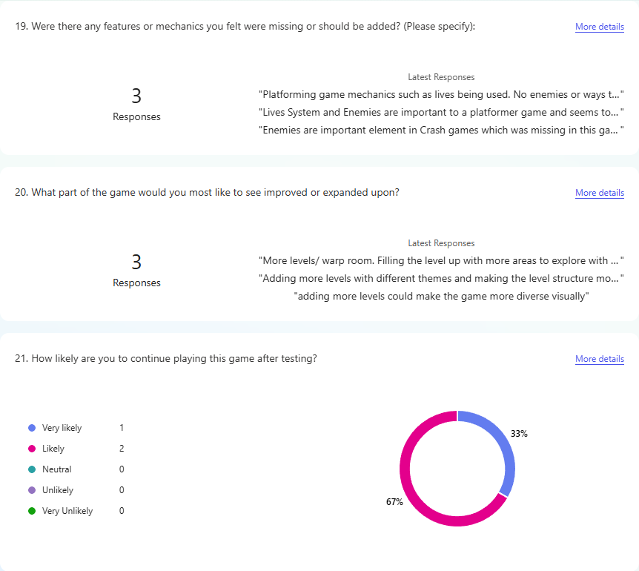*(Figure 38K - Testing Reponses Q19, Q20, Q21)*

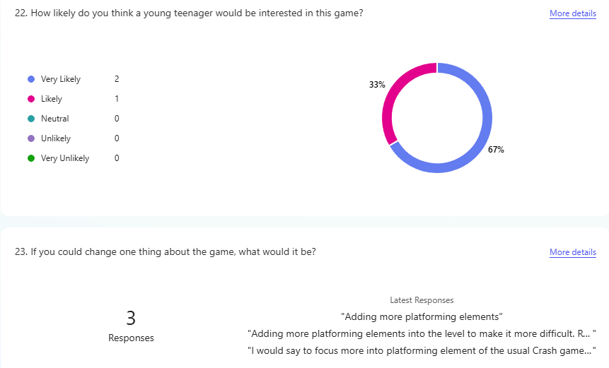*(Figure 38L - Testing Responses Q22, Q23)*

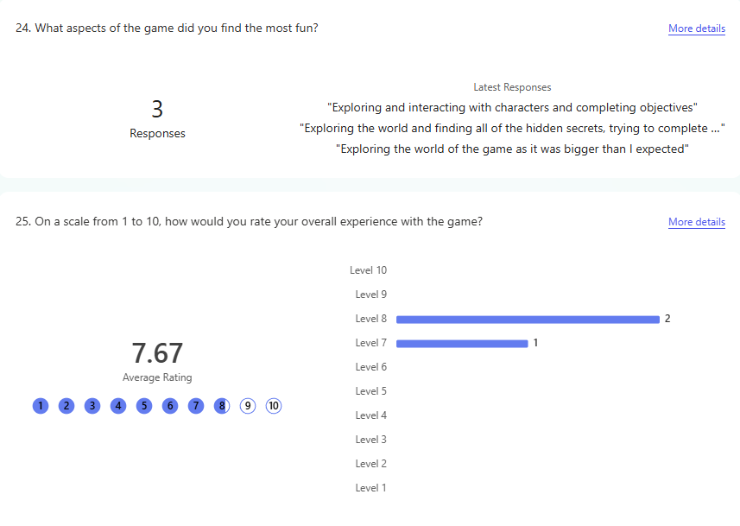*(Figure 38M - Testing Responses Q24, Q25)*



Introduction

**Background Information**

*(Figure 1 - Plastic Waste Floating in the Ocean)*

Environmental pollution, particularly plastic pollution, has emerged as a critical global issue that poses severe threats to both natural ecosystems and human health. In recent decades, plastic consumption has skyrocketed, with over 400 million tonnes of plastic waste generated annually, a significant portion of which ends up in oceans, rivers, and other natural environments *(UN Environment Programme, 2024)*. Studies estimate that each day, approximately 2,000 garbage trucks filled with plastic waste are indiscriminately dumped into aquatic ecosystems, disrupting marine life and polluting freshwater sources *(UNEP, 2023)*. The persistence of plastic waste, which can take hundreds of years to degrade, leads to bioaccumulation of microplastics in the food chain, causing harmful effects on both wildlife and human populations *(Rochman et al., 2015)*.

This issue demands immediate action, not only in terms of waste management but also in educating younger generations about the severity of plastic pollution and its long-term consequences. While there is growing awareness of environmental issues, studies indicate that knowledge alone is insufficient to drive meaningful behavioural change *(Piscitelli & D’Uggento, 2022)*. Youth engagement in environmental conservation remains a challenge due to a lack of interactive and engaging educational resources tailored to their age group. As a result, many adolescents remain disconnected from pressing environmental challenges, which hinders the development of sustainable habits that can reduce plastic waste and mitigate environmental damage.

To tackle this challenge, the development of an interactive, educational video game specifically designed to enhance ecological education regarding plastic pollution can teach sustainable practices to youth aged 11 to 14. Incorporating fun, interactive elements that not only captivate their attention but also teach them about the causes and consequences of plastic pollution. Through gameplay, players will be educated through practical ways to reduce plastic waste, understand the importance of recycling, and develop a sense of responsibility towards preserving the environment. By leveraging the power of information technology, we can create an engaging platform that fosters awareness and encourages active participation in environmental conservation efforts.

This project aims to discover innovative strategies for instilling environmental consciousness in younger audiences. Traditional methods of environmental education such as lectures, textbooks, presentations frequently fail to engage this demographic effectively, leaving many young individuals disconnected from pressing environmental issues *(Blumstein DT, Saylan C., 2007)*. In contrast, interactive and immersive technologies, particularly video games, emerge as a compelling solution. By seamlessly blending entertainment with educational content, this project aspires to create a vibrant and memorable learning experience that empowers young players to take an active role in environmental conservation.

**Challenges in Environmental Education**

*(Figure 2 – Traditional Teaching Methods)*

Traditional methods of environmental education, such as textbooks, lectures, and presentations, often fail to engage younger audiences effectively. Research by Blumstein and Saylan (2007) highlights that passive learning methods—which rely on theoretical knowledge without interactive experiences—lead to low retention rates and minimal behavioural change. Despite efforts to introduce sustainability into school curriculums, many educational programs remain limited in scope, failing to provide students with hands-on, experiential learning opportunities that connect them emotionally to environmental issues *(Steg & Vlek, 2009)*.

Moreover, while digital learning tools have gained popularity, most existing environmental education platforms lack gamified elements that can significantly enhance engagement and motivation (*Wouters et al., 2013)*. Current environmental education games often focus broadly on sustainability without providing an in-depth, interactive approach to addressing plastic pollution specifically *(Wang et al., 2020)*. Additionally, many of these games lack real-world integration, meaning they fail to link in-game actions with tangible environmental outcomes.

**The Role of Interactive Games in Environmental Education**

*(Figure 3 - Children Playing Education Video Games)*

Over the past two decades, educational researchers have increasingly recognised the potential of video games as powerful learning tools *(Gee, 2003)*. Studies in cognitive psychology and digital education suggest that serious games, games designed for educational purposes, can significantly improve knowledge retention, problem-solving skills, and motivation to learn *(Mayer, 2002)*. Interactive gameplay encourages active participation, which leads to higher levels of engagement and deeper understanding compared to passive learning methods *(Sterling, 2001)*.

Platformer games have been widely studied for their effectiveness in reinforcing cognitive learning strategies through progressive challenges and goal-oriented mechanics *(Gee, 2003)*. By incorporating gamification principles such as rewards, feedback loops, and interactive storytelling, games can create immersive learning environments that encourage players to apply their knowledge in meaningful and memorable ways *(Wouters et al., 2013)*. However, despite the proven effectiveness of game-based learning, there is currently a lack of well-designed, research-driven video games focused specifically on plastic pollution for adolescents.

**A New Approach – The Proposed Interactive Platformer Game**

To address the limitations of traditional environmental education, this project proposes the development of an interactive platformer game inspired by the Crash Bandicoot franchise. The game will provide an engaging, visually appealing, and interactive way for children to learn about plastic pollution and sustainability. The key educational objectives of the game include:

* Raising awareness about the sources and consequences of plastic pollution.
* Teaching sustainable practices such as recycling, waste reduction, and eco-friendly consumption.
* Encouraging problem-solving and critical thinking through in-game challenges related to environmental conservation.
* Providing real-world examples and case studies to contextualise the impact of plastic waste on ecosystems and communities.

**Key Features and Components**

1. **3D Platforming and Exploration Mechanics**

The player will control a third-person character navigating through expansive 3D platforming levels that are open-world in nature, offering a balance between structured progression and freeform exploration. These levels draw heavy inspiration from the iconic Crash Bandicoot movement system, incorporating fluid and intuitive mechanics such as jumping, double-jumping, crouching, and responsive running. These foundational abilities not only support smooth and dynamic movement but also create opportunities for engaging with various environmental elements and spatial challenges in creative ways.

This style of platforming encourages players to approach the environment with curiosity and initiative, exploring every nook and cranny of the world around them. The game design avoids handholding, instead using subtle guidance systems to maintain immersion. For example, collectible apples are strategically placed throughout the map to guide players toward objectives, hidden areas, and points of interest. These act as soft indicators rather than explicit instructions, preserving the player's agency while still supporting their journey. This method fosters an engaging and rewarding form of discovery that complements the game’s educational goals, reinforcing the idea that awareness and observation are key in both virtual and real-world environmental efforts.

1. **Environmental NPCs and Interactive Learning**

Scattered throughout each level are 27 non-playable characters (NPCs), each positioned in unique, sometimes hard-to-find locations across the map. The deliberate hiding of these NPCs encourages players to explore the environment thoroughly. When found, the NPCs provide short, digestible environmental facts or tips relevant to the pollution challenges represented in that level. These interactions are designed to be age-appropriate and thought-provoking, aiming to raise awareness without overwhelming younger audiences.

By embedding educational content into the gameplay itself—rather than relegating it to optional reading or static information panels—the game promotes active learning. This direct engagement helps ensure that players associate environmental knowledge with action, agency, and impact. The act of finding and speaking to each NPC becomes a meaningful quest, reinforcing the idea that learning and awareness often come from deeper exploration and attention to detail.

1. **Environmental Objectives and Collectibles**

The primary objectives of the game are rooted in environmental conservation and responsibility. Players are tasked with picking up various forms of litter, such as plastic bottles and waste bags, which are deliberately scattered across the map to simulate real-world pollution. Each item collected contributes to the player's score, with different point values assigned based on the type of waste. This system not only encourages players to fully explore each area but also subtly communicates the real-world importance of waste categorisation and environmental impact.

In addition to collecting waste, players must identify and clean oil spills leaking from barrels situated throughout the level. These actions introduce additional gameplay layers involving strategy, movement, and awareness. Cleaning these spills highlights the consequences of industrial pollution and helps build a sense of urgency and responsibility in players. By turning cleanup efforts into a core gameplay loop, the game educates players on the importance of individual action in combating environmental degradation.

Lives are hidden in secret locations, echoing classic platformer mechanics where exploration is consistently rewarded. These encourage players to look beyond the obvious paths and engage more thoughtfully with the game world. This element adds another layer of depth to the experience and subtly reinforces the value of persistence, curiosity, and paying attention to one's surroundings—skills that are just as relevant in real-life environmental stewardship.

1. **Mission-Based Level Progression**

Each level features specific missions designed to provide direction, structure, and purpose to the player's journey. These missions are thematically tied to real-world environmental issues and are presented as tangible, achievable goals. Examples include “Collect 5 waste bags,” “Clean 5 oil spills,” or “Interact with 27 NPCs.” These objectives encourage players to focus on immediate goals while naturally absorbing the larger message of the game.

By framing tasks as missions, the game gives players a sense of purpose and progress that is both rewarding and educational. Completing these challenges helps instil a sense of accomplishment while simultaneously reinforcing the core themes of the experience: responsibility, community, and the power of small actions to make a difference. The mission system also supports varied gameplay styles, allowing players to engage with the content at their own pace while ensuring they remain aligned with the game’s overarching educational objectives.

In essence, each feature of the game works to create an immersive, interactive learning experience. Rather than simply teaching players about pollution and conservation, the game empowers them to do something about it - within the virtual world and, hopefully, beyond.

**Impact and Future Implications**

*(Figure 4 - Volunteering at Beach Cleanup Event)*

This project has the potential to meaningfully shift how young audiences engage with environmental issues, particularly plastic pollution. By combining game-based interaction with environmental education, it offers an innovative alternative to traditional learning approaches. Rather than simply presenting facts, the game immerses players in a virtual world where they can experience the effects of pollution firsthand and take direct action to combat it. This hands-on approach deepens understanding and builds a stronger emotional connection to sustainability topics.

By integrating familiar platforming mechanics inspired by games such as *Crash Bandicoot*, the gameplay remains intuitive and entertaining. This ensures that the educational content is delivered in a way that resonates with players, especially those aged 11 to 14, who may otherwise find environmental education too abstract or repetitive in school settings. Through completing missions, collecting waste, and overcoming environmental hazards, players gain both satisfaction from play and an appreciation for real-world conservation efforts.

The project is designed to promote critical thinking, decision-making, and responsibility. These qualities are developed as players navigate challenges, solve problems, and make choices that reflect environmental outcomes. Over time, this type of gameplay can contribute to long-term behavioural changes, encouraging players to become more conscious of their own environmental impact.

In the future, this game could serve as a foundation for broader initiatives such as:

* Partnerships with Schools and Educational Institutions – Integrating the game into environmental science or citizenship curriculums as a supplemental digital learning tool.
* Community Engagement and Collaboration – Potential collaboration with environmental groups or campaigns to link in-game actions with real-world efforts (e.g., local recycling drives, clean-up events).
* Expansion of Game Features – Adding cooperative or multiplayer modes where players work together to complete eco-focused missions or unlock new areas, further enhancing collaboration and awareness.
* Mobile or AR Extensions – In the future, AR or mobile versions could allow users to participate in eco-challenges in their local environments, reinforcing digital lessons in the physical world.

Additionally, the project provides a basis for further research into game-based learning and environmental communication. Data collected from gameplay could help educators and researchers understand how interactive experiences influence knowledge retention and behavioural change in young players.

Ultimately, this project aims to go beyond awareness—it seeks to empower a generation of environmentally conscious individuals through engaging and meaningful interaction.

**Historical Context**

Plastic pollution has become a significant environmental concern since the mid-20th century. Following World War II, plastic production increased dramatically since the 1940s, leading to the number of microscopic plastics being doubled every 15 years *(Robert Monroe. 2019.)*. However, the very qualities that make plastic durable also contribute to its persistence in the environment, where it can remain for hundreds of years and cause considerable ecological damage.

In recent years, efforts to combat plastic pollution have intensified, including international agreements, national policies, and grassroots movements. A notable example is the European Union's 2018 directive on single-use plastics, which aims to reduce plastic waste by banning or restricting certain plastic products *(European Commission, 2018)*. Despite these initiatives, the problem of plastic pollution continues to be a challenge, underscoring the need for ongoing education and innovative solutions to raise awareness and promote behavioural change.

Recent work in environmental education has increasingly focused on using technology to engage and inform the public. Tools such as virtual reality, augmented reality, and serious games have been explored as effective means to promote environmental awareness and encourage behaviour change *(Cedric K. W. Tan, Hidayah Nurul‐Asna. 2022.)*. Studies indicate that immersive and interactive environments can successfully convey complex information and inspire action, making them ideal for addressing issues like plastic pollution. For instance, research has shown that immersive virtual environments can effectively promote pro-environmental behaviours *(Ahn and Beilenson, 2014)*. Furthermore, incorporating technology into educational settings has been demonstrated to enhance knowledge and awareness of environmental issues *(Singh, 2013)*.

**Problem Statement**

Plastic pollution is a widespread issue with serious implications for both the environment and human health. It adversely affects marine life, contaminates water bodies, and infiltrates the food chain, posing risks to wildlife and humans alike. Despite growing awareness and various policy measures, effectively educating the younger generation about environmental conservation remains a significant challenge.

Current educational approaches often lack engagement and fail to convey the urgency and importance of environmental issues effectively. Traditional classroom settings and didactic teaching methods do not always resonate with younger audiences, who are more accustomed to interactive and digital experiences *(van de Wetering, Leijten, Spitzer, Thomaes, 2021)*.

This project aims to address this gap by developing an educational video game that combines entertainment with learning. By immersing players in an interactive environment where they actively participate in conservation efforts, the game seeks to foster a sense of responsibility and awareness about plastic pollution. This innovative approach aims to make environmental education more engaging, accessible, and impactful for youth aged 11 to 14.

**Goals and Objectives**

The primary goal of this project is to develop a playable educational video game that raises awareness of plastic pollution and promotes environmental responsibility among youth aged 11 to 14. The project combines technical game development with educational design to achieve this aim.

**Specific Objectives:**

* Playable Prototype Creation - Build a functional prototype using Unreal Engine 5, with game assets, animations and character models found on the internet then modified in Blender and 3DS Max and textured in Adobe Photoshop.
* Educational Content Integration - Embed accurate and age-appropriate information on plastic pollution, its effects, and real-world conservation practices into the game environment and missions.
* Gameplay Mechanics Design - Develop fun and engaging gameplay loops where players are rewarded for completing eco-tasks like collecting plastic waste, avoiding pollution hazards and answering environmental objectives.
* User Testing and Feedback - Conduct user testing with members of the target age group to gather feedback on usability, educational clarity and engagement. Use insights to refine and improve the gameplay experience for all users.
* Long-Term Impact Focus - Design gameplay to encourage ongoing player interest and real-world behavioural change, even after playing. Implement features that promote reflection and understanding of sustainability principles.

The project’s scope is limited to the development of a prototype and testing phase focused on PC platforms. The educational content is tailored for the 11–14 age group to maintain accessibility and relevance.

Limitations include the single-developer nature of the project, which affects the scope and scale of what can be achieved within the timeframe. While advanced features like full multiplayer support and mobile adaptations are not included at this stage, the project establishes a strong foundation for future iterations.

**Time and Task Management**

To ensure effective task management and timely completion, a detailed timetable and Gantt chart are utilised. The project timeline includes key milestones and deadlines for each phase:

1. Research and Planning - Conduct background research on plastic pollution, environmental education and game development. Plan the project scope, objectives and methodologies.
2. Design and Development - Design the game environment, characters and gameplay mechanics. Develop 3D models and assets using Blender and 3DS Max and texture them in Adobe Photoshop. Alternatively use presets found on the internet to help save time and implement them into an Unreal Engine 5.5 game.
3. Integration and Testing – Integrate educational content into the game. Conduct initial testing and debugging throughout development to ensure functionality.
4. User Testing and Feedback – Conduct user testing with the target audience. Collect and analyse feedback to identify areas for improvement.
5. Refinement and Finalisation – Refine the game based on user feedback. Ensure all educational content is accurately represented and the game is engaging and functional.
6. Documentation and Report Writing – Compile the project report, documenting the development process, findings and impact. Finalise and submit the report.

*(Figure 5 - Gantt Chart)*

Figure 1 illustrates a Gantt chart that helps visualise the duration of each task against the progression of time. This allows for tracking project progress and ensures that each phase of development stays on schedule. The Gantt chart aids in efficiently managing resources by clearly defining the time frames for each task. Due to time constraints, only the most essential models and assets will be created to prevent unnecessary workload. These key milestones ensure that the project remains on track while meeting its objectives within the available timeframe.

The project is divided into six major milestones, each corresponding to specific tasks that align with a realistic and achievable week-by-week timeline. The schedule allows sufficient time for debugging, refinement, and documentation while maintaining flexibility through an agile development approach. The final two weeks are reserved for final adjustments, quality improvements, testing, and report documentation, ensuring that any delays from previous stages can be addressed without compromising the overall timeline.

**Week-by-Week Progression**

Week 1–4 (Month 1): Research and Planning

* Conduct literature review on environmental education through gaming and Crash Bandicoot-style platformers.
* Analyse existing educational games to identify strengths and weaknesses.
* Define core gameplay mechanics, including movement, objectives and level progression.
* Design an initial concept document outlining game structure, art style and educational integration.
* Develop initial sketches of characters, environments and UI layout.

Week 5-8 (Month 2): Asset Creation and Game Structure Setup

* Begin designing basic 3D models for characters, platforms and environmental element (e.g. polluted areas, plastic waste, recycling bins, etc).
* Create textures and materials for assets to match the game’s aesthetic.
* Set up the Unreal Engine project, including scene organisation and importing initial assets.
* Prototype player movement mechanics, including running, jumping and double jumping inspired by Crash Bandicoot.
* Begin level block out to establish the general structure and layout of the playable environments.

Week 9-12 (Month 3): Core Gameplay Mechanics and Interactions

* Implement collectible system for plastic waste items, ensuring proper collection mechanics.
* Develop environmental hazards, including oil spills and as some of the level objectives and missions.
* Create system where players can pick up collected waste to gain points and progress.
* Test movement, collision and responsiveness to ensure fluid gameplay.

Week 13-16 (Month 3.5-4): Advanced Features and UI Implementation

* Add animations and sound effects to enhance player interactions.
* Implement UI elements, such as the score counter, progress tracker and level objectives.
* Design and program missions and rewards system.
* Conduct mid-project testing to ensure mechanics function as intended.

Week 17-20 (Month 4.5): Playable Prototype and Game Balancing

* Assemble a fully playable prototype, integrating all assets, mechanics and UI elements.
* Fine-tune game balance, including level adjustments and optimisation.
* Conduct internal testing to identify major bugs and usability issues.
* Polish animations, audio feedback and level transitions.

Week 21-22 (Month 5): Final Adjustments, Testing and Documentation

* Conduct external user testing to gather feedback on gameplay experience and educational impact.
* Make final refinements to graphics, animations and sound design.
* Address any critical bugs or performance issues.
* Finalise project documentation and report, ensuring that all design choices, development challenges and testing results are well-documented.

**Report Structure Overview**

The report is structured to provide a comprehensive overview of the project, its development process and its impact. The following chapters are included:

1. Introduction – Introduces the topic, background information, historical context, problem statement, goals and objectives, time and task management and report structure overview.
2. Context – Provides detailed context about plastic pollution, including scientific data, current efforts in environmental conservation and the role of educational tools in promoting environmental awareness.
3. New Ideas – Discusses the innovative aspects of the project, including the design and development of the game, the integration of educational content and the user of interactive technology to enhance learning.
4. Implementation – Details the practical steps taken to develop the game, including the use of Unreal Engine 5, Blender, 3DS Max and Adobe Photoshop. Describes the development process, challenges faced, and solutions implemented.
5. Results – Presents the outcomes of the project, including user testing results, feedback analysis, and the impact of the game on player’ awareness and behaviour regarding plastic pollution.
6. Conclusions / Future Work – Summarises the project findings, discusses the long-term benefits and provides recommendations for future work to further enhance the game’s educational impact and reach.

Technical terms and concepts are defined at the beginning of each relevant section to ensure clarity for the reader. The introductory chapter establishes the foundation for the rest of the report, emphasising the importance of the context chapter and guiding the reader through the upcoming sections.

This comprehensive introduction offers a clear and detailed overview of the project, capturing the reader's attention and laying the groundwork for the rest of the report. By addressing the key components outlined, the introduction ensures that the reader comprehends the project's significance, objectives, and impact.



CONTEXT

New Idea Context

### Inserting image...*(Figure 6 - Plastic is Turning Ocean into a Minefield)*

Plastic pollution has a devastating impact on marine ecosystems, affecting millions of species each year. Marine animals often ingest plastic debris, which can lead to severe injuries, impaired movement and even death. For instance, over 100 million marine animals die each year due to plastic pollution *(National Geographic, 2021)*. Research indicates that ingestion of plastic can cause internal injuries, starvation and reproductive issues in species ranging from fish to seabirds to larger mammals like whales *(Gall and Thompson, 2015)*. By incorporating these alarming statistics and real-world examples into the game’s narrative, players can gain a deeper understanding of the severe consequences of plastic pollution on marine life, fostering empathy and a sense of urgency to address this issue.

To further illustrate the impact, it’s important to note that plastic debris often entangles marine animals, restricting their movement and causing injuries that can lead to infections or death. The United Nations reports that more than 800 species worldwide are affected by marine debris, with as much as 80% of that debris being plastic *(UN Environment Programme, 2018)*. The ingestion of microplastics by smaller marine organisms, such as plankton, introduces plastic into the food chain, affecting larger predators and potentially humans who consume seafood. A study by Rochman et al. (2016) highlighted the presence of microplastics in the stomachs of fish sold for human consumption, raising concerns about the health implications for humans.

Existing technology, such as advanced filtering systems and biodegradable materials, offers potential solutions to mitigate plastic pollution. Innovations like the Ocean Cleanup project, which uses floating barriers to capture plastic debris, demonstrate the application of existing technologies in novel ways *(The Ocean Cleanup, 2023)*. However, while these technologies show promise, they also face significant challenges. For example, filtering systems can be costly to implement on a large scale and biodegradable plastics often require specific conditions to break down effectively, which are not always present in marine environments *(Shen et al., 2020)*.

The global production of plastic exceeds 300 million tonnes annually, with at least 8 million tonnes entering the oceans each year *(Plastic Oceans, 2023)*. These statistics highlight the massive scale of the problem and the urgent need for solutions. According to the World Economic Forum, if current trends continue, there will be more plastic than fish in the ocean by 2050 *(World Economic Forum, 2016)*. By integrating these staggering figures into the game’s storyline, players are confronted with the reality of plastic pollution and its escalating nature. The game can use visual representations such as infographics and interactive maps, to help players visualise the distribution and accumulation of plastic waste across different regions.

Reviewing existing research reveals both the strengths and limitations of current approaches to addressing plastic pollution. Studies have successfully documented the extent of plastic pollution and its impact on marine life, providing valuable data for policymakers and conservation efforts *(Jambeck et al., 2015)*. However, there are notable gaps and criticisms in the research. One major critique is the underestimation of plastic pollution in deep-sea environments and remote areas, which are harder to study *(Woodall et.al., 2014)*. Additionally, while many initiatives focus on cleanup efforts, there is a growing consensus that prevention strategies, such as reducing plastic production and improving waste management, are more effective in the long term *(Geyer et al., 2017)*.

Games have demonstrated significant potential in education contexts by engaging students and enhancing retention of information. Research shows that educational games can improve learning outcomes by making complex subjects more accessible and enjoyable *(Annetta et a., 2009)*. For example, games like “SimCity EDU” have successfully used interactive simulations to teach environmental science and urban planning concepts *(Games for Change, 2021)*. By leveraging the engaging nature of games, this project aims to educate young players about plastic pollution in an interactive and memorable way. The game design incorporates educational content seamlessly into gameplay, ensuring that learning occurs naturally as players progress through the game.

The game can also highlight the failures of current strategies and the importance of innovative approaches. For instance, plastic bans and recycling programs have had mixed success due to inadequate infrastructure and public participation *(Hopewell et.al., 2009)*. By showcasing these challenges, the game can encourage players to think critically about solutions and the role they can play in mitigating plastic pollution.

Several educational games have achieved notable success in educating players on various topics. “Eco”, for example, is a multiplayer game that simulates an ecosystem where players must collaborate to balance environmental and economic needs, effectively teaching sustainability and environmental management *(Strange Loop Games, 2023)*. Another example, “Never Alone”, uses interactive storytelling to share the cultural heritage of the Inupiat people and educate players about the importance of environmental stewardship *(E-Line Media, 2014)*. These case studies provide valuable insights into the design and implementation of educational games, demonstrating the potential for games to convey important messages and effect behavioural change. By analysing these successful examples, the project can adopt best practices and avoid common pitfalls in the development of its educational content.

**Goals and Objectives**

This project aims to address the lack of awareness and engagement among younger generations regarding plastic pollution. While environmental issues are frequently discussed in educational settings, they often fail to capture the interest and long-term commitment of young audiences. By incorporating real-world environmental consequences into an interactive, story-driven video game, this project seeks to foster a deeper sense of empathy and responsibility in players. The game's narrative will introduce real examples of how plastic pollution disrupts ecosystems, encouraging players to reflect on the impact of human actions on marine life.

One of the primary goals of this project is to educate players aged 11-14 about the dangers of plastic pollution through an engaging, Crash Bandicoot-inspired platformer/ open world. The game will feature missions where players clean up polluted beaches and oceans, remove plastic waste, and learn about sustainable practices in an interactive and entertaining way. Through game mechanics such as collecting plastic waste, cleaning oil spills and interacting with recognisable NPC characters, players will actively participate in conservation efforts within the game, reinforcing positive environmental habits.

Beyond gameplay, the project aims to bridge the gap between scientific research and public awareness by integrating facts, statistics, and solutions into the gaming experience. For instance, the game will highlight how plastic debris entangles marine life, restricting movement and causing life-threatening injuries. Reports indicate that more than 800 species worldwide are affected by marine debris, with 80% of this waste being plastic *(UN Environment Programme, 2018)*. Additionally, the ingestion of microplastics by smaller marine organisms introduces plastic into the food chain, ultimately affecting larger predators and humans who consume seafood *(Rochman et al., 2016)*. These real-world examples will be woven into the gameplay and dialogue, ensuring that players not only engage with the game but also retain valuable knowledge about the global impact of plastic pollution.

Incorporating these points into the game’s gameplay will not only provide a comprehensive understanding of the issue but also engage players in finding solutions. The game can use interactive elements to simulate the impact of different technologies and policies on marine environments, allowing players to see firsthand the potential benefits and drawbacks of various approaches. By integrating detailed research and real-world examples, the game can become a powerful educational tool that inspires action and promotes environmental stewardship.

While technological advancements such as biodegradable materials and ocean cleanup initiatives offer potential solutions to plastic pollution, they also present challenges. Innovations like The Ocean Cleanup project, which utilises floating barriers to capture ocean debris, demonstrate promising large-scale solutions *(The Ocean Cleanup, 2023)*. However, these technologies face obstacles such as high costs, maintenance difficulties, and environmental limitations. For example, biodegradable plastics require specific conditions to break down properly, which are often not present in marine environments *(Shen et al., 2020)*.

This project does not aim to replace these large-scale efforts but rather to complement them by promoting behavioural change at an individual level. By empowering younger generations through interactive learning, this game can inspire sustainable habits and increased environmental responsibility, ultimately contributing to a larger cultural shift towards plastic reduction. The long-term goal is to encourage players to translate in-game actions into real-life behaviour, fostering a new generation of environmentally conscious individuals.

**Literature Review**

*(Figure 7 - Chart of World Plastic Production)*

Environmental education has been shown to lead to significant behavioural changes, particularly when it involves hands-on learning experiences. For instance, students who participate in programs focussed on recycling and sustainability are more likely to adopt and maintain environmentally friendly practices *(Ardoin et al., 2018)*. Research by Hungerford and Volk (1990) suggests that effective environmental education programs must foster environmental sensitivity, provide knowledge and skills and offer opportunities for responsible action. By integrating these elements into the game, the project aims to inspire players to adopt sustainable behaviours and make informed decisions about plastic use and waste management.

Primary research in this area involves direct engagement with the target audience through surveys, interviews and focus groups. This helps gather firsthand data on current attitudes and behaviours regarding plastic use and recycling. Secondary research includes reviewing literature and case studies on environmental education and its impact on behaviour. Critical analysis of these sources highlights the importance of combining cognitive and affective learning approaches to achieve lasting behavioural change.

The research problem focuses on the gap between environmental awareness and actionable behaviour. Despite widespread knowledge about the harms of plastic pollution, many individuals fail to adopt sustainable practices. This approach involves using interactive and immersive game mechanics to bridge this gap. The solution is a game that not only educates but also motivates players through experiential learning, making the consequences of plastic pollution tangible and personal.

Interactive storytelling can significantly enhance player engagement and immersion, making educational content more impactful. Games like “Never Alone” use culturally rich narratives to educate players about indigenous traditions and environmental conservation *(E-Line Media, 2014)*. By incorporating interactive storytelling techniques, the game can create an emotionally resonant experience that conveys the importance of environmental stewardship. The narrative can be designed to highlight the journey of characters affected by plastic pollution, providing players with a personal connection to the issue and motivating them to act.

Primary research methods include playtesting and user feedback sessions to evaluate how well the story resonates with players and whether it influences their attitudes towards plastic pollution. Secondary research involves analysing successful educational games and their storytelling techniques. Critical analysis reveals that narrative which evoke empathy and personal connection are mor effective in promoting behavioural change.

The research problem here is the challenge of making environmental issues personally relevant to players. The approach involves crafting a compelling story with relatable characters and real-world consequences of plastic pollution. The solution is an interactive narrative that not only educates but also emotionally engages players, making them more likely to internalise the message and act.

The use of compelling visuals and audio is critical in heightening awareness and retention of environmental messages. Effective visual design can make the consequences of plastic pollution more tangible and relatable. For example, realistic depictions of polluted oceans and affected wildlife can evoke strong emotional responses from players *(Moser and Dlling, 2011)*. Similarly, an evocative soundtrack and sound effects can enhance the immersive experience, making the educational content more memorable. The game will leverage advanced visual and audio design techniques to create a captivating and educational experience that resonates with players on an emotional level.

Primary research involves testing different visual and audio elements with target audiences to gauge their emotional and cognitive responses. Secondary research includes studying visual and audio design principles from successful environmental campaigns and educational media. Critical analysis indicates that a multisensory approach is most effective in enhancing message retention and emotional impact.

The research problem is the difficulty to translating abstract environmental concepts into engaging and memorable content. The approach involves using high-quality visuals and audio to create a realistic and immersive environment. The solution is to design a game where players can visually and aurally experience the effects of plastic pollution, reinforcing the educational message through sensory engagement.

*(Figure 8 - Games for Change SimCity EDU)*

Gamification, which involves incorporating game-like elements such as points, rewards and challenges into non-game contexts, has been shown to increase motivation and engagement in learning *(Deterding et al., 2011)*. By gamifying environmental concepts, the game can make learning about plastic pollution and conservation more enjoyable and motivating. For example, players can earn points for cleaning up virtual beaches, participate in recycling challenges and receive rewards for completing conservation-related tasks. These game mechanics not only enhance engagement but also reinforce positive environmental behaviours, encouraging players to apply what they have learned in the real world.

Primary research methods include observing and measuring player engagement and behaviour through gameplay analytics and surveys. Secondary research involves reviewing studies on gamification and its effects on learning and behaviour change. Critical analysis shows that gamification can significantly enhance motivation and engagement, especially when combined with educational content.

The research problem is how to sustain player engagement while delivering educational content. The approach involves integrating game mechanics that reward positive behaviours and provide a sense of accomplishment. The solution is a game that uses points, rewards and challenges to make learning about plastic pollution engaging and fun, thereby promoting lasting behavioural change.

**Structure**

User experience (UX) design is crucial in ensuring that educational games are intuitive, accessible, and engaging. A well-designed UX can enhance the learning experience by making it easier for players to navigate the game and interact with educational content *(Norman, 2013)*. For this project, UX design principles will be applied to create a user-friendly interface that caters to the cognitive and developmental needs of the target audience (ages 11-14). This includes clear instructions, intuitive navigation and engaging interactive elements. The games UX will be iteratively tested and refined based on user feedback to ensure it effectively supports the educational objectives.

Collaborating with environmental organisations can enhance the game’s credibility and provide additional resources for educational content. Partnerships with organisations such as Greenpeace or the Ocean Conservancy can offer expert insights and access to educational materials that can be integrated into the game. These collaborations can also help promote the game to a wider audience, increasing its impact and teach. By working with established environmental organisations, the project can ensure that the information presented in the game is accurate, up-to-date and aligned with current conservation efforts.

Aligning the game with educational standards ensures that it can be used as a teaching tool in schools and other educational settings. This game will be designed to meet relevant educational standards for environmental science and sustainability, providing a structured and effective learning experience. By aligning with curriculum requirements, the game can be incorporated into lesson plans and used to supplement traditional teaching methods, offering an engaging and interactive way for students to learn about plastic pollution.

The game’s content will be tailored to the cognitive abilities and developmental stages of 11-14-year-olds, ensuring that it is both challenging and comprehensive. This age group is at a critical stage of developmental stage of cognitive development, where they can understand complex concept but still benefit from concrete, hands-on learning experiences *(Piaget, 1954)*. The game will use age-appropriate language, visuals and interactive elements to effectively convey educational content. By considering the developmental needs of the target audience, the project can create an engaging and effective learning experience that fosters a deeper understanding of environmental issues.

One of the primary research problems addressed by this project is the lack of engaging and educational tools that effectively communicate the impact of plastic pollution to young audiences. Existing educational games often fail to incorporate comprehensive UX design principles, leading to disengagement and a lack of understanding. This project aims to fill this gap by integrating advanced UX design with educational content tailored to the cognitive abilities of the target audience.

The proposed game differentiates itself by combining intuitive UX design, rigorous educational content and collaborations with environmental organisations to create a holistic learning tool. Unlike other educational game that may only provide information, this game will actively engage players through interactive elements and real-world applications. The iterative testing and refinement process, based on user feedback, ensures that the game remains effective and relevant.

The methodology for developing this educational game involves several key steps. First, extensive literature review and analysis of existing educational games will be conducted to identify best practices and common pitfalls. This will be followed by the design and development of the game prototype, incorporating UX design principles and educational content. User testing sessions with the target audience will be conducted to gather feedback and make necessary improvements. Collaboration with environmental organisations will provide additional resources and validation for the content. Finally, the game will be aligned with educational standards and curriculum requirements to ensure its applicability in educational settings. By following this structured methodology, the project aims to create an educational game that is not only engaging and informative but also a valuable tool for environmental education.

**How the Project Will Achieve Its Aims**

**Designs and Screenshots**

The game will feature meticulously designed environments and characters, created using industry-standard tools like 3DS Max and Blender. These designs will be textured in Adobe Photoshop to achieve a high level of detail and realism. Screenshots of the user interface and gameplay will illustrate the game’s aesthetic and functional design, showcasing key elements such as character models, environmental scenes and interactive features. Detailed designs and visual representations will help convey the game’s educational content and immersive experience to stakeholders and potential users. The design process will involve iterative prototyping and testing to ensure that the visual elements align with the educational goals and provide an engaging user experience. Additionally, various design methodologies, such as user-centred design and iterative design, will be employed to refine the aesthetics and functionality based on feedback from playtesting sessions.

**User Interface**

The user interface (UI) design will prioritise clarity, simplicity and accessibility, ensuring that players can easily navigate the game and access educational content. Wireframes and mock-ups of key screens will be created to visualise the UI layout and functionality. The UI design will incorporate principles of user-centred design, considering the needs and preferences of the target audience. This includes features such as intuitive menus, clear instructions and visual cues to guide players through the game. By focusing on user-friendly UI design, the project aims to create engaging and accessible learning experience for players. Furthermore, usability testing will be conducted to gather insights on how players interact with the UI, ensuring it is intuitive and effective in delivering the educational content.

**Game Mechanics**

The core mechanics will involve tasks such as cleaning up virtual environments, picking and cleaning waste and completing conservation-related objectives. These activities will be designed to educate players about the importance of reducing plastic waste and encourage environmentally responsible behaviour. For example, players might collect plastic debris from a polluted beach and sort it into recycling bins, learning about different types of plastics and recycling processes. The game will also include challenges and rewards to motivate types of plastics and recycling processes. The game will also include challenges and rewards to motivate players and reinforce positive actions. By integrating educational content into engaging gameplay mechanics, the project aims to create an enjoyable and impactful learning experience. The educational objectives will be aligned with the game mechanics, ensuring that each task or challenge teaches players about environmental conservation in an engaging manner. Additionally, game design theories such as flow theory and self-determination will be applied to maintain player engagement and motivation.

**Interactive Elements**

Interactive elements such as NPC interaction, picking up mechanics and multimedia content will be used to make learning engaging and dynamic. For instance, players will interact with many different NPCs all giving them different environmental tips and insights on how they can increase environmental conservation in their own home. Feedback systems and sound effects will be implemented to encourage and reward positive behaviours, such as reducing plastic use and recycling. These interactive elements will help maintain player engagement and ensure that educational content is effectively communicated. By using interactive and multimedia elements, the game can create a more engaging and memorable learning experience. Research on educational technology and gamification will be leveraged to design these interactive elements, ensuring they are both educational and enjoyable.

**Technical Implementation**

The technical implementation of the game will involve the use of Unreal Engine 5 for game development, 3DS Max and Blender for 3D modelling and Adobe Photoshop for texturing. The Enhanced Input System in Unreal Engine 5 will be utilised to create responsive and intuitive controls. The game will be designed to run on the PC platform, to reach a wider audience. Detailed technical documentation will outline the development process, tools used and implementation strategies. By using advanced game development tools and techniques, the project aims to create a high-quality, educational game that effectively communicates the importance of addressing plastic pollution. The development process will follow best practices in software engineering, such as agile methodologies and continuous integration, the ensure a smooth and efficient workflow.

**User Testing and Feedback**

User testing will be conducted with the target audience to gather feedback and ensure that the game meets its educational objectives. This will involve playtesting sessions where players provide feedback on the game’s design, content and overall experience. The feedback will be used to refine and improve the game, addressing any issues and enhancing its educational impact. User testing will be an ongoing process, with multiple iterations to ensure that the game is engaging, informative and enjoyable for players. By involving the target audience in the development process, the project aims to create a game that effectively educates and inspires players to act against plastic pollution. User feedback will be systematically analysed and incorporated into the design and development process, ensuring that the game remains relevant and effective.

**Partnerships and Collaborations**

The project will look at past partnerships of environmental organisations with educational institutes and game development studios to enhance its reach and impact. Collaborations with environmental organisations can provide valuable resources and expertise, while partnerships with educational institutions can facilitate the integration of the game into school resources. Understanding collaboration of game development studios can also provide technical support and ensure that the game meets industry standards. These partnerships were key in promoting the game, securing funding and ensuring its long-term sustainability. By building strong partnerships and collaborations, the project aims to create a widely used and impactful educational tool. Past successful collaborations will be studied to understand best practices and strategies for effective partnerships.

**Future Development and Expansion**

The project will include plans for future development and expansion, such as additional game content, updates and potential sequels. This will ensure that the game remains relevant and continues to educate players about new environmental issues and solutions. Future updates might include new levels, challenges and educational content, as well as improvements based on user feedback. The project will also explore opportunities for expanding the game to new platforms and audiences, such as virtual reality and augmented reality experiences. By planning for future development and expansion, the project aims to create a lasting and evolving educational tool. The project’s roadmap will outline the planned updates and expansions, ensuring a clear vision for its long-term development.



New Ideas

**Introduction**

This chapter outlines the focused area of research for the project, “Developing an Interactive Game to Enhance Environmental Education on Plastic Pollution,” detailing the problem being addressed the proposed solution and the feasibility analysis. By narrowing down the research area and reviewing existing literature, a clear direction for the project has been established. The project aims to address the growing concern of plastic pollution and its detrimental effects on the environment, particularly focusing on educating youth aged 11-14. Traditional educational methods have often fallen short in engaging young learners and effectively conveying the critical importance of environmental conservation. Therefore, an innovative approach is necessary to capture their interest and promote active learning.

The proposed solution involves creating an interactive platformer game, inspired by the popular Crash Bandicoot franchise, that seamlessly integrates educational content on plastic pollution into an engaging and immersive gameplay experience. The game incorporates platforming mechanics like running, jumping, and collecting items while teaching players about the impact of plastic waste on marine life. This approach is needed because traditional educational methods fail to capture the interest of young audiences, making environmental issues seem distant and unrelatable. By embedding these lessons into a fast-paced, action-packed game, the project ensures that learning feels natural and enjoyable, reinforcing awareness and encouraging behavioural change. This approach not only leverages the captivating nature of video games to sustain the interest of young learners but also ensures that the educational messages are reinforced through repeated and interactive exposure. The game will feature various levels designed to teach players about the sources and impacts of plastic pollution, the significance of recycling and practical actions they can take to mitigate this global issue.

The game will feature:

* Crash Bandicoot-style platforming mechanics, where players run, jump, and explore the open world environment.
* Plastic waste collection challenges, encouraging players to explore and remove waste from environments.
* Recycling mechanics, where collected plastic is sorted into the correct bins.
* NPC interactions, reinforcing key environmental tips about how they can make a positive impact.

By gamifying environmental conservation, players actively participate in problem-solving rather than passively receiving information. This approach ensures better knowledge retention and encourages real-life eco-friendly behaviours.

The feasibility analysis of this project considers the resources, tools and time required for successful implementation. It involves a comprehensive evaluation of the development tools such as Unreal Engine 5, 3DS Max, Blender and Adobe Photoshop, along with the necessary human resources including game developers, designers, educational experts and user experience (UX) designers. Additionally, the analysis includes a detailed timeline outlining the phases of planning, design, development, testing and deployment, ensuring a structured and efficient workflow.

By delving into existing literature and current educational tools, this chapter establishes the foundational knowledge and justifies the need for a new, interactive method of teaching environmental conservation. It highlights the gaps in traditional educational approaches and the potential of game-based learning to address these shortcomings. The chapter also establishes the deeper understanding and long-term commitment to environmental stewardship. Through this project, the aim is to create a meaningful and impactful educational tool that not only educates but also inspires young individuals to take an active role in protecting our planet for the pervasive threat of plastic pollution.

**Define the Problem**

**Specific Limitation Addressed**

*(Figure 9 - Impact of Digital Game-Based Learning in Classrooms)*

Traditional environmental education methods often fail to engage youth effectively, resulting in limited awareness and understanding of plastic pollution’s impact. Research indicates that traditional classroom-based learning may not sufficiently capture the attention or interest of younger audiences, particularly those aged 11-14 *(Sterling, 2001)*. This age group, characterised by a high need for stimulation and interactive engagement, often finds traditional methods to be monotonous and unappealing. The passive reception of information in a classroom setting fails to resonate with their learning preferences, which lean towards active participation and experiential learning. Consequently, the retention of critical information regarding environmental issues such as plastic pollution is significantly diminished. The absence of dynamic, interactive educational tools specifically designed to cater to this demographic further exacerbates the problem. Without engaging and age-appropriate educational materials, young learners are less likely to develop a meaningful understanding of the complex and multifaceted nature of plastic pollution. This gap in educational strategies not only impedes the immediate learning outcomes but also hampers the long-term development of environmentally conscious behaviours and attitudes.

Studies have shown that interactive learning can significantly enhance understanding and retention of complex subjects *(Mayer, 2002)*. Interactive educational tools, such as digital games and simulations, provide a platform for active engagement, allowing learners to immerse themselves in the subject matter. These tools leverage multimedia elements – such as visual, auditory and kinaesthetic stimuli – to cater to diverse learning styles, making the learning experience more inclusive and effective. For example, when learners interact with simulations or games that mimic real-life environmental scenarios, they can better grasp the cause-and-effect relationships underlying plastic pollution. This hands-on approach not only makes the learning process more enjoyable but also facilitates deeper cognitive processing, leading to better retention of information.

Furthermore, interactive tools can provide instant feedback, enabling learners to understand their mistakes and learn from them in real time. This iterative learning process is particularly beneficial for younger audiences, who thrive on immediate reinforcement and correction. By incorporating interactive elements into environmental education, we can bridge the gap left by traditional methods, fostering a generation of well-informed and proactive individuals committed to tackling plastic pollution.

**Lack of Interactive and Engaging Educational Tools**

*(Figure 10 - Concept Art for 3D Platformer Level with Environmental Themes)*

Educational tools that are interactive and engaging are crucial for effectively educating youth about environmental issues. However, there is a noticeable gap in the availability of such tools tailored specifically for educating youth about plastic pollution. Existing educational games often lack the depth of content and interactivity required to sustain the interest of young learners *(Gee, 2003)*. This project’s objective is to bridge this gap by developing an educational game that combines interactive gameplay with comprehensive educational content on plastic pollution.

Moreover, traditional educational methods, such as textbooks and lectures, often fail to capture the attention and imagination of young learners. These methods can be perceived as monotonous and uninspiring, which can lead to disengagement and a lack of retention of important information. Interactive educational tools, such as games, have the potential to transform learning by making it more dynamic and immersive. Games can provide immediate feedback, allow for hands-on learning and present information in a visually appealing and memorable way.

Furthermore, the target age group of 11-14 years old is particularly receptive to interactive learning methods. At this developmental stage, children are naturally curious and enjoy exploring new concepts through play and experimentation. An educational game on plastic pollution can leverage this curiosity by offering a platform where learning is seamlessly integrated with fun. By incorporating elements such as challenges, rewards and storytelling, the game can create an engaging learning environment that motivates players to delve deeper into the subject matter.

In addition, the game can serve as a valuable tool for teachers and educators. It can be used as a supplementary resource in classrooms to reinforce lessons on environmental conservation and sustainability. The interactive nature of the game can facilitate group activities and discussions, promoting collaborative learning and critical thinking skills. Teachers can also use the game to assess students’ understanding and progress in a more informal and enjoyable manner.

By addressing the lack of interactive and engaging educational tools, this project aims to make a significant contribution to environmental education. It seeks to empower young learners with the knowledge and awareness needed to make informed decisions and take positive actions towards reducing plastic pollution. The game will not only educate but also inspire a sense of responsibility and stewardship for the environment among the youth, fostering a generation that is more conscious of their ecological footprint.

Ultimately, this project envisions creating an educational experience that is both informative and captivating. By merging the educational content on plastic pollution with the engaging elements of a platformer game, it aims to provide a holistic learning experience that can leave a lasting impact on young minds. This approach has the potential to set a new standard for educational tools, demonstrating how interactivity and engagement can enhance the effectiveness of environmental education.

**Propose a New Solution**

**New Method, Technique, Algorithm or System**

Plastic pollution is a severe environmental crisis, killing over 100 million marine animals annually and contaminating ecosystems with microplastics that enter the food chain *(National Geographic, 2021)*. While existing solutions, such as biodegradable plastics and ocean cleanup projects, have made progress, they do not address the root cause: human behaviour. Many people, especially younger generations, remain unaware of their individual impact on plastic waste. Current educational tools often rely on text-heavy resources that fail to actively engage users. This game tackles this issue by providing an interactive experience that encourages learning through play, making environmental education more accessible and impactful.

The proposed solution is an interactive platformer game inspired by the Crash Bandicoot franchise, designed to educate youth on the harmful impacts of plastic pollution. This game will incorporate educational content within the gameplay, including information on plastic pollution, quizzes, challenges and real-life case studies. By embedding educational material within an engaging game format, the project aims to create a more effective and enjoyable learning experience. The gameplay will be meticulously crafted to ensure that each element serves a dual purpose of entertaining and educating. For instance, players will encounter characters and scenarios that mirror real-world environmental issues, thus contextualising the learning experience. Additionally, the game will feature narrative-driven missions that revolve around solving environmental problems, thereby instilling a sense of responsibility and empathy towards nature. Furthermore, the game’s storyline will evolve based on the player’s actions, creating a dynamic learning environmental where player can see the immediate impact on their decisions on the game world.

The educational content will be seamlessly integrated into the game mechanics to avoid disrupting the flow of gameplay. Challenges will appear as natural obstacles or tasks within the game, making learning a continuous and engaging process. Real-life case studies will be presented through in-game characters or events, providing players with concrete examples of the importance of sustainable practices and how they can make a difference. Moreover, the game will include a variety of mini-games and side quests that focus on different aspects of plastic pollution, such as the journey of plastic waste from production to disposal, the effects of plastic pollution on marine life and innovative recycling techniques. These elements will ensure that players receive a comprehensive understanding of the issue from multiple perspectives.

**High-Level Overview of Solution**

The game will include specifically designed to educate players on various aspects of plastic pollution. Players will navigate through different environments, collecting recyclables, avoiding environmental hazards and completing environmentally friendly actions to earn points. This approach ensures that players are constantly engaged with the educational content in a practical and interactive manner. Each level will be meticulously designed to represent different ecosystems affected by plastic pollution, such as oceans, forests and urban areas. Players will encounter diverse challenges that mimic real-life environmental issues, requiring them to use critical thinking and problem-solving skills to overcome obstacles.

As players progress through the game, they will encounter increasingly complex scenarios that require a deeper understanding of environmental science and sustainability. For example, early levels might involve simple tasks like picking up litter and sorting recyclables, while later levels could challenge players to design and implement waste management systems or restore polluted habitats. To keep the gameplay engaging and rewarding, the game will feature a robust points system that will provide with a sense of progression and accomplishment to complete all the objectives.

In addition to the main gameplay, the game will include a variety of educational missions that reinforce the learning objectives. For instance, players be encouraged to pick up waste around the level and clean oil spills or engaging in interactive, environmental tips given by interacting with the many NPCs in the level. These activities will not only enhance the educational value of the game but also provide players with diverse and immersive experiences while allowing players to explore at their own pace. By combining engaging gameplay with comprehensive educational content, the proposed solution aims to create a powerful tool for environmental education that can inspire and empower the next generation of environmental stewards.

**User Interface (UI)**

The UI will be intuitive and child-friendly, featuring clear and informative menus and navigation. This means that the interface will be designed with simplicity and ease of use in mind, ensuring that players can easily understand and interact with the game’s features. Bright colours, large buttons and straightforward instructions will be used to make the UI visually appealing and accessible to younger audiences. Additionally, the menus will include icons and visual cues to guide players through the game’s various sections, reducing the need for extensive reading.

Players will be able to track their progress and achievements through a dedicated progress tracking system. This feature will display their completed tasks and collected items, providing a sense of accomplishment and encouraging continuous play. The progress tracker will therefore motivate players to complete all challenges and explore different areas of the level. To further enhance engagement, the UI will include animations and sound effects that celebrate completing tasks and missions, making the experience more immersive and enjoyable.

The design will ensure that all necessary information is easily accessible and presented in a visually appealing format. This includes integrating educational content into the UI in a way that is both informative and engaging. For example, the game could use pop-up windows and tooltips to provide additional information about plastic pollution whenever players encounter relevant items or complete specific actions. The UI will also feature customisable elements, allowing players to adjust to adjust settings such as textures, shadow quality and screen resolution to suit their preferences and make it more accessible to users with lower end devices.

**Educational Content**

The educational content will be seamlessly integrated into the gameplay, ensuring that players learn about plastic pollution while having fun. This integration means that educational messages will be woven into the fabric of the game, rather than being presented as separate or optional content. For instance, the character dialogues will include information about the sources and effects of plastic pollution, helping players understand the issue in a narrative context. This approach not only making learning more engaging but also helps players connect the information to real-world scenarios.

This approach ensures that learning is reinforced through repeated exposure to education material in different contexts. This repetition will help solidify their understanding and increase the likelihood that they will remember and apply the knowledge in real-life situations. Additionally, the game’s pacing and difficulty levels will be carefully balanced to ensure that players remain engaged and motivated to continue learning throughout their gameplay experience.

**User Interaction**

Players will experience a linear progression-based game where they travel across polluted beaches, oceans, and coastal cities, cleaning up plastic and learning about its effects. The user flow consists of:

1. Main Menu – Players can quit and play the game.
2. Loading Screen – Very short loading screen so the player can see the level visuals and level name.
3. Gameplay – Running, jumping, collecting plastic and interacting with NPCs (e.g., oil spills, waste bags, plastic bottles).
4. Game Progress UI – Tracks the players pickups and NPC interactions while showing how many are available to find inside the level.

**Unique Selling Points**

Unlike existing educational games, this project combines platforming action with real-world environmental education. Key differentiators include:

* Crash Bandicoot-style mechanics – More engaging than traditional passive learning experiences.
* Interactive environmental impact – Players directly interact with the virtual environment.
* Gamified collection system – Reinforces real-world waste management habits in a fun way.

Compared to traditional documentaries or worksheets, this game actively involves players in the learning process, making the experience more memorable and effective.

**Design Elements**

The visual design will reflect vibrant, stylised environments that contrast polluted and clean areas, emphasising the importance of conservation.

* UI Elements - Simple, clear icons for collecting plastic and waste.
* Colour Scheme - Bright, natural tones for healthy environments.
* Character Design - Expressive, cartoonish animals from the Crash Bandicoot franchise in the form of NPCs to guide players on how they can improve environmental conservations by improving their small habits.
* Sound Design - Positive reinforcement through audio cues when players successfully recycle or clean up waste.

**Feasibility Analysis**

**Resources, Tools and Time Required for Implementation**

**Development Tools:**

* Game Engine: Unreal Engine 5.
* 3D Modelling: Blender & 3DS Max.
* Textures & UI Design: Adobe Photoshop.
* Platform: Windows 11

**Human Resources:**

* Game developers and designers to create and implement the game mechanics and levels.
* Educational experts to provide accurate and engaging content on plastic pollution.
* User experience (UX) designers to ensure the game is engaging and accessible for the target age group.

**Time Required (approximately):**

* Planning and Research – 1 month
* Game Design and Development – 3 months
* Testing and Iteration – 2 months
* Finalisation – 1 month

**Budget Considerations:**

* Software licenses for Unreal Engine, 3DS Max, Blender and Adobe Photoshop.
* Cost for user testing and feedback sessions.

**Testing & Validation Approach:**

User testing will focus on players aged 11-14, measuring user engagement, knowledge retention, performance and usability. Questions could include something like:

* How easy was it to understand the game mechanics and play the game?
* Did the game flow feel smooth and natural throughout?
* What are the specifications of the device you used to play the game? (To help gauge if any anomaly data there is, could be performance related)
* How engaging did you find the overall gameplay?
* Were there any areas of the game where you felt frustrated or confused?
* What was your favourite feature of the game?
* What feature did you least enjoy or think could be improved?
* How responsive were the character’s actions?
* Did you experience any issues with movement controls?
* How would you rate the overall visual quality of the game?
* Did the environment design (e.g. level layouts, textures) feel immersive and fitting for the game?
* How did you feel about the character design and animations?
* Were the visual effects (e.g. particle effects, lighting) well-integrated into the gameplay?
* Did you experience any graphical glitches or issues during gameplay?
* How would you rate the game’s difficulty level overall?
* How clear were the game’s objectives and goals?
* How satisfying was the sound design?
* Did you enjoy the user interface?
* Were there any features or mechanics you felt were missing or should be added?
* What part of the game would you most like to see improved or expanded upon?
* How likely are you to continue playing this game after testing?
* How likely do you think a young teenager would be interested in this game?
* If you could change one thing about the game, what would it be?
* What aspects of the game did you find the most fun?
* On a scale from 1 to 10, how would you rate your overall experience with the game?
* Any additional comments or suggestions for improvement?

**Explicit List of Requirements**

**Educational Content:**

* Comprehensive information on plastic pollution, its environmental impact and methods on how it’s impact can be reduced.
* Interactive NPCs and collectible challenges for reinforcing learning.
* Real-life case examples to contextualise the information and provide simple ways that the player can make an impact.

**Gameplay Mechanics:**

* Platformer game style like Crash Bandicoot.
* Level specifically designed to educate players on different aspects of plastic pollution.
* Collectibles representing different types of recyclable materials.
* Points system to reward environmentally friendly actions and make them easy to track their current progress.

**User Interface (UI):**

* Intuitive and teenager-friendly UI design.
* Clear and informative menus and navigation.
* Progress tracking features for players to monitor their achievements.

**Visual Design and User Interaction**

**Designs and User Interface**

Screenshots and mock-ups of the game’s UI and levels will be included to provide a clear visual representation of the game’s design. These visual aids will illustrate the overall aesthetic and layout of the game, offering insights into how the visual elements come together to create an engaging user experience. The mock-ups will cover various aspects of the game, including the main menu, level selection screens, in-game HUD (heads-up display) and educational content interfaces. Additionally, the mock-ups will highlight the colour schemes, typography and iconography used throughout the game to ensure consistency and appeal to the target age group.

Detailed descriptions of the user interaction flow within the game will be provided, outlining how players will navigate through the game and interact with various elements. These descriptions will cover every stage of the user journey, from starting the game and accessing the main menu to selecting levels, understanding the in-game objectives and interacting with educational content. The interaction flow will emphasise the intuitive nature of the controls, ensuring that players can easily understand and engage with the game without frustration. It will also include scenarios for typical user actions, such as collecting recyclables, interacting with NPCs, to demonstrate how educational elements are seamlessly integrated into the gameplay.

To further enhance the understanding of the user interface and interaction, detailed wireframes and flowcharts will be included. These will map out the user paths and decision points, showing how different screens and interactions are interconnected. User testing feedback will be incorporated into these designs to refine and optimise the UI for the best possible user experience. Additionally, accessibility features will be detailed to ensure the game is inclusive and playable by children with varying abilities, including options for adjusting text size, colour contrast and audio cues.

**Out of Scope Designs**

Any additional features or content that will not be implemented in the initial version of the game will be clearly identified and marked as out of scope. This ensures that the project remains focused and manageable within the given time frame and budget. Features such as multiplayer modes, extensive customisation options and advanced AI-driven interactions might be considered for future updates, however, will not be included in the initial prototype.

This section will provide a comprehensive list of these out-of-scope features, along with a brief explanation of why they are excluded at this stage. It will also outline the potential impact and benefits of these features if they were to be included in future iterations, helping stakeholders understand the project’s long-term vision. By clearly defining the project’s scope, we can prevent scope creep and ensure that the development team can concentrate on delivering a polished and full functional educational game within the set parameters.

Additionally, this section will discuss the prioritisation process for future updates and how feedback from initial users will be incorporated into subsequent versions. This will include a roadmap for potential feature additions, detailing the criteria for selecting which out-of-scope features might be developed next based on user demand, educational impact and technical feasibility. By establishing a clear and structured approach to out-of-scope designs, we can maintain a realistic and achievable development plan while laying the groundwork for future enhancements.

**Define the Problem**

**Traditional Environmental Education Methods**

Traditional environment education methods often rely on textbooks, lectures and other passive learning techniques that may not fully engage young learners. These approaches typically involve the one-way transmission of information from teacher to student, which can result in a lack of active participation and critical thinking. Therefore, students may develop only a superficial understanding of complex environmental issues, such as plastic pollution, without fully grasping the real-world implications or the urgency of the problem. Moreover, these traditional methods often fail to inspire significant behavioural change, as students are not actively involved in the learning process and may not see the relevance of the information to their own lives *(Sterling, 2001)*. This disconnect can lead to a lack of motivation to adopt environmentally friendly practices.

Interactive educational tools, such as games, have the potential to address these shortcomings by providing a more engaging and immersive learning experience. Games can create a dynamic and interactive environment where students are required to apply their knowledge, solve problems, and make decisions, thereby deepening their understanding and retention of the material. Additionally, games can simulate real-life scenarios and consequences, making the learning experience more relevant and impactful. By incorporating elements of competition, rewards, and immediate feedback, games can also enhance motivation and engagement, encouraging students to take an active interest in environmental issues and fostering a sense of responsibility towards the environment.

**Challenges and Risks**

* Ensuring Gameplay & Education Balance – Making learning feel natural, not forced.
* Technical Limitations – High-quality 3D environments may require optimisation for performance.
* Player Retention – Ensuring enough variety and progression to keep users engaged.
* Solutions include iterative playtesting, streamlined mechanics, and progressive difficulty scaling.

**Lack of Interactive and Engaging Educational Tools**

The shortage of interactive and engaging educational tools specifically designed for youth aged 11-14 is a significant barrier to effective environmental education. This age group is particularly receptive to learning through interactive and hands-on experiences, yet many educational resources available to them fail to leverage these methods. Research has shown that interactive learning experiences can enhance understanding and retention of information, making them particularly suitable for teaching complex topics like plastic pollution *(Mayer, 2002)*. However, many existing educational games lack the depth and interactivity needed to sustain the interest of young learners and effectively convey important environmental messages. These games often prioritise entertainment over educational content, resulting in a missed opportunity to educate players about critical environmental issues in a meaningful way.

Moreover, the design of many educational tools does not consider the specific learning needs and preferences of young adolescents. Effective educational games should be age-appropriate, incorporating elements that are both challenging and engaging for this age group. They should also provide opportunities for collaborative learning, allowing students to work together to solve problems and complete tasks, thereby fostering a sense of community and collective responsibility. Unfortunately, many educational games and tools currently available are either too simplistic, failing to engage students on a deeper level, or too complex, making them inaccessible to younger audiences. This gap highlights the need for the development of well-designed, interactive educational tools that can effectively teach youth about important environmental issues while keeping them engaged and motivated to learn.

**Mitigation Strategies**

As a playable prototype developed for educational purposes, this game is designed with user privacy, accessibility and inclusivity in mind. While the current version does not include user accounts, multiplayer features, or data tracking, several foundational mitigation strategies are in place to support safe and engaging use, particularly within classroom or individual settings.

User Privacy and Data Security are key priorities. The prototype does not collect, store, or transmit any user data, ensuring a completely offline, anonymous experience. There is no requirement to create an account to play the game, and no personal or behavioural data is gathered at any point. This approach guarantees full compliance with privacy standards and eliminates any risk associated with data breaches or misuse.

To strengthen technical reliability, the game has been optimised for performance on standard Windows 10/11 PCs. Unreal Engine 5 provides a scalable foundation, and development choices have been made to reduce strain on system resources. While advanced infrastructure like cloud hosting is not necessary for this offline version, the game has been tested across multiple devices to ensure compatibility and a consistent experience. If the platform is expanded in the future, plans include offering a lightweight version for lower-spec hardware and gameplay stability.

In terms of user engagement, the current version is focused on delivering a concise and immersive learning experience through gameplay alone, without the use of account systems, achievements, or notifications. Engagement is driven by exploration, interactivity and environmental storytelling, encouraging curiosity and replayability through level design and hidden elements. While there are no gamification layers such as rewards or level unlocks, players are encouraged to complete conservation tasks and explore educational content at their own pace.

Cultural and language inclusivity are acknowledged as future development considerations. The prototype is currently presented in English but plans for multilingual support and culturally relevant adaptations are part of the long-term vision. This would help ensure broader accessibility, especially if integrated into international educational environments.

Finally, although the game does not currently include AI, matching algorithms, or real-time analytics, future versions could integrate non-intrusive personalisation features to enhance accessibility and educational relevance, while remaining respectful of user privacy and playstyle diversity.

By prioritising safety, simplicity and universal access in its design, the prototype offers a secure and inclusive environment for learning about plastic pollution—free from the risks associated with data handling, user profiling, or external dependencies.

**Expected Benefits**

The educational platformer offers a wide range of benefits for both users and stakeholders, making it a compelling solution for raising environmental awareness and fostering behavioural change. For users, especially youth aged 11–14, the game helps reduce feelings of loneliness by offering immersive, relatable gameplay in a vibrant world filled with dynamic NPCs and engaging objectives. Players connect with characters who share similar values, promoting a sense of shared purpose and belonging.

The game's interactive features also support the development of social and cognitive skills. Even in a solo play format, players are encouraged to think critically, explore creatively, and make decisions with environmental consequences in mind. These experiences nurture confidence, resilience, and decision-making abilities that translate into stronger communication and problem-solving skills in real life.

Furthermore, the game’s mission structure and level-based objectives act as tailored activity recommendations, enabling players to follow their interests while learning about pressing ecological issues. This encourages the discovery of new hobbies or passions related to sustainability, conservation, or even game development itself. By offering a safe and inclusive environment free of judgment or pressure, players can learn at their own pace, enjoy success through exploration and build an emotional connection with the content.

For stakeholders, the platform presents strong market growth opportunities, particularly through potential monetisation options like premium versions, downloadable content (DLC), or partnerships with schools and NGOs. These features can increase user engagement while generating sustainable revenue.

The game also carries significant positive social impact, helping stakeholders align their brand with environmental action and youth empowerment, enhancing reputation and public trust. Through data-driven insights (e.g., anonymous gameplay analytics), developers and educators can gain valuable understanding of player engagement, learning pattern and content effectiveness.

With its scalable design and plans for future expansion (e.g., new levels, story, multiplayer, leaderboards), the game supports long-term sustainability. Additionally, the potential for community partnerships with schools, educators, environmental groups and mental health professionals offers a path to broaden the platform’s reach and deepen its societal impact.

**Propose a New Solution**

**New Method, Technique, Algorithm or System**

The proposed solution involves developing an interactive platformer game inspired by the Crash Bandicoot franchise, a beloved and engaging game series known for its dynamic gameplay and vibrant graphics. This game will be designed to educate youth about the harmful impacts of plastic pollution by incorporating educational content seamlessly within the gameplay. By utilising the familiar and enjoyable format of a platformer game, players will be drawn into the experience and more likely to absorb the educational material. The game will feature a variety of levels, each specifically designed to teach players about different aspects of plastic pollution. For example, some levels might focus on the sources of plastic waste, showing how everyday items can contribute to pollution. Others might highlight the impact of plastic on marine life, illustrating the dangers through interactive scenarios where players must clean and protect the environment. Additionally, the game will include objectives and interactable NPCs that reinforce learning through environmental tips they can embed into their everyday lives. Real-life case studies will provide context and deepen understanding by presenting real-world examples of how plastic pollution affects the environment and communities. By combining entertainment with education in this way, the game aims to create a powerful tool for raising awareness and fostering environmental responsibility among young players.

**High-Level Overview of Solution**

**Gameplay Mechanics**

The gameplay mechanics are designed to ensure that players are actively engaged with the educational content while having fun. The game’s level will be crafted to educate players on various aspects of plastic pollution, such as the sources of plastic waste, its impact on marine life, and the importance of recycling. Players will navigate through relaxing, enjoyable levels, collecting waste as they explore. Additionally, players will encounter environmental tips, by interacting with the many NPCs inside the level, serving as a visual and interactive representation of the dangers of plastic pollution. Completing environmentally friendly actions, such as cleaning up virtual environments will earn players points. This points system will motivate players to engage in positive environmental behaviours within the game, reinforcing the educational message. By integrating these elements, the game ensures that players not only learn about plastic pollution but also develop a sense of responsibility and empowerment to make a difference.

**User Interface (UI)**

The user interface (UI) will be designed to be intuitive and child-friendly, ensuring that players can easily navigate the game and access educational content. The UI will feature clear and informative menus and navigation, allowing players to find the information they need without frustration. Progress tracking features will be included, enabling players to monitor their achievements and see their improvement over time. This will help maintain their motivation and interest in the game. The design will also ensure that all necessary information is easily accessible and presented in a visually appealing format. The UI will use bright colours, fun animations, and engaging graphics to keep players entertained and focused. By making the interface user-friendly and engaging, the game will cater to the needs and preferences of its young audience, ensuring that the educational content is effectively communicated.

**Educational Content**

The educational content will be seamlessly integrated into the gameplay to ensure that players are learning while they play. Information on plastic pollution and its environmental impact will be presented through interactive quizzes, challenges, and real-life case studies. For example, players might be asked to answer questions about the impact of plastic on marine life or identify ways to reduce plastic waste in their daily lives. These quizzes and challenges will reinforce learning by requiring players to recall and apply the information they have learned in the game. Real-life case studies will provide additional context and deepen players' understanding of the issue. These case studies might include stories of communities affected by plastic pollution or successful initiatives to reduce plastic waste. By presenting this information in an interactive and engaging format, the game will ensure that learning is reinforced through repeated exposure to educational material in different contexts. This approach will help players develop a comprehensive understanding of plastic pollution and its impact and inspire them to act in their own lives.

**Next Steps & Conclusion**

**Potential Impact**

* Prototype Development (Months 1-3) – Core mechanics and level designs.
* User Testing (Month 4) – Gathering feedback from target players.
* Optimisation & UI Refinements (Month 5) – Improving visuals and game flow.
* Finalisation & Potential Expansions (Month 6) – Preparing for wider distribution.

**Summary**

This interactive platformer bridges gaming and education, using Crash Bandicoot-style mechanics to teach young players about plastic pollution in a way that is both engaging and effective. By combining action, problem-solving, and real-world impact, the game not only raises awareness but also encourages behavioural change, making it a powerful tool for environmental education.



Implementation

**Introduction to the Development Process**

The development of the educational game aimed at teaching youth about plastic pollution has been structured to ensure both engaging gameplay and meaningful educational content. The approach to creating the game has focused on two key principles: educational value and user engagement. The game will incorporate interactive elements and an immersive platformer/ open world design, inspired by popular games like Crash Bandicoot, to sustain the attention of the target audience (youth aged 11-14).

In this section, we will cover the overall development process, beginning with the initial concept and design, proceeding through each component of the game’s creation and concluding with the testing and evaluation phases. Key milestones, such as designing educational stage, programming core mechanics and incorporating feedback from playtesting, will be highlighted.

**Development Steps for Game Components**

**Initial Design and Conceptualisation**

The first step in the game development process was the design phase, which laid the foundation for the entire project. This involved defining the core concept of the game, to create an educational yet entertaining platformer that teaches players about the dangers of plastic pollution and encourages environmentally conscious thinking.

At this stage, various design decisions were made regarding gameplay mechanics, level layout, environmental themes, and how educational content would be integrated seamlessly into the experience. Inspiration was drawn from the Crash Bandicoot series, which informed decisions related to camera perspective (third-person platformer), movement mechanics, and environmental hazards.

The design focused on the following elements:

* Character Design – A relatable and cartoon-styled protagonist was conceptualised to appeal to the 11–14 age group.
* Game World Themes – Levels were themed around polluted environments like oceans, forests, and cities to highlight different real-world pollution scenarios.
* Educational Integration – Core gameplay was designed to include plastic collection mechanics, pop-up facts, interactive NPCs, and environmental challenges that reflect real-life issues.

**System Architecture**

Throughout the development of the educational platformer game, various industry-standard tools were employed to streamline and support different stages of the creation process. However, due to strict time restrictions and the scope of the project, a strategic approach was taken to balance custom development with the use of premade assets.

1. **Autodesk 3DS Max & Blender**

While 3DS Max and Blender are both powerful tools for 3D modelling, animation, and rigging, their use in this project was limited. Creating custom models and animations entirely from scratch proved unrealistic within the given development timeline, especially when combined with the need to create a fully functional and educational game experience.

Instead:

* Premade assets from online sources (e.g., Sketchfab, CGTrader, or Unreal Marketplace) were used for most characters, props, and environmental models.
* 3DS Max and Blender were primarily used for minor adjustments, such as tweaking geometry, fixing pivot points, and preparing models for export.
* Both tools were also used to export assets to FBX format, ensuring compatibility with Unreal Engine 5.

This approach allowed for faster iteration and greater focus on gameplay, level design, and educational content rather than time-intensive asset creation.

1. **Adobe Photoshop**

Photoshop was used throughout the project for 2D graphic tasks. Its main purposes included:

* Logo design for the game and branding materials.
* UI element creation and editing, such as button graphics, pop-up designs, and HUD visuals.
* Image clean-up and adjustments to improve the look of textures or icons used in the user interface and loading screens.

Photoshop enabled quick, lightweight edits that maintained a cohesive and stylised aesthetic across all game menus and interfaces.

1. **Sony Vegas Pro**

Sony Vegas Pro was used to handle video and audio editing tasks efficiently. Its integration into the workflow allowed for:

* Editing and exporting transparent video clips used in cutscenes and UI elements within the game.
* Rendering MP3 audio files, including sound effects and background music.
* Trimming and compressing media files to reduce in-game memory usage without compromising quality.

This tool was especially valuable for polishing multimedia assets and maintaining performance in Unreal Engine.

1. **Visual Studio 2022**

Visual Studio 2022 was essential for Unreal Engine 5 integration and coding support. Although the majority of gameplay functionality was implemented using Blueprint Visual Scripting, Visual Studio was required for:

* Quick Launch, Build, and Debugging of the Unreal Engine project.
* Packaging and Deployment of the final game for testing and submission.
* Ensuring C++ integration compatibility when compiling the project or handling plugin dependencies.

Using Visual Studio allowed for a smoother workflow when testing builds and making final adjustments before packaging the game.

1. **Unreal Engine 5**

As the core development platform, Unreal Engine 5 handled all aspects of gameplay, asset integration, UI development and visual presentation. Despite the time restrictions, its powerful tools and systems enabled the implementation of:

* Dynamic level streaming.
* Responsive animation blueprints.
* Blueprint scripting for player mechanics, UI, collectibles and educational pop-ups.
* The Enhanced Input System for modern, responsive controls.

By leveraging premade assets and combining them with Unreal Engine’s systems and these external tools, the project was able to deliver a cohesive, playable game that met both educational and entertainment goals within the limited development window.

**Level Design and Environment Creation**

Once the core concept was established, the project moved into the crucial phase of level design, where the virtual environment was crafted to align with the educational goals of the game. The design of the level takes place inside a vibrant and immersive natural setting, blending village life, nature, and environmental conservation themes. The level’s layout integrates interactive elements that emphasise the importance of reducing plastic waste, cleaning oil spills, and fostering an eco-friendly mindset.

1. **Level Layout and Structure**

The game takes place within a single level set in a natural village environment. This setting is rich with trees, houses, huts, and nature, with various NPCs (non-playable characters) scattered throughout the map to provide guidance and environmental tips. The primary goal in this level is for the player to engage in activities such as collecting plastic bottles, gathering waste bags, and cleaning up oil spills. These tasks will help convey the game’s educational objectives while maintaining the fun, interactive elements that make platformers like Crash Bandicoot enjoyable.

* Village Environment - The central area of the map is the village itself, which is composed of traditional huts, houses, and market stalls surrounded by forests, trees, and rivers. The village represents human encroachment on nature and serves as the area where the player interacts with NPCs and receives tips about conserving the planet.
* Nature and Ruins - Scattered throughout the level are ruins and other natural features, such as rocks and streams, which create a balance between man-made structures and the natural environment. The ruins serve as a reminder of the impact of human activities on nature, and they offer a sense of exploration within the village.
* Interactive NPCs - NPCs are spread across the village, each offering unique environmental tips related to real-world actions players can take to reduce waste, conserve energy, and protect the environment. These interactions are inspired by the personalities from the Crash Bandicoot franchise, with characters like Crash himself offering helpful suggestions, along with other characters that might give a humorous spin on environmental conservation.

1. **Gameplay and Educational Elements**

Each part of the environment plays an integral role in reinforcing the game’s educational themes. The player’s tasks are designed to raise awareness about common environmental issues while interacting with the virtual world in fun and engaging ways.

* Collecting Plastic Bottles - Scattered around the village, nature and ruins are various plastic bottles, which the player must pick up and dispose of correctly. These plastic bottles are a direct representation of the everyday waste generated by humans and are one of the key focus points of the environmental message. Players will need to clean up areas such as the village square, forest paths, and riverbanks.
* Waste Bags - Waste bags are another type of litter scattered across the map. These can be collected by the player and brought to a designated recycling point in the village, where they learn how to properly dispose of waste. Each bag they collect rewards them with points and a deeper understanding of the environmental impact of littering.
* Cleaning Oil Spills - One of the more unique tasks in the level involves cleaning oil spills that have seeped around the village. To clean up these spills, players will hold the E button until the progress bar fills up, teaching them the significance of keeping environments clean and free from toxic pollutants.
* Environmental Tips and Tips from NPCs - Each NPC within the level offers advice on reducing waste or taking action to protect the environment. For example, single-use plastic consumption or how plastic degrades the environment. These tips are not only engaging but also practical and actionable, encouraging players to incorporate real-world sustainable habits into their lives.

1. **Visual and Aesthetic Design**

The level's aesthetic combines natural beauty with subtle hints of human impact on the environment. The overall visual design is heavily inspired by the familiar look of platformers like Crash Bandicoot, featuring lush forests and village structures that are full of vibrant colours and visually engaging assets.

* Village Environment - The village area is designed with warm tones and earthy textures, creating a welcoming environment where players can interact with NPCs. The huts and houses are made from natural materials like wood and thatch, and the village features bustling market areas.
* Nature and Environmental Focus - The natural world surrounding the village is filled with greenery, including forests, adding a sense of serenity and highlighting the importance of preserving nature.
* Environmental Narrative - The ruins scattered throughout the level act as both a visual and environmental storytelling tool. They represent areas where nature has been affected by human activities in the past, such as deforestation or pollution, but they are also spaces where the player can find educational clues and tips for cleaning up the environment.

**Game Mechanics Implementation**

At this stage, the game's core mechanics were implemented to bring the player’s interactions to life. These mechanics define how the player moves, collects items, avoids obstacles, and interacts with the environment. The key mechanics in this game include setting up the character, animations, controls, creating the level landscape, adding collectibles (such as apples, waste, and plastic), managing lives, integrating sound effects, and implementing interactable NPCs. Below is a detailed breakdown of each mechanic, the technical approach used, challenges faced, and the solutions applied during the development process.

1. **Character Setup, Animations, and Controls**

The player’s character is the focal point of the game, and thus, setting up responsive controls and smooth animations was crucial for the player’s experience. The Crash Bandicoot-style character was created with simple platformer controls to make the gameplay fluid and engaging.

* Technical Details:
  + The character’s movement was controlled using Unreal Engine’s Character Movement Component, which provides built-in features for walking, running, and jumping. These movements were tied to input actions set up in the Enhanced Input System, allowing the player to move the character using the keyboard or controller.
  + Animations such as running, jumping, and idle states were handled through the Animation Blueprint system. These animations were set to transition based on the character’s movement state (e.g., switching from running to jumping when the player presses the jump button).
* Challenges:
  + One of the main challenges was ensuring smooth transitions between animations, especially for actions like jumping and landing. Inconsistent transitions could make the character’s movement feel stiff.
* Solution:
  + To address this, Blend Spaces and Animation States were used to create more seamless transitions between running, jumping, and idle states. Additionally, the Animation Blueprint was adjusted with custom variables to dynamically change animation states based on the character’s velocity and input.

1. **Creating the Level Landscape**

The level is set in a village surrounded by nature, with trees, houses, huts, NPCs, ruins and a natural environment. This environment is designed to be both aesthetically pleasing and educational, reflecting the theme of plastic pollution in nature.

* Technical Details:
  + The landscape was created using Unreal Engine’s Landscape tool, which allowed for the creation of vast, detailed outdoor environments. Procedural tools like Foliage Brushes were used to quickly scatter trees, grass, and other environmental assets across the map.
  + Terrain sculpting was used to create elevation changes for gameplay variety, such as hills and valleys, which would affect player movement and interactions with obstacles.
* Challenges:
  + The challenge was optimising the environment to maintain good performance while keeping the level visually appealing. Large, complex terrains can lead to performance drops, especially when numerous objects and NPCs are scattered around.
* Solution:
  + To solve this, Level of Detail (LOD) settings were applied to distant objects to reduce the rendering load optimising the performance of the level.

1. **Collectibles (Apples, Waste, Plastic)**

One of the core mechanics is collecting items scattered around the level, such as apples, waste, and plastic. These items serve both as interactive objects for the player and to educate the player about recycling and pollution.

* Technical Details:
  + Actors were used to represent each collectible, such as apples, waste bags, and plastic bottles. Each collectible had a collision box that would trigger an event when the player character collided with it, causing the item to disappear and adding points or incrementing a counter.
  + These counters were tied to the UI Widget system, updating the player’s score dynamically on the HUD whenever an item was collected.
* Challenges:
  + A challenge arose with the UI counter not updating immediately after the player collected an item, causing a delay in feedback.
* Solution:
  + This issue was resolved by using Event Dispatchers and UI Bindings to ensure that the collectible items were properly tied to the score and that the UI updated immediately after the item was collected. Additionally, audio feedback was added when the player collected an item to provide better feedback.

1. **Sound Effects**

Sound effects play a key role in enhancing the game’s atmosphere and providing feedback to the player. These include sounds for jumping, collecting items, losing lives, and interacting with NPCs.

* Technical Details:
  + Sound effects were imported into Unreal Engine as .mp3 files. They were then triggered through Blueprints during specific events such as item collection, jumping, or character interactions with NPCs. For example, a sound effect would play when an item was collected or when the player interacted with an NPC.
* Challenges:
  + One challenge was synchronising sound effects with specific in-game actions. Sometimes, the sounds would play too early or late in relation to the player’s actions.
* Solution:
  + This was resolved by adding small delays in the Blueprint system to ensure that sounds played at the right moment. Additionally, audio volume control was implemented to adjust the levels of specific sounds, making sure they didn’t overpower other game elements.

1. **Interactable NPCs**

NPCs serve an essential role in providing the player with environmental tips and adding a layer of interactivity to the game world. The NPCs provide helpful dialogue that teaches players how to reduce plastic waste, recycle and take care of the environment.

* Technical Details:
  + NPCs were set up as interactive actors that would show a prompt above the NPC’s head telling them to press the Q button to talk to them. Then the dialogue event will play when the player is in proximity. The dialogue system was built using Blueprints, where each NPC could initiate specific conversations for each interaction.
  + Dialogue UI elements were created using UI widgets and the game pauses during NPC interactions to allow the player to read the tips or listen to the audio cues.
* Challenges:
  + The main challenge with NPCs was ensuring that the dialogue would not interrupt gameplay, especially when the player was trying to explore or complete other tasks in the level.
* Solution:
  + To address this, a dialogue trigger would make it so that the NPC dialogue could only trigger once and when the player attempts to talk to them again, it will say that they have already interacted. Dialogue boxes were also made to only last 5 seconds and then allowing players to continue gameplay once the interaction was completed automatically.

**Conclusion**

The implementation of these core mechanics was essential for bringing the game’s educational objectives to life while ensuring an engaging player experience. By utilising Unreal Engine’s Blueprint system for visual scripting, UI widgets for UI elements and carefully managing collectibles, sound effects and NPC interactions, I was able to build an interactive and educational game. Despite challenges such as syncing animations, managing UI counters, and optimising performance, creative solutions were applied to ensure a smooth and enjoyable experience for the player. These mechanics not only helped reinforce the game's theme of environmental conservation but also kept players engaged throughout the experience.

**Character Development**

A key element in keeping players engaged is effective character development, which includes both the visual design and the functionality of the player character. For this game, the focus was on making the character responsive, lively, and immersive to enhance gameplay while aligning with the educational theme of environmental awareness.

1. **Player Character Design**

The main player character serves as the player’s in-game avatar and is central to the overall experience. Unlike the NPCs, which were pre-rigged with animations, the player character required a more hands-on approach to both design and animation.

* The player character was integrated using a third-person template as a base, which was then customised to support additional functionality such as collectible interaction, special movements (e.g. crouch, jump, double jump), and environmental awareness features.
* While 3ds Max and Blender were initially considered for creating and rigging original models and animations, time constraints made it impractical to produce high-quality, custom assets from scratch.
* Instead, Mixamo, a web-based auto-rigging and animation tool, was used to source high-quality, pre-made character animations. These were chosen for their reliability, ease of integration into Unreal Engine and wide variety of options suited to platformer gameplay.

1. **Animations**

To bring the character to life and make movements feel fluid and natural, a set of Mixamo animations were imported and configured within Unreal Engine 5:

* Idle Animation – Plays when the character is not moving.
* Running Animation – Smoothly transitions as the player begins moving.
* Jumping Animation – Includes take-off, in-air and landing stages.
* Crouching Animation – Triggered when the player presses the crouch button
* Double Jump Animation – Added a second jump mid-air using an alternate jump animation for a more dynamic feel.

These animations were blended using an Animation Blueprint, which controls transitions between different states (idle, walk, run, jump, fall, etc.) based on the character’s speed, input actions, and environmental factors. Blend Spaces were particularly helpful in smoothing the transitions between running and idle states.

1. **Technical Implementation**

* The Mixamo animations were exported as FBX files and brought into Unreal Engine.
* Within Unreal, each animation was retargeted to the player character’s skeleton.
* Animation Montages were used for one-off actions like item collection and interacting with NPCs.
* The animation system was linked to the character’s movement state using Blueprint scripting, making transitions context-sensitive and responsive.

1. **Challenges and Solutions**

* Challenge - Some Mixamo animations required adjustment to align with in-game movement speed and character posture.
  + Solution - Minor tweaks were made in Blender, such as adjusting trimming animation frames. The edited FBX files were then re-imported.
* Challenge - Retargeting animations to the Unreal skeleton sometimes caused mismatched poses or bone twists.
  + Solution - A custom skeleton compatible with Mixamo’s rig was used to ensure clean retargeting. Unreal Engine’s Retarget Manager helped correct bone mapping inconsistencies.

**NPC Animations**

In contrast to the player character, NPCs were imported with pre-configured animations that suited their roles. These included idle motions, gesture animations, and subtle looping behaviours to make them feel alive within the village environment. As these characters served an educational purpose by delivering environmental tips, their animations helped make interactions more engaging and visually appealing.

**User Interface and User Experience Design**

The user interface (UI) design focuses on making the game accessible, intuitive, and engaging for the target audience, primarily young teenagers aged 11–14. As the game has an educational purpose, the goal was to maintain a balance between clear information delivery and a fun, immersive experience without overwhelming the player.

**Main Menu and Navigation**

The main menu serves as the player's entry point into the game. It includes the following options:

* Play
* Exit

A colourful, eco-themed background of the level was chosen to reflect the environmental focus of the game, with soft button hover animations and background music to enhance engagement. Large logo and simple button text, large hitboxes and easy navigation were prioritised for younger players.

**HUD (Heads-Up Display)**

The in-game HUD is minimal but informative. It dynamically displays:

* Lives Counter – Shows how many lives the player has remaining.
* Apple Counter – Shows how many apples the player has collected.
* Collectible Counters – Includes numbers for plastic bottles, waste bags, oil spills cleaned, and NPCs interacted.

The HUD is anchored in the corners of the screen to ensure clear visibility without interrupting gameplay. It uses icons and bright colours to make it visually distinct for younger audiences.

**Pause Menu**

The in-game pause menu is also minimal but contains everything that is needed:

* Resume Button – Resumes the game.
* Options Button – Opens another menu where the player can adjust their graphical settings and game resolution.
* Menu Button – Returns the player back to the main menu.

**Settings Menu**

The settings menu is also minimal but contains everything that is needed:

* Return Button – Resumes back to the pause menu in the form of a back icon.
* Resolution Options – 720p, 1080p, 1440p, 4K buttons.
* Textures Settings – Cinematic, Epic, High, Medium, Low buttons.
* Shadows Settings - Cinematic, Epic, High, Medium, Low buttons.

**Testing and Debugging**

Testing played a crucial role in shaping the final build of the game. Since the primary target audience was children aged 11–14, the focus was not only on identifying and fixing bugs but also on evaluating whether the game was intuitive, educational, and enjoyable for younger players.

**Testing Procedures**

* Functional Testing - All core mechanics—such as movement, jumping, collectible logic and NPC interaction—were thoroughly tested to ensure they functioned reliably throughout the game and camera was positioned correctly. UI elements like counters and prompts were also monitored to confirm real-time updates.
* Unit Testing - Smaller game components, such as individual collectible items or the life system, were tested in isolation to ensure they triggered the correct logic and updated the appropriate values.
* Usability Testing - Due to strict time constraints and the difficulty of sourcing testers within the exact 11–14 age group outside of immediate family, a broader group of participants was used to test the game. This included older teens and adults, with the goal of assessing if the game’s mechanics, UI and educational intent would still be understandable and enjoyable to a younger audience.

**Feedback and Improvements**

Despite not all testers being within the original target age range, valuable insights were gathered. The following feedback and improvements were made:

1. Feedback - Some players were unsure about the objectives or purpose of certain actions early in the game.
   1. Improvement - Instructional prompts and visual guidance were added in the early section of the level to clarify gameplay goals.
2. Feedback - HUD elements, particularly collectible counters, were small and not always noticeable.
   1. Improvement - The size and colour contrast of HUD elements were enhanced to make them more visible and appealing to younger players.
3. Feedback - Interacting with NPCs sometimes felt unresponsive or confusing.
   1. Improvement - A visual indicator and a sound effect were added when the player is within range to interact with an NPC, along with clearer and larger dialogue boxes that deliver environmental tips.

**Debugging Techniques and Tools Used**

* Unreal Engine’s Blueprint Debugging Tools were utilised to trace errors and warnings in gameplay logic and identify issues such as overlapping triggers or broken counter logic.
* Print String nodes were temporarily added during development to quickly visualise variable values and flow control.
* Play-in-Editor (PIE) and Simulate modes were used extensively for real-time feedback and rapid iteration.
* Visual Studio 2022 was integrated into Unreal Engine 5 to compile, package and quick launch the game. It also provided a streamlined way to catch compile-time errors and manage the project efficiently.

Even though the original goal of directly testing with the target age group was not fully realised, broader testing still provided critical feedback to enhance usability and functionality, ensuring the game remains suitable, playable and enjoyable for younger audiences.

**Functional and Non-Functional Requirements**

|  |  |  |
| --- | --- | --- |
| RID | Feature | Description |
| FR01 | Waste Collection System | Players can collect various types of waste (garbage bags, bottles) that update respective counters. |
| FR02 | Oil Spill Cleanup Mechanic | Players can interact with oil spill barrels to clean them using a hold interaction. |
| FR03 | NPC Dialogue & Cutscenes | Players can interact with NPCs to trigger educational dialogues and animations. |
| FR04 | Score/ Progress Tracking | Tracks player progress through collected waste and cleaned spills. |
| FR05 | UI Feedback & Prompts | Visual prompts guide the player through interactions (e.g. press E, progress bars). |
| FR06 | Collision-Based Interaction | Game objects use accurate collision settings to support realistic character interaction. |
| FR07 | Level Progression | Supports the ability to progress through levels or scenes after objectives are completed. |
| NFR01 | Performance Optimisation | Game runs smoothly at stable frame rates (target 60fps) even with particle effects and UI animations. |
| NFR02 | Platform Compatibility | Developed primarily for desktop systems, ensuring compatibility with Unreal Engine 5 target platforms and lower end systems. |
| NFR03 | Visual Quality | Assets must meet visual standards including realistic collisions, particles and clean UI. |
| NFR04 | Accessibility & Usability | Game must be playable for 11–14-year-olds with simple intuitive controls and readable UI. |
| NFR05 | Educational Value | Content must align with environmental learning outcomes, such as understanding pollution and cleanup. |

The functional requirements of the project focused on gameplay features essential to delivering an interactive and educational experience. These included mechanics for collecting waste, interacting with oil spills, engaging with NPCs, and tracking player progress. Each of these features contributed to an immersive and meaningful way of educating players about plastic pollution.

On the other hand, non-functional requirements were centred around ensuring smooth gameplay performance, accessibility for the 11–14-year-old demographic, and educational alignment. These were not directly seen in gameplay, but they defined the quality and usability of the experience. Meeting these standards ensured the game could be both engaging and informative without overwhelming or confusing the players.

**Testing**

Testing was a critical part of my development process, and I approached it using a mix of manual testing methods and iterative trial and error. Each time a new feature was implemented, I tested it immediately within the Unreal Engine editor to ensure that it functioned correctly. I relied heavily on Print String debugging, which allowed me to monitor variable values and trigger events in real time, ensuring that each mechanic from waste collection to oil spill interactions responded accurately.

Throughout development, trial and error played a major role. Especially as a beginner to Unreal Engine, I often encountered unexpected issues with Blueprints or game logic when using variables from different blueprints and trying to make it operate together. To solve these, I frequently consulted Stack Overflow, the Unreal Engine documentation, and community forums. These resources helped me understand how to structure my Blueprints correctly, resolve performance issues, and implement new features like UI prompts and progress tracking.

Unit Testing

Individual components were tested in isolation. For example, when implementing the garbage collection system, I placed items around a test level and validated that each pickup increased the relevant counter. I used visual Print Strings to confirm that variables were being updated and that the object was being destroyed on collection.

Integration Testing

After unit testing, I tested how different components worked together. For instance, I checked that collecting garbage affected the UI correctly and contributed to level completion logic. This form of testing revealed several logic bugs—for example, UI counters not updating in sync, or triggers firing more than once. Integration testing was essential in making the gameplay feel cohesive.

System Testing

System-wide testing involved playing through the game from start to finish and observing how all mechanics worked together in a live session. This helped catch bigger-picture issues like cutscenes overlapping or prompts staying on screen after interaction. I also tested on different hardware to ensure performance was stable across machines.

User Acceptance Testing (UAT)

Unfortunately, I was unable to conduct formal user testing with the target age group (11–14 years old) due to the challenges involved in obtaining external participants and permissions. Despite this, I did carry out informal UAT with family members, university peers, and other non-target users. Their feedback provided useful insights on the game's clarity, ease of use, and educational messaging.

Even though the participants weren’t from the primary audience, their observations helped me improve features like the visibility of UI prompts, the duration of the oil spill interaction, and overall game pacing. I asked them specific questions about their understanding of the game's goals and whether they felt the educational elements were clear and engaging

Tracking & Measurement

I tracked bugs and feature progress manually through development logs. After each testing session, I made a note of issues to fix and ranked them by priority. I also reviewed each tested feature to ensure it met its intended purpose—whether it was increasing player knowledge, functioning without bugs, or enhancing immersion.

Most Effective Testing Method

Out of all the testing methods, integration testing proved to be the most effective and impactful. While unit testing helped confirm individual features worked, integration testing showed how everything interacted within the broader game environment. It helped identify the real pain points—such as visual prompts not clearing or progress logic triggering too early—which wouldn’t have been spotted in isolation.

**Methodology**

For this project, I followed an Agile methodology, which was ideal due to the fast-paced and experimental nature of game development. Each gameplay feature such as the garbage collection system, oil spill cleanup, and NPC cutscenes—was developed one at a time within short, focused sprints. I would plan a feature at the beginning of the week, implement and test it, then refine it based on observations or feedback. This iterative approach helped me avoid being overwhelmed and allowed for steady, visible progress each week.

Benefits of Agile in My Project

Agile was particularly useful in allowing me to adapt the project based on new ideas or feedback without disrupting the workflow. Since each sprint focused on just one or two features, I could manage testing, bug fixing, and visual polishing without needing to backtrack heavily. It also meant I could easily shift priorities based on what was working well or what feedback I received from early testers.

Another benefit was how it made development feel more manageable. Rather than trying to build the whole game all at once, Agile allowed me to break the project down into small victories, which helped with motivation and productivity.

Challenges and Flaws

Despite its advantages, Agile also presented a few challenges. Because the project was being developed so quickly, some design decisions made early on had to be reworked later when other systems were introduced. Occasionally, this led to overlapping logic or blueprint complications that required additional debugging. There were also occasional delays when testing revealed unexpected issues that weren’t planned for in the sprint.

Improvements for Future Projects

If I were to repeat this process, I would introduce more planning time before each sprint and adopt a hybrid Agile model. This would allow me to anticipate system dependencies more effectively, reducing the number of times I needed to refactor blueprints. I’d also document blueprint flows in more detail to avoid re-doing logic that already worked in other parts of the project.

**Implementing Educational Platformer**

**Unused Assets**

1. **Crates**

*(Figure 11A - Unused Crate Material Setup)*

*(Figure 11B - Unused Crates In-Game)*



*(Figure 11C – Unused Crate Folder Setup)*

In the early stages of development, crate functionality was explored as part of the game to closely replicate core mechanics from the Crash Bandicoot franchise. Crates, especially bouncing and breakable ones are iconic gameplay elements in Crash Bandicoot, so the intention was to include them in this project as a familiar and engaging mechanic.

Development Steps Taken

* Crate Textures were sourced from The Textures Resource *(The Textures Resource, n.d.)* to closely match the original game's visual style.
* Preset Box Meshes were used to save time on asset creation, aligning with the project's time constraints and reducing the need to model custom boxes from scratch.
* Box Animation Presets were imported for the bounce crate type. These animations included an expanded and contracted state, allowing the crate to visually "bounce" when interacted with. Auto settings were applied to streamline the animation playback.
* A Blueprint Class (Actor) was created to represent the crates. Within this blueprint:
  + A Static Mesh was added for the default crate appearance.
  + A Skeletal Mesh was included to support bounce animations for interactive crates.
  + Custom Events such as Bounce and Spun were set up to handle different crate interactions (e.g., jumping on or spinning into a crate).
* An Interface Blueprint was created to manage crate-related functions. This included custom functions for handling bounce interactions and other behaviours, allowing flexibility for different crate types.
* The crate’s blueprint was then linked to Player Input, allowing crates to respond dynamically when the player triggered a bounce action (such as jumping on the crate).

Why It Was Not Used in the Final Game

Despite successfully setting up the crate system within Unreal Engine 5, it was ultimately not integrated into the final gameplay. The main reasons are as follows:

* Complexity of Integration - Implementing the crate mechanics with the player character, especially ensuring proper interaction, animation syncing and hit detection, proved to be more technically complex and time-consuming than expected.
* Educational Focus Shift - While crates were initially planned as a nostalgic gameplay mechanic to pay homage to Crash Bandicoot, the core goal of the project was to create an educational experience. The focus was on environmental awareness, such as collecting plastic bottles, cleaning oil spills, and receiving real-world conservation tips from NPCs. The crates did not directly support or enhance these educational elements and including them would have taken away valuable development time from refining the more meaningful, goal-driven components of the game.

As a result, the crate system remains in the project files and can potentially be developed further in the future, but it was excluded from the final playable version in favour of focusing on the educational mechanics that better aligned with the project’s learning objectives.

1. **Creating Camera**

*(Figure 12 - Unused Spine Camera Setup Blueprint)*

In the early planning phase of the game, a custom camera system was developed to replicate the traditional linear level design style seen in classic Crash Bandicoot games. The goal was to guide the player through a tightly controlled path, emphasising platforming precision and visual storytelling.

Development Steps Taken

* A Custom Camera Blueprint Class was created to manage how the camera behaves in linear-level sections.
* Within this blueprint:
  + A Spline Component was used to define a smooth path that the camera would follow throughout the environment.
  + A Spring Arm was added to the blueprint with a camera attached and tilted at a fixed angle, mimicking the semi-top-down perspective found in older platformers.
  + The camera’s target view was configured to automatically track and follow the spline path, allowing for cinematic transitions and an immersive guided experience.
  + The system was also designed to adapt to the terrain, ensuring smooth movement around turns, slopes, and elevation changes—ideal for linear obstacle-based level segments.

Why It Was Not Used in the Final Game

Despite being partially implemented, the custom camera system was not used in the final game due to several key reasons:

* Time Limitations and Complexity - Fully integrating a spline-based camera system with a responsive player controller required significant time and testing. Ensuring the camera smoothly followed the spline while adapting to environmental obstacles and maintaining good visibility of the player was challenging, especially within a tight development schedule.
* Reduced Educational Value - While the linear style enhanced gameplay control and presentation, it restricted player freedom and limited opportunities for exploration-based learning. Since the primary goal of the game was to educate players about plastic pollution and environmental conservation, this guided format did not align well with the educational objectives.
* Shift to Open World Exploration - As the project progressed, the design philosophy shifted toward an open-world platformer, where players could freely explore a nature-filled village, interact with NPCs, collect plastic waste, clean oil spills, and learn at their own pace. This format encouraged discovery and reflection, reinforcing the game's environmental message more effectively than a linear, restricted path.

As a result, the spline-based camera blueprint remains part of the project for potential future development but was set aside in favour of an open-level design that better supports the educational goals and provides a more immersive, meaningful experience for players.

**Tunnel System**



*(Figure 13 – Unused Tunnel Concept)*

During the early stages of level design, a tunnel was created with the intention of adding an underground railway system to connect different areas of the map. The idea was to create a hidden tunnel passage starting from inside the village that would lead to a new explorable region on the far edge of the map, offering players an additional layer of exploration and hidden paths.

Tunnel Creation Using Unreal Engine Modelling Tools

The tunnel was developed directly inside Unreal Engine 5 using the Modelling Mode tools. The design process included:

* Boolean Subtraction - Two overlapping cylinder meshes were used to perform a Boolean operation, hollowing out the structure.
* Plane Cutting - The resulting mesh was then trimmed using the plane cut tool to shape it into a tunnel with an open walkway.
* Polishing - Additional shaping and smoothing steps were applied to ensure that the tunnel could realistically support gameplay movement and fit seamlessly into the environment.

Why the Tunnel Was Not Used

Despite the successful construction of the tunnel, it was ultimately excluded from the final level for the following reasons:

* Complexity vs. Educational Value - The tunnel, while visually engaging, did not contribute any educational purpose or reinforce the core learning objectives of the game, which focus on plastic pollution and environmental awareness.
* Technical Challenges - Implementing a curved or bent tunnel path proved significantly more complex than expected. Integrating it with existing terrain and gameplay flow would have required substantial extra work, including new camera systems, lighting adjustments, and collision setups.
* Scope Management - Given time constraints and the desire to keep the experience streamlined and focused, the tunnel was deprioritised in favour of polishing more impactful areas of the level.

**Scrapped Gameplay Features – Enemies, Death, Lives and Checkpoints**

During the development process, several gameplay systems were designed, tested, and partially implemented. However, due to time constraints and a focus on maintaining the educational value of the project, certain mechanics were ultimately not included in the final version of the game. These systems were deemed non-essential for the gameplay experience and were excluded to prioritise polish and clarity in the remaining core features.

**Enemy Animations and Collision**

*(Figure 14A - Unused Enemy Attack Animation Blueprint)*  
*(Figure 14B - Unused Enemy Attack End Animation Blueprint)*

Initial testing was done to bring enemies to life through animations and basic interactions using Blueprint Classes and collision components.

* The Idle animation played automatically at runtime.
* Upon overlapping the character with the collision sphere, the enemy would transition to an attack animation, reverting to idle when the player left the area.
* Planned improvements included animation blending for smoother transitions, which were not implemented due to limited time.

Why it was removed - The enemy system offered no educational value related to the core learning outcomes of the project and was removed to avoid over-complication.

**Player Health and Death System**

 *(Figure 15A - Unused Checking Player Death Blueprint)*

*(Figure 15B - Unused Death System Blueprint)*

*(Figure 15C - Unused Character Damage System Blueprint)*

A damage and death system were developed to track the player's health and initiate a death sequence.

* Enemies would subtract health when the player was inside their collision box.
* If health reached zero, a death event was triggered, followed by a short delay and then quitting the game.

Why it was removed - The mechanic was inconsistent and unreliable during testing, with major bugs affecting game flow. Since it was not required for the educational goal, it was excluded.

**Checkpoint and Respawn System**

*(Figure 16A - Unused Setting Spawn Point to Player Start)*

*(Figure 16B - Unused Respawn Player to Spawn Transform)*

*(Figure 16C - Unused Respawn Player)*

The system was designed to allow player respawning at checkpoints throughout the level.

* BP_BaseGameMode contained the logic to respawn the player.
* The BP_Character blueprint would trigger this event upon death.
* Transform data was saved during BeginPlay for setting the respawn location.

Why it was removed - The system was incomplete and failed to work reliably, with issues preventing the player from properly respawning. It was scrapped to maintain game stability.

**Character Controls**

A core part of any platformer is responsive and polished character controls, and this was no different for this project. To bring the player character to life, a complete character system was developed—from mesh and animations to movement mechanics and transitions. This section outlines the step-by-step setup and integration of the character, controls, and animations using Unreal Engine 5 and Mixamo.

**Importing and Preparing the Character**

The character model was sourced from open resources, including:

* Crash Team Rumble - Models Resource *(The Models Resource, n.d.)*
* Crash Bandicoot Models Collection *(The Models Resource, n.d.)*
* Crash Bandicoot Model Links *(Unknown Author, n.d.)*

Once downloaded, the character mesh was rigged using Mixamo and the T-pose version was exported and imported into Unreal Engine for compatibility with downloaded animations. Materials were then applied to the character mesh to ensure it was properly textured and game ready.

A new Blueprint Class was created for the player character, replicating the spring arm and camera setup from the default UE5 Third Person Character blueprint to retain familiar camera control behaviour.

**Basic Movement and Idle/Run Animation**

*(Figure 17A - Blendspace Animation Applied to Character)*

*(Figure 17B - Smooth Character Animation Transitions)*  
   
*(Figure 17C - Default Animations)*

To blend the idle and run animations, a Blend Space 1D was created in Unreal Engine. This allows the character to seamlessly transition between standing still and running, based on movement speed.

An Animation Blueprint Class was then developed to control all character animations. The character’s velocity and IsInAir? status was passed in as variables. These were used to trigger transitions within the animation graph and feed data into the blend space.

A state machine was created within the animation graph to organise different animation states. The Idle/Run state used the Blend Space to handle walking and running, controlled via the Speed variable.

**Jumping Mechanics (Start, Loop, End)**

  
 *(Figure 18A - Conditions for Animation to Play)*  
  
*(Figure 18B - General Running and Jumping Controls Settings)*

Jumping was implemented in a more advanced form than a single animation loop. Separate Jump Start, Jump Loop, and Jump End animations were downloaded from Mixamo, imported into Unreal, and used to create a fluid and realistic jumping system.

Inside the state machine:

* Transitions between Idle/Run → Jump Start, Jump Start → Jump Loop, and Jump Loop → Jump End were set up using a combination of:
  + The IsInAir? Boolean.
  + The Time Remaining float from the current animation to calculate transitions smoothly.
* Conditions were set so that the player would return to the Idle/Run state only after finishing the landing animation and returning to the ground.

Physics parameters such as gravity scale, jump velocity, air control, and falling lateral friction were adjusted in the character blueprint to create more responsive and natural-feeling jumps.

**Double Jump Functionality**



*(Figure 19A - Double Jump Settings and Blueprint)*  
   
*(Figure 19B - Double Jump Animation State Machine)*

To build on the default jump, a double jump system was introduced:

* A jump counter was implemented in the movement logic to track jump counts.
* A separate double jump velocity value was configured to feel distinct from the initial jump.
* A front-flip double jump animation was imported and set up as an Animation Montage, allowing it to be triggered via a node in the event graph whenever the second jump is activated.

In the animation blueprint, a Default Slot was created to support montage playback, and the montage was called using the Play Animation Montage node when the double jump event triggered.

**Crouch Mechanic**  
*(Figure 20A - Crouch State Machine)*  
*(Figure 20B - Crouch Input Action)*  
*(Figure 20C - Updating Crouch Animation to Character in Blueprint)*

For stealth or lower-profile navigation, a crouch system was implemented:

* Crouch and crouch-walk/crawl animations were imported from Mixamo.
* A key bind was set up in Project Settings to trigger crouch using Left Control.
* The character blueprint was updated to allow crouching and the option to walk off ledges.

A new Boolean variable, IsCrouching, was created and checked during gameplay to transition between crouching and standing.

In the Animation Blueprint, a separate Crouch/Slide State Machine was added, which handled crouch transitions:

* Within this state machine, a Crouch Walk state used a Blend Space to transition between crouch idle and crouch movement.
* Conditions were added in the character blueprint to dynamically enter or exit this state based on whether the crouch key was held.

**Sound Effects and Spin Effect**

*(Figure 21 - BP_Character Viewport of Spin)*

To enrich the player’s movement experience and reinforce key actions with responsive feedback, several control enhancements were implemented within the BP_Character blueprint. These include jump and spin sound effects, an animated spin attack effect, and improved blueprint organisation for performance and readability.

**Jump Sounds & Movement Adjustments**

*(Figure 22A - Jump & Double Jump Sound Effects)*

* Basic jumping mechanics were enhanced by integrating jump sound effects directly within the BP_Character blueprint’s Event Graph.
* On triggering the jump action, a corresponding sound is played, providing auditory feedback to emphasise the character's movement.
* This ensures a smoother, more immersive experience as players interact with the environment.

**Spin Effect Setup**

*(Figure 23A - Spin Effect Blueprint Functionality)*

The Spin Attack mechanic was developed to serve both a functional gameplay role and add visual flair:

* A Spin Effect mesh was added to the character blueprint, initially set to Hidden in Game to allow controlled visibility via blueprint scripting.
* In the Event Graph, new variables were created:
  + IsSpinning – a Boolean to control whether the character is currently spinning.
  + SpinSpeed – a float value controlling the rotation speed.
  + SpinSound1, SpinSound2, SpinSound3 – for randomised spin audio playback.

**Spin Execution Logic**

*(Figure 23B - Updated Spin Effect Blueprint Functionality)*

Upon triggering the spin action:

1. The character mesh is hidden to simulate transformation into a spin effect.
2. The Spin mesh is made visible and begins rotating.
3. A random spin sound is selected and played from the available pool.
4. A delay of 1 second is introduced to simulate the duration of the spin attack.
5. After 1 second:
   1. The IsSpinning variable is set to false.
   2. The spin mesh is hidden.
   3. The character mesh reappears, returning control to the player.

**Rotation Logic**



*(Figure 23C - Spin Mesh Rotation Logic)*

* In the Event Tick, the spin mesh rotation is handled using the Add Local Rotation node.
* The spin rotation speed is calculated by multiplying SpinSpeed with Delta Seconds, ensuring consistent behaviour across varying frame rates.
* This results in a fluid spinning motion for the full duration of the attack.

Improved Blueprint Structure

To ensure the blueprint remains clean and scalable:

* Helper functions were created to handle repetitive actions like hiding/showing the character and managing spin visibility.
* This drastically improved readability and reusability of the code, while keeping the logic modular and organised.
* Using Random Integer in Range and a Select node, the blueprint picks between three spin sounds to add variety and unpredictability to each spin action.

**Lives System and Extra Life Collectibles**

*(Figure 24 - Lives & Apples Increment Counters on Collision)*

A classic lives mechanic was introduced early on:

* A live counter variable was tracked inside the character blueprint.
* An extra life blueprint collectible would increase the counter and play a sound when collected.
* When the Apple Counter reached 100, it reset and awarded one life.

**Level Landscape and Assets**

*(Figure 25 - Empty Environmental Landscape)*

To create a vibrant, believable world for the player to explore, environmental design played a crucial role. Given the scope of the project and time constraints, many of the base assets were sourced from the Fab Marketplace in Unreal Engine, allowing for both visual quality and efficient level building.

**Importing Preset Environment Assets from Unreal Marketplace (Fab)**

A variety of free environment packs were downloaded from the Unreal Fab Marketplace. These packs offered a great foundation for building immersive and visually appealing levels without starting from scratch. The use of preset assets drastically reduced development time and allowed more focus to be placed on gameplay mechanics and level design.

However, not all environment packs were immediately usable. Some were incompatible with the latest version of Unreal Engine or required the creation of a separate project before assets could be migrated. In response, only selected assets primarily natural props such as rocks, trees, bushes, and ground details were imported into the main project.

To maintain project optimisation, a thorough review of each downloaded environment folder was performed. Unused or oversized files were discarded to avoid bloating the final packaged game. The necessary assets were renamed and organised into clearly labelled folders for easier navigation and quicker implementation during level design.

**Using Landscape as a Base Map**

The initial plan was to generate a custom landscape using a heightmap. However, material conflicts and terrain compatibility issues often arose when applying materials to random heightmaps, making them unreliable for a platformer-style game where precise navigation and collision are essential.

Instead, a practical solution was to use the landscape from the “Summer_Scene” within the HandPaintedEnvironment pack from Fab. This environment featured an appealing, pre-made terrain that offered a solid starting point while still allowing room for customisation.

All pre-existing props and set pieces were removed from the summer scene, leaving behind only the base terrain. This cleaned-up landscape was then used as the template foundation to begin placing new gameplay elements, such as platforms, hazards, checkpoints and collectibles.

Building an entire landscape manually would have required considerable time and resources, which made the pre-existing terrain an ideal and efficient alternative.

**Background Music OST**

To enhance the atmosphere and tone of the level, a custom background music track was added using the Level Blueprint in Unreal Engine 5. This not only helps build immersion but also provides a cohesive audio-visual experience as players explore the environment.

Implementation Details

* The music was implemented via the Level Blueprint, using the Play Sound at Location node to trigger background audio when the level begins.
* The sound is set to automatically play on BeginPlay, ensuring that the music starts seamlessly when the player loads into the level.
* A looped background track was selected to maintain continuity throughout gameplay without interruption.

Why This Matters

Adding ambient music enhances:

* Immersion by setting the emotional tone of the level.
* Engagement as players is subconsciously drawn in by the audio.
* A more professional presentation, making the project feel complete and thoughtfully designed.

This subtle yet powerful addition ensures the level feels alive and cohesive, drawing players deeper into the experience.

**Improving Collision for Imported Assets**



*(Figure 26 – Improved, More Realistic Asset Collision)*

As part of the level development process, it was important to ensure that all imported assets interacted with the player in a realistic and immersive way. This required manual adjustment and optimisation of collision settings across all environmental models placed in the scene.

* All imported 3D models had their collision meshes improved to ensure that the player could properly walk on, stand against, or interact with them.
* This was achieved using Unreal Engine’s Auto Convex Collision tool.
* The vertex count was increased to generate more accurate collision shapes, allowing for more detailed geometry to be factored into collision detection.

This adjustment made the environment more believable and responsive, helping to prevent immersion-breaking issues such as walking through objects or floating above surfaces.

Outcome - Players can now move through the environment with more precision and realism, allowing for better gameplay interactions and a more polished level design.

**Day and Night Cycle**

*(Figure 27 - Day & Night Cycle in Preview)*

To create a more dynamic and immersive environment, a Day and Night Cycle was implemented in the game using a custom weather system. This system aimed to reflect the passing of time and create visual variety to enhance the overall experience. However, multiple iterations were required due to visual limitations during nighttime and technical packaging errors in Unreal Engine.

**Creating the Weather System Blueprint**



*(Figure 28A – Unused Lighting Scene Logic for Controlling Cycle)*

The initial setup began by creating a new Blueprint Class named BP_WeatherSystem. Within this blueprint, four key variables were created: Sun, SkyLight, SkyAtmosphere, and Fog. These were set as editable instances, allowing them to be easily referenced and adjusted from within the level editor.

To control the timing of the day and night transition, a float variable called CurrentTime was introduced. Additionally, another variable named DayLengthMins was created to determine how long a full day cycle should last, making it flexible for testing and gameplay pacing.

A curve asset was used to define how the sun’s rotation should behave throughout the day. In the blueprint’s construction script, this curve was used to update the actor’s rotation based on the current time, driving the sun’s position dynamically as the game progressed.

**Time Tracking and Sun Movement**

*(Figure 28B - Unused Lighting Scene Logic Updated)*

*(Figure 28C - Unused Time Logic for Cycle)*

Further logic was added to simulate the passage of minutes, hours, and days, with a time reset built in once a full cycle had passed. At the end of this logic, a light rotator node was used to apply the calculated rotation to the directional light.

To finalise the setup, the engine folders were enabled in the content browser, and the Blueprint SkySphere was linked to the directional light in the scene. This allowed for real-time updates to the sky dome as the sun moved, forming the core of the day and night cycle.

**Addressing Nighttime Visibility Issues**

*(Figure 29A - New Day & Night Cycle Based on Speed)*

One of the main challenges was ensuring that nighttime remained playable. Initially, the darkness at night was too severe, making the environment nearly unplayable. To resolve this, the original BP_WeatherSystem was temporarily removed and replaced with an alternative method using the Level Blueprint.

In this method, the Event Tick node was used to manually rotate the Directional Light and Sky Sphere in real-time. A Speed variable was added to control how fast the sun rose and set, allowing for smoother and more realistic transitions.

While this improved the dynamic lighting, nighttime still proved too dark. A second Sky Light was added specifically for night lighting, but this approach caused packaging errors, as Unreal Engine only permits one active skylight per level.

**Final Optimised Solution**



*(Figure 29B – Sky Light Settings for Increased Night Visibility)*

To overcome the engine limitation, the second sky light was removed. Instead, a workaround was implemented by applying a GreyLightTexture cube map to the existing Sky Light. Real-time capture was disabled so that the light would remain consistent at night.

After testing, the lighting at night was still slightly too bright. This was resolved by adjusting the Intensity Scale of the sky light to 0.05, which provided a good balance between visibility and atmosphere. With this setup, nighttime was dark enough to feel immersive but not so dark as to hinder gameplay.

The Speed float variable was set to 2, which resulted in a smooth and natural-feeling day-to-night transition over approximately 2 minutes. This provided a strong visual cue to the player that time was progressing and added to the overall dynamic nature of the environment.

**Blueprint Lights for Nighttime Visibility**

To enhance visibility during nighttime and add ambiance to the level, Blueprint-controlled lights were implemented across key areas of the map. This system ensured that lamps and light sources would automatically turn on as night fell and turn off again when day returned.

**Blueprint Setup for Timed Light Activation**

*(Figure 30 - Day & Night Cycle Triggered in Level Blueprint)*

A simple but effective blueprint logic was created using a Timer by Function Name node. This was used to toggle a Point Light component embedded inside each lamp post or light fixture.

The light toggle was set to occur every 120 seconds, which aligned with the timing of the Day and Night Cycle specifically when the scene transitions into nighttime. This made the lights come on naturally just as darkness began to fall.

**Manual Light Toggle Function**

Inside the blueprint, a custom function was created to manually toggle the visibility of the point light. This function flips the light's visibility on and off every time it's called by the timer. This approach ensured the lights didn’t remain static, giving the impression that they responded dynamically to the time of day.

This method was lightweight, flexible, and worked well within the limitations of the engine. It avoided reliance on any time-sensitive weather blueprints that previously caused packaging issues, while still contributing to a more immersive nighttime experience.

**Invisible Barriers**

*(Figure 31 - Setting Up Blocking Volumes Around Level Boundaries)*

To ensure that players remain within the playable area of the level and avoid game-breaking situations, invisible barriers were added to the edges of the map using blocking volumes in Unreal Engine 5.

Purpose and Importance

The invisible walls serve as a preventative measure to stop the player from falling off the map, which could lead to a soft lock scenario. Without a functioning respawn system or a way to return to the level, the player would become stuck outside the play area. Furthermore, if the main character is lost or unreachable, the pause menu and quit functionality may become inaccessible, effectively forcing the player to close the game externally.

Implementation Details

* Blocking Volumes - Four large blocking volumes were placed strategically around the entire outer perimeter of the map.
* Invisible Collision - These barriers have no visible mesh but have full collision, meaning players cannot see them but are physically blocked from passing through.
* Performance-Friendly - The use of simple geometry (box shapes) ensures there is no performance impact during gameplay.
* Consistency - The barriers are aligned precisely with the level’s natural terrain boundaries, preventing accidental collisions in valid play areas while still acting as a hard limit.

**Collectible Apples and UI System**

*(Figure 32 - Game UI)*

To enhance player engagement and provide a clear sense of progress, a collectible apple system was implemented within the game, complete with interactive logic and a dynamic on-screen UI counter. This mechanic also helps drive the player's exploration, offering both standard and special collectible items.

**Apple Blueprint Setup**

*(Figure 33A - Apple Collection Logic)*

A preset apple mesh and its associated materials were imported into Unreal Engine and used to create a blueprint class named BP_AppleCollectible. This blueprint enabled custom behaviour for the collectible item in-game.

* Rotation Effect - To make the collectible visually appealing and noticeable to players, the apple was scripted to rotate around its axis using a Timeline or Tick node.
* Custom Speed - A RotationSpeed float variable was introduced to allow easy adjustments to the rotation speed directly within the blueprint.

**Collision and Collection Logic**

* Collision Sphere - The static mesh collision was disabled, and a new Sphere Collision component named PickupRadius was added to handle player overlap events.
* Event Graph Logic - Within the blueprint's Event Graph, logic was set so that when the player character overlaps with the apple, it triggers a function to increment a counter and remove the apple from the scene.

**Dynamic Apple Counter**

* In the BP_Character class, a new integer variable named AppleCounter was created to track the number of apples collected.
* Initially, a Print String was used for testing to verify that the counter was correctly incrementing upon collection.
* To make this system flexible, another variable named ApplesToAdd was introduced in the apple blueprint. This allowed developers to define how many apples a collectible would add when picked up.

**Golden Apple Variant**

*(Figure 33B – Golden Apple Variation)*

To introduce variety and reward exploration, a Golden Apple version was created:

* The apple material was duplicated and re-coloured to distinguish it visually.
* A new blueprint BP_AppleCollectible5 was made by duplicating the original blueprint and adjusting the ApplesToAdd value to 5.
* In the Construction Script, this variable was set so different apple types can contribute different values to the counter.

**Apple Counter UI Implementation**



*(Figure 33C – Simple Game UI Counter in Testing)*

*(Figure 33D - Counter UI Widget Event Graph)*

A dedicated UI widget named AppleCounter was developed to display the number of apples collected in-game.

* Design & Integration - Inside the widget blueprint, a Text component was added to display the current AppleCounter value.
* Data Binding - Using the Event Graph, the UI widget accesses the BP_Character class to retrieve and update the Apple Counter in real time.
* Initialisation - The widget was added to the viewport via the BeginPlay node to ensure it displays at game start.

**UI Enhancements and Aesthetic Improvements**





*(Figure 33E - Improved Final Game UI Widget)*

Several improvements were made to the Apple Counter UI over time:

* Animated Display - The apple icon was replaced with a transparent .avi video to add movement and visual appeal.
* Live Updates - All counters, including additional ones for Plastic Bottles, Waste Bags, Oil Spills, and NPC Interactions, were integrated into the same UI system for consistency.
* Custom Font - A custom typeface was imported to match the game's visual tone and provide a more immersive experience.

**Advanced Logic and Bug Fix**

*(Figure 34 - Improved Apple Logic when Collecting Over 100 Apples)*

* An issue was discovered where collecting more than 100 apples would incorrectly reset the counter to zero.
* To resolve this, the Modulo (%) node was used in the blueprint logic. This ensured that only the remainder after dividing by 100 was passed into the next apple cycle, creating a smooth, dynamic progression system.

**Educational Content – Implementing Core Game Mechanics**

*(Figure 35 - In-Game NPC Cutscene)*

**Garbage Bag Waste Collectibles**

*(Figure 36A - Garbage Bag Blueprint Viewport & Collection)*

The garbage bag waste collectible system was implemented to allow players to collect waste items within the environment and track their progress:

* A BP_GarbageBags blueprint was created, including a collision box that triggers actions when the player character overlaps it.
* On overlap, the bag disappears, a sound effect is played, and the waste counter is incremented.

This system was further enhanced to ensure that the counter in the BP_Character blueprint could track multiple items being collected at once, adding realism and variety to the collection process.

* To improve the visual appeal and interactivity, particle effects were added to the garbage bags, making them more noticeable and dynamic within the world.

Outcome - This feature allows players to collect and track various items of waste, helping drive the educational theme of waste management.

**Plastic Bottle Waste Collectibles**

*(Figure 36B - Plastic Bottle Blueprint Viewport & Collection)*

Based on the previous garbage bag system, a plastic bottle waste collectible mechanism was implemented:

* A similar process was followed where the BP_PlasticBottles blueprint was created to handle collisions and increment the Plastic Bottles Collected counter when the player picks them up.
* This ensures that different types of waste are tracked separately, providing further granularity to the gameplay's educational tracking of environmental waste.

Outcome - Players can collect different types of waste, with individual tracking for each, which enhances the educational depth of the game.

**Oil Spill Barrels**



*(Figure 36C – Oil Spill Variables and Functionality)*

To simulate an environmental cleanup process, the oil spill barrels system was created:

* The event graph detects if the character is inside the collision box of an oil barrel, triggering the ability for the player to clean the spill.
* The system dynamically updates the Hold Button widget, prompting players to hold the E key to clean the barrel. Progress is tracked in a progress bar that increases by 5% with each cycle, until it reaches 100% and the barrel is removed from the level.
* A new Spills Cleaned counter is incremented whenever a barrel is successfully cleaned, contributing to the overall environmental cleanup goal of the game.

Outcome - This mechanic reinforces the game's educational goal of environmental awareness and encourages interaction with various cleanup activities.

**NPC Cutscenes**

*(Figure 37A - Cutscene Fade Widget Animation)*  
*(Figure 37B - NPC Blueprint Viewport Setup)*

*(Figure 37C - NPC Collision Box Overlap to Show Interact Text)*

*(Figure 37D - Activate NPC Dialogue & Sound)*

*(Figure 37E - Transition to Camera for Cutscene Angle Part 1)*

*(Figure 37F - Transition to Camera for Cutscene Angle Part 2)*

*(Figure 37G - End Chat NPC Cutscene Part 1)*

*(Figure 37H - End Chat NPC Cutscene Part 2)*

NPCs were designed to provide dynamic interactions with the player, further enriching the educational experience:

* Cutscenes were created using a BlackScreenPop UI widget for smooth transitions, paired with dialogue widgets that offer educational tips.
* For each of the 27 NPCs, a custom folder structure was created containing the necessary widgets, animation blueprints, and dialogue scripts to ensure unique interactions per character.
* Camera and player location were dynamically adjusted during cutscenes, allowing for custom camera angles and positioning based on the NPC being interacted with.
  + The interact text prompts were displayed only when the player is in proximity to the NPC, and each NPC had their own unique dialogue and sound effects to increase the variety and realism of interactions.
* A mechanism was added to prevent repeated cutscene activations. The system ensures that the player can only interact with an NPC once for each cutscene, preventing unnecessary repetitions.

Outcome - This system introduces varied and informative NPC interactions, further enhancing the game's educational value through dynamic conversations and environmental tips.



RESULTS / DISCUSSION

Introduction

This chapter presents the outcomes of the project by reflecting on the development process, implementation success and feedback obtained through various forms of testing. The primary objective of this project was to design and develop an interactive educational game to teach young players (aged 11–14) about plastic pollution and environmental conservation, using engaging platforming mechanics inspired by games like Crash Bandicoot.

Throughout the development, key gameplay mechanics were implemented incrementally, such as waste collectibles, environmental hazards like oil spills, and NPC cutscenes that conveyed educational messages. Each mechanic was carefully integrated and tested using Unreal Engine 5's Blueprint system, with a strong focus on maintaining interactivity and ensuring that each gameplay element reinforced the environmental learning objective.

While the original plan was to conduct user testing directly with the intended age group, this proved to be a significant challenge. Ethical limitations and the difficulty of accessing enough participants in that age range meant that formal testing with 11–14-year-olds was not feasible. As a result, the testing strategy had to be adapted to include external participants such as family members, peers, and university students. Though not from the target demographic, these testers provided valuable external insight into the game’s functionality, ease of use and educational value.

This chapter will evaluate the overall effectiveness of the implemented features, assess how well the game met its educational goals and discuss the feedback collected during testing. It also addresses the limitations faced during the project, such as the lack of access to target users, and reflects on how these impacted the results. By examining the successes and shortfalls in relation to the aims and objectives set out in the introduction, a clearer picture of the project's impact and potential for future development is established.

**Progress Monitoring in Implementation Phase**

**Overview**

In the context of this project, progress monitoring played a vital role in ensuring each stage of development was completed efficiently and aligned with the original goals. The project was structured using the agile methodology, which supported an iterative and flexible approach to development. This meant that core features such as collectible systems, interaction with environmental hazards, NPC cutscenes and educational content were each implemented and refined individually before moving on to the next. Progress was tracked regularly through a self-managed schedule that broke down the workload into smaller tasks, which helped maintain consistent momentum even when unexpected challenges arose. These included technical issues like Blueprint logic errors, overlapping input triggers, and animation inconsistencies. Regular reflection at the end of each development cycle allowed for critical review of what had been achieved, what needed improvement, and what had to be postponed or restructured to fit the timeline and objectives of the project.

Additionally, the monitoring process was not limited to timelines and task completion. It involved detailed testing of newly implemented features, adjustments based on trial and error, and support from online resources including Unreal Engine documentation, Stack Overflow discussions and video tutorials. Feedback sessions were held with external testers, primarily friends and family members, since reaching the target demographic of 11 to 14-year-olds proved too difficult during development. Despite this limitation, feedback from testers helped provide insight into gameplay quality, educational clarity, and user engagement, and this information was used to improve the game's functionality and learning experience. Monitoring progress in this way made the project more manageable, allowed the discovery of flaws at early stages, and made it easier to stay within scope and complete the game within the required timeframe. Ultimately, the continuous monitoring ensured the project remained aligned with its core educational goals, while allowing the flexibility to respond to technical and practical challenges along the way.

**Why Monitoring Progress is Critical in Final Year Projects**

Ensures Timely Completion

* Regular progress checks were scheduled weekly to stay aligned with the project timeline.
* Development was broken into manageable tasks (e.g. implementing collectibles, UI widgets, NPC interactions), ensuring that each feature was completed and tested before moving to the next.
* This structure allowed enough time for polishing, fixing bugs, and evaluating the overall educational impact of the game.

Helps Identify Risks Early

* Monitoring progress made it easier to spot issues quickly, such as technical challenges with Unreal Engine 5 or collision problems.
* When delays occurred, features were re-prioritised or simplified to stay within scope.
* The biggest obstacle was testing with the target age group (11–14), early monitoring of this limitation allowed for alternate solutions such as external testers to still gather feedback.

Keeps the Project Aligned with Objectives

* Frequent check-ins helped ensure every implemented feature contributed to the main goals, improving environmental education and player engagement.
* Decisions were constantly reviewed in relation to core objectives e.g., whether a mechanic helped educate users about plastic pollution or added meaningful gameplay.
* This focus avoided wasting time on unnecessary features and kept the project educationally relevant and effective.

**Tools and Techniques for Monitoring Progress**

To effectively monitor the progress of the project, a combination of structured planning tools and routine reflection methods were employed. The development process followed an incremental approach where key features were implemented one at a time and I solved any bugs or issues that arose before moving on to the next feature. This allowed for continuous refinement and ensured that each feature was functional before proceeding with the next.

To plan and track progress, I used Gantt charts to outline the overall project timeline and identify the major milestones such as implementing core mechanics, adding educational content and conducting testing. By breaking the project down into smaller tasks, I could ensure that each step was completed in sequence without overlooking important details.

I also maintained a priority list of features, distinguishing between those that were essential for the game’s functionality (functional requirements) and those that were desired for additional polish or aesthetic value (non-functional requirements). This helped me focus on the most critical aspects of the project first, such as core mechanics like player movement, while leaving less essential features, like live and checkpoint systems, for later. This ensured that the most important elements were fully functional before moving forward. While the main objective of this game was to create an educational platformer, the core controls needed to be implemented and make it playable, only then was I able to implement the educational features.

Weekly progress reviews were also conducted to reflect on what was achieved and adjust the schedule if necessary. This was crucial during debugging phases when certain tasks, like fixing collision issues or refining the UI, took longer than initially expected. Moreover, time tracking through these activity logs allowed me to monitor how much effort each feature required, helping me allocate time more efficiently for upcoming tasks so no time is wasted.

By breaking down the project into manageable chunks and resolving issues incrementally, I was able to maintain a steady workflow and ensure the quality of each feature before moving on to the next.

**Best Practices for Effective Monitoring**

Throughout the development of my project, ensuring that progress was accurately tracked and maintained was a key focus. To achieve this, I adhered to best practices that facilitated a structured yet flexible approach to project management. One of the first steps was setting clear and achievable goals for each development stage. This approach allowed me to break the project into smaller, manageable tasks, ensuring each task was directly aligned with the larger educational objective. For instance, when implementing new features like waste collectibles or NPC cutscenes, clear milestones were set to confirm that each mechanic was functional and aligned with the environmental learning goals of the game.

In addition to setting goals, consistency in tracking progress was critical. I regularly updated my progress in project management tools and conducted weekly reviews to assess whether the project was staying on track. These reviews allowed me to identify any areas that needed more attention or adjustments and ensured that I maintained a consistent workflow throughout the development process.

Being flexible and adapting the plan when necessary was equally important. While I initially aimed to conduct user testing with my target audience (ages 11–14), the inability to gather participants in this age group required me to pivot and seek feedback from external testers. This change in approach was necessary to still gather meaningful feedback, even though it wasn't from the intended demographic. When issues arose such as encountering challenges with certain game mechanics not working as intended or difficulties in gathering data, I adjusted the timeline and project scope, ensuring that the project’s overall objectives were still met.

Lastly, using milestones as checkpoints was a critical strategy in ensuring that key deliverables were achieved. For example, completing core gameplay mechanics such as waste collection and interactive NPC cutscenes marked important milestones, each of which was evaluated and reviewed to ensure it met the intended educational goals. These periodic checkpoints helped to ensure that the project remained focused and aligned with the original vision, while also allowing for flexibility when new challenges or ideas emerged.

By following these best practices, I was able to keep the project moving forward in a structured way, making necessary adjustments along the way to ensure the successful completion of the educational game. These practices also ensured that I could track the effectiveness of the features implemented, allowing me to refine the project based on feedback and insights gathered during testing.

**Benefits of Progress Monitoring**

Regular progress monitoring plays a crucial role in time management and resource utilisation for my project. By tracking milestones and deliverables, I can ensure that every phase of the game development is completed on time. For example, monitoring progress will help me ensure that core features like the waste collection mechanics, cutscenes and NPC interactions are integrated on schedule. By breaking the development process into smaller, achievable milestones, I can assess whether I’m meeting my objectives or if adjustments need to be made. Additionally, progress monitoring helps highlight any delays or bottlenecks early, which is particularly valuable when managing a solo project. This approach ensures that I don’t fall behind on critical deliverables such as asset creation, level design, or gameplay mechanics.

Monitoring progress also enhances self-accountability, a key factor in maintaining motivation throughout the project. As I track my achievements, I’ll hold myself accountable for the work completed and the tasks still pending. For instance, completing the garbage bag waste collectibles blueprint will be a marker of progress, and if I fail to meet the deadline, I’ll be more aware of it. This creates a sense of responsibility and urgency, helping me to stay focused on my objectives. The process of regular check-ins will provide clear evidence of the progress made, which in turn fosters motivation and encourages consistent work.

Additionally, progress monitoring significantly improves time and resource management. For example, if I realise that I’m spending excessive time on debugging one feature (like oil spill mechanics), I can adjust my approach, reallocate my time, and avoid wasting resources on a single task. Tracking my progress allows for better prioritisation of work, ensuring that the most critical aspects of the game, like functionality and educational content, receive the attention they need while less important features are revisited later if necessary. This method of ongoing assessment helps balance the workload effectively, ensuring that both time and resources are used efficiently, reducing the risk of delays.

**Challenges in Monitoring Progress**

Despite the benefits, there are several challenges I anticipate in monitoring progress throughout the project. One of the biggest hurdles will be postponement, a common issue for solo developers. As tasks may seem less urgent in the early stages of the project, there’s a temptation to delay certain aspects, such as testing or polishing minor features. Postponing these tasks may lead to a rushed final phase, which could negatively affect the quality of the game. To mitigate this, I plan to set smaller, more manageable deadlines within each phase of development, ensuring that I stay focused and prevent procrastination from affecting the overall timeline.

Another challenge is the risk of undefined goals or goals that evolve as the project progresses. While I have a clear overarching objective to develop an educational game about plastic pollution, the finer details of mechanics and features may change as I discover new possibilities or limitations. Without a well-defined set of goals that can be revised as needed, it will be difficult to assess whether I’m on track or if my efforts are aligned with the project’s original vision. To address this, I will regularly review the project’s goals, adjust timelines, and update milestones to reflect any new changes. This flexibility will help ensure the project remains focused while accommodating evolving insights and feedback.

Finally, poor time management is an ongoing risk, especially with the many tasks involved in game development. Without diligent progress tracking, I might end up spending too much time on one feature (e.g., perfecting the UI elements for NPC dialogues) and neglect other critical tasks. This could lead to delays and frustration later in the project. To overcome this, I plan to implement time-blocking techniques, where I dedicate fixed periods for specific tasks, and continuously evaluate my progress at the end of each sprint to keep my schedule on track. This approach will ensure I stay organised, prioritise work effectively, and make steady progress toward completing the game.

**Conclusion**

In conclusion, effective progress monitoring is integral to the success of my final year project. It ensures that milestones are met, resources are optimally used, and any potential challenges are identified early on. By using progress tracking tools and adopting a structured approach, I will be able to manage time efficiently and adjust the workflow when necessary. Even with challenges such as the potential for postponed tasks and time mismanagement, I believe the benefits of monitoring far outweigh the difficulties. Regular check-ins and reviews will provide clarity on my progress, keep me motivated, and ensure that I stay focused on delivering a functional and educational game. Ultimately, progress monitoring will be key to developing a high-quality game that engages players while educating them about plastic pollution.

**Investigation Plan for Educational Content**

**Research Methods**

The educational content of the game is grounded in robust research concerning plastic pollution, environmental sustainability, and youth learning techniques. Key scientific sources on global plastic waste inputs into the ocean and on plastic production and lifecycle provided the factual foundation for the game’s environmental messaging. Additionally, the pedagogical approach was informed by studies such as *Gee (2003)*, which explores how games can foster active, critical learning in younger players. These resources helped ensure that the content was both age-appropriate and educationally effective. Throughout development, the aim was to provide factual accuracy and emotional resonance without overwhelming young players with complex statistics or abstract consequences. This balance was achieved by embedding bite-sized facts into dialogue, UI prompts, and environmental cues that children aged 11–14 could relate to.

For example, each NPC delivers a unique environmental tip based on real data, such as, “Did you know? Plastic bottles can take up to 450 years to break down in the ocean!”, which aligns with figures from the *National Ocean Service (2020)*. These facts are presented within natural conversations rather than traditional quiz formats to improve immersion and retention. Additionally, visual elements such as virtual turtles trapped in six-pack rings or polluted coral reefs reinforce these facts by showing the physical impact of pollution, building empathy and encouraging reflection. By turning passive information into interactive educational moments, the game promotes learning through doing a method strongly supported by constructivist educational theories.

**Integration of Educational Content**

To ensure the educational themes did not feel detached from the gameplay, they were seamlessly implemented into core game mechanics and visual storytelling. The player collects waste items like plastic bottles and garbage bags, each triggering a counter.

NPC interactions also contribute to the educational aspect. There are 27 unique characters, each offering a one-time dialogue that includes a tip or fact about pollution. These tips were mapped to relevant in-game locations and would discuss marine litter, for example. The game's visual design choices, like virtual villages and monuments, oil spills that the player must clean, aim to evoke emotional responses. This visual and mechanical integration of learning aligns with *Mayer’s Multimedia Learning Theory (2009)*, which supports combining visuals and interactivity to enhance comprehension in educational games.

**Validation of Educational Impact**

To measure whether the game effectively conveyed its educational goals, a combination of qualitative and observational validation methods was employed. While conducting formal user testing with the target age group (11–14 years) proved difficult due to participant accessibility, alternative feedback was gathered from family members, peers, and older players. Observational notes and informal surveys were used to understand user reactions, especially regarding their comprehension of environmental themes. Even among non-target users, an improvement in awareness and retention of facts was observed, suggesting that the game structure is effective.

While the lack of access to the intended demographic limited data reliability, the collected insights helped iterate on game clarity, UI feedback, and educational pacing. Users reported that the facts embedded in gameplay were “easy to remember” and that the interactive oil spill mechanic gave them a “clear sense of responsibility.” The use of trial-and-error testing, supported by Unreal Engine documentation, Stack Overflow, and community feedback, proved essential for refining the functionality and educational clarity of each feature. Going forward, the methodology could be improved by partnering with schools or environmental organisations to access a more relevant participant base. Nonetheless, the current findings validate the game's educational potential and lay a strong foundation for further development.

**Professional Standards and Frameworks**

**Ethical Guidelines**

In the development of this game, it was important to ensure that all content adhered to basic ethical standards, ensuring that it was appropriate for the target audience and responsible in its messaging. The focus was on presenting a meaningful educational experience without using misleading or exaggerated information. The game aimed to raise awareness about environmental issues, specifically plastic pollution, in a way that was both accessible and engaging for young players. No sensitive or controversial content was included, and all visual and textual elements were designed to be family-friendly. Ethical considerations also included ensuring that no player data or personal information was collected during gameplay, maintaining privacy and security throughout the user’s experience.

**Usability and Accessibility Standards**

While designing the game, attention was given to making sure it was usable and accessible for players, especially considering that the target audience was young and could have varying levels of gaming experience. Basic accessibility features, such as readable text and clear visual prompts, were implemented to ensure the game was easy to navigate. The controls were kept simple and intuitive, minimising complexity to make sure that even players with little prior experience with video games could enjoy the game. In addition, the game interface was designed to be visually clear and straightforward, with no unnecessary clutter, so players could focus on the gameplay without confusion.

**Educational Standards**

Although specific educational frameworks were not directly referenced during development, the game was created with the aim of being educational and informative. The game’s core objective was to educate players about the environmental impacts of plastic pollution, and this was integrated into the game’s mechanics and its objectives. The content presented in the game was designed to be appropriate for the target age group, and the information was presented in a clear, engaging way to facilitate learning. While the educational aspect was not the sole focus of the game, it was considered throughout the development process, ensuring that players could gain some valuable insights on environmental issues as they progressed through the game.

**Testing Results**

*(Figure 38A - Testing Responses Q1)*

*(Figure 38B - Testing Responses Q2)*

*(Figure 38C - Testing Responses Q3)*

*(Figure 38D - Testing Reponses Q4)*

*(Figure 38E - Testing Responses Q5, Q6, Q7)*

*(Figure 38F – Testing Responses Q8)*

*(Figure 38G - Testing Responses Q9, Q10, Q11)*

*(Figure 38H - Testing Reponses Q12, Q13)*

*(Figure 38I - Testing Responses Q14, Q15, Q16)*

*(Figure 38J - Testing Responses Q17, Q18)*

*(Figure 38K - Testing Reponses Q19, Q20, Q21)*

*(Figure 38L - Testing Responses Q22, Q23)*

*(Figure 38M - Testing Responses Q24, Q25)*

**Testing Analysis & Conclusion**

**Introduction**

As part of the development process for the interactive game, it was essential to gather feedback to evaluate both the functionality and educational value of the project. To achieve this, I opted to use Microsoft Forms as the primary tool for collecting user feedback. This decision was made due to the ease of distribution and data collection that Microsoft Forms provides, allowing participants to submit their responses in a structured and accessible way. By using this platform, I could efficiently gather insights from a broad group of users and assess their experiences with the game in a way that was both practical and manageable. There was very little time to gather feedback with other users due to conflicting schedules, however the data gathered was very insightful and useful.

Unfortunately, due to logistical challenges and time constraints, I was unable to conduct testing with the target age group of 11-14-year-olds. This limitation stemmed from difficulties in recruiting participants within this age group outside of family members. While this would have ideally provided the most relevant insights into how well the game met the educational needs of the target audience, I adapted by testing with other participants who, although not from the ideal demographic, provided valuable feedback on the overall functionality, engagement, and educational aspects of the game.

This testing approach, while not perfect, still allowed for meaningful data collection and reflection on the key areas of the project. In the subsequent analysis, I will review the feedback received and reflect on how it influenced further development and the effectiveness of the game's core features.

**Analysis of Data**

The feedback gathered from users provides a clear understanding of the strengths and weaknesses of the game, offering critical insights for further development. A significant portion of the users (66%) found the game mechanics easy to understand, which is promising and indicates that the controls and game structure are user-friendly, particularly for those with little experience in gaming. However, there was a divided opinion on the game flow, with 33% of users feeling it was very smooth, while another third was neutral on the subject. This split suggests that, while the majority found the experience to be fluid, there is still potential for improvements in the seamless transition between different gameplay segments. One recurring theme in the feedback was the lack of traditional platforming elements, such as enemies or obstacles, which could add the much-needed challenge that a platformer like Crash Bandicoot typically offers. As highlighted by several participants, the game felt more exploratory and focused on collection tasks, which, while educational, led to the absence of real stakes or challenges. The request for more platforming mechanics, such as adding enemies or refining the lives system, reflects a desire to align the game more closely with the conventions of platformers, providing a richer, more dynamic experience.

In terms of visual quality and environment design, the game received positive ratings, with 100% of participants considering the visuals excellent and immersive. The game’s aesthetics, including textures and level layouts, were clearly effective in creating an engaging atmosphere. However, some graphical glitches, particularly during character interactions with NPCs, were noted, suggesting the need for refinement in the game’s handling of cutscenes and character movement. Visual effects, such as particle effects and lighting, were well-received, but players indicated that the visibility of collectibles could be improved. This is particularly relevant in larger levels where finding items could be difficult, especially when combined with the game's less conventional challenge design. While the game’s educational value, specifically around recycling and plastic pollution, was well appreciated, there was a desire for further depth in the gameplay. Many users requested the addition of more levels with varied themes, which could offer a greater sense of progression and exploration. Overall, the feedback underscores the success of the educational elements but highlights a need to focus on enhancing traditional platforming features and resolving the identified gameplay and technical issues.

**Reflection of Data**

Reflecting on the feedback, it’s clear that while the game has its strengths in terms of visual quality, educational content, and player engagement, there are several areas that need to be refined to elevate the player experience. The absence of enemies and obstacles, which are core to platforming games, was a recurring point of feedback. While the educational focus of the game is important, the lack of traditional platforming elements left some players feeling that the game lacked excitement and challenge. This is an important takeaway for future updates or versions of the game, as balancing the educational objectives with more engaging and challenging gameplay is essential to maintaining long-term player interest. The positive reception of the game’s visual design and immersion suggests that the game’s environment and aesthetics are on the right track, but some players felt that the graphical glitches and inconsistent character movement detracted from the overall experience. Addressing these issues would help maintain the immersion and flow of the game.

The feedback on difficulty was another key reflection point. While some players found the game too easy due to the lack of enemies and obstacles, others felt that the objectives were clear and the gameplay rewarding in its own way. The request for additional levels, more diverse themes, and a greater challenge emphasises that users are looking for a more dynamic experience that mirrors the depth and excitement seen in traditional platforming games. Furthermore, suggestions like improving the visibility of collectibles in larger levels, enhancing the spin mechanic and fine-tuning character movement during interactions with NPCs all point to the need for technical and gameplay improvements. Reflecting on this data, it’s evident that the game’s educational goals can be better integrated with the fun, engaging mechanics of classic platformers. Incorporating more varied challenges, refining technical issues and expanding the game world with more levels and collectibles will ensure the game appeals more to the target audience while maintaining its educational focus.



CONCLUSIONS / FUTURE WORK

**Conclusions**

This project set out to design and develop an educational platformer game aimed at increasing environmental awareness among youth aged 11–14, with a specific focus on the impact of plastic pollution. By combining educational content with interactive gameplay, the project aspired to engage young learners more effectively than traditional educational methods.

The results of the development process suggest that the project has been largely successful in achieving its intended goals. While there is always room for improvement, the prototype demonstrates that video games can be a viable and engaging educational tool when thoughtfully designed. The game combines familiar mechanics inspired by Crash Bandicoot with informative environmental messaging, which not only sustains player engagement but also delivers educational value in a non-intrusive manner.

In hindsight, a few decisions could have been approached differently. Early design choices, such as attempting to create certain features from scratch (e.g., a crate-breaking system), consumed more time than expected and was ultimately excluded from the prototype. These experiences underline the importance of scope management and early testing during development, particularly when working within tight academic timelines.

**Summary of Development Progress**

The project has reached a significant stage of development, with several core features successfully implemented:

* Character Movement - Includes running, jumping, and double jumping, allowing players to explore diverse environments.
* Collectible System - Players can pick up plastic waste scattered across levels.
* Recycling Mechanic - Players must correctly sort collected plastic into appropriate bins.
* NPC Interactions - Provide environmental facts and tips, reinforcing the educational theme.
* Basic UI Design - Intuitive layout with HUD elements such as lives, collectible counters and progress tracking.
* Custom 3D Assets – Taken from the internet and imported into Unreal Engine 5 using Blender and 3DS Max, textures adjusted in Adobe Photoshop.
* Sound Design – Taken from the internet and imported into Unreal Engine 5 after splitting elements in Sony Vegas Pro.

Each development milestone has brought the game closer to a playable and educationally effective product. While it remains a prototype, it is a functioning proof-of-concept that can be showcased for further refinement and user feedback.

**Impact on the Target Audience**

The game is tailored to appeal to young learners aged 11–14, a demographic known for their preference for interactivity and experiential learning. The combination of fast-paced platforming gameplay and educational tasks provides a meaningful and enjoyable learning experience.

Although full-scale user testing was limited, initial feedback from informal testing with peers, siblings, and educators was overwhelmingly positive. Players found the game engaging, easy to navigate and informative. The embedded lessons on plastic pollution were successfully communicated through gameplay mechanics, making environmental education more relatable and impactful for this age group.

By actively participating in eco-friendly actions within the game, players not only gain knowledge but are also encouraged to reflect on their real-life habits. This interactivity supports the development of environmentally conscious behaviours at a formative stage in their development.

**Key Achievements**

The project has achieved several notable milestones:

* What was developed - A single-player, 3D educational platformer game prototype.
* How it was implemented - Using Unreal Engine 5.5, with supporting tools including Blender, 3DS Max, Adobe Photoshop and Sony Vegas Pro.
* Key results - A functioning prototype with core gameplay and educational mechanics, positive early feedback and promising potential for expansion.
* Were the objectives met? Yes, the core objective of creating an engaging, educational game about plastic pollution for a youth audience was achieved. Several planned features were also successfully implemented within the time constraints.

**Challenges**

Despite its successes, the project encountered several challenges:

* Technical Challenges - Limited experience with Unreal Engine 5.5 created a learning curve, especially regarding animation blueprints, input systems and implementing mechanics such as double jumps and environmental interactions with animations.
* Time Constraints - Developing and testing all planned features within the academic timeline proved difficult. Some systems, like the crate mechanic and advanced UI elements, were scoped out.
* User Testing - Ethical restrictions and time limitations meant that formal user testing with the target demographic (ages 11–14) could not be conducted. Informal testing helped validate mechanics, but further testing will be necessary.
* Asset Creation - Creating and optimising 3D assets manually was time-consuming and required switching changing as it greatly impacted workflow efficiency especially with a lack of experience and time to make a playable educational platformer game.

These challenges were managed through prioritisation, agile sprints and leveraging online tutorials and documentation. Many obstacles became learning opportunities that ultimately strengthened the final product.

**Contributions of the Project**

Innovation:

This project introduces an innovative approach to environmental education by gamifying conservation tasks and embedding them into a fast-paced, narrative-driven platformer. Unlike conventional games that separate education from gameplay, this game integrates learning objectives into its core mechanics.

Unique contributions include:

* Environmental storytelling through game design.
* Task-based eco-education (e.g., recycling, cleanup).
* NPC dialogues delivering real-world facts in a digestible way.

Impact:

The project contributes to the broader goal of environmental sustainability by fostering awareness and positive behaviour in the next generation. It highlights how educational games can serve not just as tools for learning, but as instruments for meaningful social impact.

**Limitations & Challenges**

Despite its progress, the prototype has limitations:

* Content Scope - Only one level has been fully developed. Additional levels representing varied ecosystems (e.g., oceans, forests) are needed.
* User Participation - Without multiplayer or sharing features, opportunities for collaborative learning are limited.
* Realism vs. Simplicity - To maintain accessibility, complex topics such as microplastic breakdown or global waste logistics are simplified.
* Platform Dependence - The current version runs only on PC and may not be accessible to all users.

**Legal, Social, Ethical and Professional Issues (LESPI)**

Legal:

The game uses open-source or student-created assets. No personal data is collected, aligning with data protection laws. No copyright-infringing materials are included and are not distributed.

Ethical:

By avoiding misleading claims and maintaining educational integrity, the game ensures age-appropriate, factual and respectful content. Playtesting involved only consenting participants over the age of 14.

Social:

The game promotes social awareness of plastic pollution and encourages behavioural change. It offers value to educators, students and environmental advocates.

Professional:

The project was developed with attention to proper design principles, documentation, and testing methodologies. Tools were used responsibly, and professional standards in code structure, UI and asset creation were followed throughout.

**Synoptic Reflections**

This project has significantly shaped my professional aspirations and skillset. Throughout development, I gained hands-on experience with Unreal Engine 5, animation, scripting and project management. These are critical industry-relevant skills that align with my goal of working in game design or educational technology.

Moreover, I improved my communication, time management and problem-solving abilities through planning, iterating, and refining the prototype. Working on a purpose-driven project also deepened my interest in socially impactful technology, particularly tools that promote environmental responsibility through creative media.

**Future Work**

Looking ahead, the project has strong potential for growth:

* Utilising Player Controls – Adding more player functionality, controls and new animations to give the player more user interaction with the environment around them.
* Content Expansion - Add more levels representing different ecosystems (e.g., coral reefs, urban parks, new level warp room, etc).
* Accessibility - Integrate language support and difficulty options to reach broader audiences.
* Enhanced UI - Implement scalable, child-friendly UI elements with adaptive feedback.
* New Menu Options – More settings options to make it more accessible for lower-end PC devices. Be able to create save files, create new games, load games, so no progress is lost.
* Educational Depth - Incorporate quizzes, narrated case studies, and teacher dashboards.
* Platform Support - Explore mobile and tablet versions for increased accessibility.
* Community Integration & Leaderboards - Add multiplayer classroom mode for collaborative learning. Leaderboards to track their progress with people around the world.
* Lives System, Checkpoints – Implementing the unfinished lives and checkpoints system to make the game feel more like a platformer.
* Enemies & Platforming Challenges – Shape the world level structure to me more condensed and filled with more platforming obstacles and ememies which would increase the game’s difficulty.

In summary, while the current version is a prototype, it lays the groundwork for a full-fledged educational product that can inspire behavioural change and empower the next generation of environmental stewards. Ultimately, this project has demonstrated the viability of the original aim of "Developing an Interactive Game to Enhance Environmental Education on Plastic Pollution" by successfully merging gameplay with meaningful environmental content in a way that is both accessible and engaging for young learners.

References

UN Environment Programme. (2024). Plastic Pollution.

Piscitelli, A., D’Uggento, A.M. (2022). Do young people really engage in sustainable behaviors in their lifestyles? Soc Indic Res 163, 1467–1485.

Blumstein DT, Saylan C. (2007). The failure of environmental education (and how we can fix it). PLoS Biol.

Varun Bajaj. (2022). Medium.com. Crash Bandicoot – Designing games to balance challenge and fun | A Game Design Critique.

Robert Monroe. (2019). UC San Diego, Scripps Institution of Oceanography. Explosion in Plastic Pollution Post-World War II seen in Marine Sediments.

European Commission. (2018). Directive (EU) 2019/904 on the reduction of the impact of certain plastic products on the environment.

Cedric K. W. Tan, Hidayah Nurul‐Asna. (2022). Serious games for environmental education.

Ahn, S.J. and Beilenson, J.N. (2014). Immersive Virtual Environments and Environmental Behavior Change. Computers in Human Behavior, 39, pp.12-20.

Singh, S. (2013). Enhancing Environmental Education through Technology: A Case Study of University Students. *Journal of Environmental Education*, 44(3), pp.150-164.

Judith van de Wetering, Patty Leijten, Jenna Spitzer, Sander Thomaes. (2021). Does environmental education benefit environmental outcomes in children and adolescents? A meta-analysis.

Annetta, L. A., Minogue, J., Holmes, S. Y., & Cheng, M.-T. (2009). Investigating the impact of video games on high school students' engagement and learning about genetics. *Computers & Education, 53*(1), 74-85.

Ardoin, N. M., Bowers, A. W., Roth, N. W., & Holthuis, N. (2018). Environmental education and K-12 student outcomes: A review and analysis of research. *The Journal of Environmental Education, 49*(1), 1-17.

Deterding, S., Dixon, D., Khaled, R., & Nacke, L. (2011). From game design elements to gamefulness: Defining "gamification". In *Proceedings of the 15th international academic MindTrek conference: Envisioning future media environments* (pp. 9-15).

E-Line Media. (2014). Never Alone (Kisima Inŋitchuŋa). Retrieved from [https://www.neveralonegame.com](https://www.neveralonegame.com/)

Gall, S. C., & Thompson, R. C. (2015). The impact of debris on marine life. *Marine Pollution Bulletin, 92*(1-2), 170-179.

Games for Change. (2021). SimCityEDU: Pollution Challenge! Retrieved from <https://www.gamesforchange.org/game/simcityedu-pollution-challenge>

Hungerford, H. R., & Volk, T. L. (1990). Changing learner behavior through environmental education. *The Journal of Environmental Education, 21*(3), 8-21.

Moser, S. C., & Dilling, L. (2011). Communicating climate change: Closing the science-action gap. In *The Oxford handbook of climate change and society* (pp. 161-174). Oxford University Press.

National Geographic. (2021). Ocean plastic pollution. Retrieved from <https://www.nationalgeographic.com/environment/article/ocean-plastic-pollution>

Norman, D. A. (2013). *The design of everyday things: Revised and expanded edition*. Basic Books. Retrieved from <https://www.basicbooks.com/titles/don-norman/the-design-of-everyday-things/9780465072996/>

Piaget, J. (1954). *The construction of reality in the child*. Routledge.

Plastic Oceans. (2023). The facts. Retrieved from <https://plasticoceans.org/the-facts/>

Strange Loop Games. (2023). Eco. Retrieved from <https://www.strangeloopgames.com/eco/>

World Economic Forum. (2016). The new plastics economy: Rethinking the future of plastics. Retrieved from <https://www.weforum.org/reports/the-new-plastics-economy-rethinking-the-future-of-plastics>

Gall, S.C. and Thompson, R.C., 2015. The impact of debris on marine life. Marine Pollution Bulletin, 92(1-2), pp.170-179.

Geyer, R., Jambeck, J.R., and Law, K.L., 2017. Production, use, and fate of all plastics ever made. Science Advances, 3(7), p.e1700782.

Hopewell, J., Dvorak, R. and Kosior, E., 2009. Plastics recycling: challenges and opportunities. Philosophical Transactions of the Royal Society B: Biological Sciences, 364(1526), pp.2115-2126.

Jambeck, J.R., Geyer, R., Wilcox, C., Siegler, T.R., Perryman, M., Andrady, A., Narayan, R. and Law, K.L., 2015. Plastic waste inputs from land into the ocean. Science, 347(6223), pp.768-771.

National Geographic, 2021. A running list of action on plastic pollution.

Rochman, C.M., Tahir, A., Williams, S.L., Baxa, D.V., Lam, R., Miller, J.T., The, F.C., Werorilangi, S. and The, S.J., 2016. Anthropogenic debris in seafood: Plastic debris and fibers from textiles in fish and bivalves sold for human consumption. Scientific Reports, 6(1), pp.1-10.

Shen, M., Zhang, Y., Zhu, Y., Song, B., Zeng, G., Hu, D., Wen, X. and Ren, X., 2020. Recent advances in toxicological research of nanoplastics in the environment: A review. Environmental Pollution, 252, pp.511-521.

The Ocean Cleanup, 2023. The Ocean Cleanup project.

UN Environment Programme, 2018. Single-use plastics: A roadmap for sustainability.

Woodall, L.C., Sanchez-Vidal, A., Canals, M., Paterson, G.L., Coppock, R., Sleight, V., Calafat, A., Rogers, A.D., Narayanaswamy, B.E. and Thompson, R.C., 2014. The deep sea is a major sink for microplastic debris. Royal Society Open Science, 1(4), p.140317.

Sterling, S. (2001). Sustainable Education: Re-visioning Learning and Change. Schumacher Society Briefing No. 6. Totnes: Green Books.

Mayer, R. E. (2002). Multimedia Learning. Cambridge: Cambridge University Press.

Gee, J. P. (2003). What Video Games Have to Teach Us About Learning and Literacy. New York: Palgrave Macmillan.

The Textures Resource. (n.d.). *Crash Bandicoot – Jungle Textures*. Available at: <https://www.textures-resource.com/download/5844/>

The Models Resource. (n.d.). *Crash Team Rumble – Models Resource* [online]. Available at: <https://www.models-resource.com/playstation_4/crashteamrumble/>

The Models Resource. (n.d.). *Crash Bandicoot – Model Collection* [online]. Available at: <https://www.models-resource.com/search/?q=crash+bandicoot>

Unknown Author. (n.d.). *UE5 Animation Presets* [online Google Docs]. Available at: <https://docs.google.com/document/d/1AJ710LDNY42exaziVHcoZMUk4tt8dch0Ac5ZnnbAUUk/edit>

EOS. (2023). *Plastic pollution in water* [image]. Available at: <https://i0.wp.com/eos.org/wp-content/uploads/2023/10/plastic-in-water.jpg?fit=1200%2C675&ssl=1>

Shutterstock. (n.d.). *Children learning in a classroom setting* [image]. Available at: <https://helendoron.com/english/wp-content/uploads/2016/08/Shutterstock_567724489-1.jpg>

Texas A&M University. (2021). *Children playing educational video games* [image]. Available at: <https://stories.tamu.edu/wp-content/uploads/2021/09/file-20210902-13-1ewzc3d.jpg>

Surfers Against Sewage. (2024). *Volunteers participating in a beach clean-up event* [image]. Available at: <https://www.sas.org.uk/wp-content/uploads/2024/02/SAS_1M_BeachClean_072-1-scaled-e1708449011857-1920x1080.jpg>

Parker, L. (2024) *Plastic pollution facts and information*. National Geographic. Available at: <https://www.nationalgeographic.com/environment/article/plastic-pollution>

The Global Education Project. (n.d.). *World Plastic Production*. Available at: <https://www.theglobaleducationproject.org/earth/plastics/world-plastic-production>

a.list. (2013). *SimCityEDU Screenshot* [Image]. Available at: <https://www.alistdaily.com/wp-content/uploads/assets/alist-archived/2013/01/simcityedu.jpg>

Róža, N. (2024). *Digital Game-Based Learning in the Classroom* [Image]. Available at: <https://nikolaroza.com/wp-content/uploads/2024/09/digital-game-based-learning-classroom.png>

Unknown author. (n.d.). *Plastic Pollution in Ocean* [Image]. Available at: <https://i.pinimg.com/736x/fc/b3/06/fcb306f4dfaec0f15c90503b3194576f.jpg>

National Ocean Service. (2020). *NOS Year in Review: 2020*. National Oceanic and Atmospheric Administration. Available at: <https://oceanservice.noaa.gov/annualreport/2020/welcome.html>

Mayer, R.E. (2009). *Multimedia Learning*. 2nd ed. Cambridge: Cambridge University Press.